PCSP Minor Soccer
Policies and Procedures

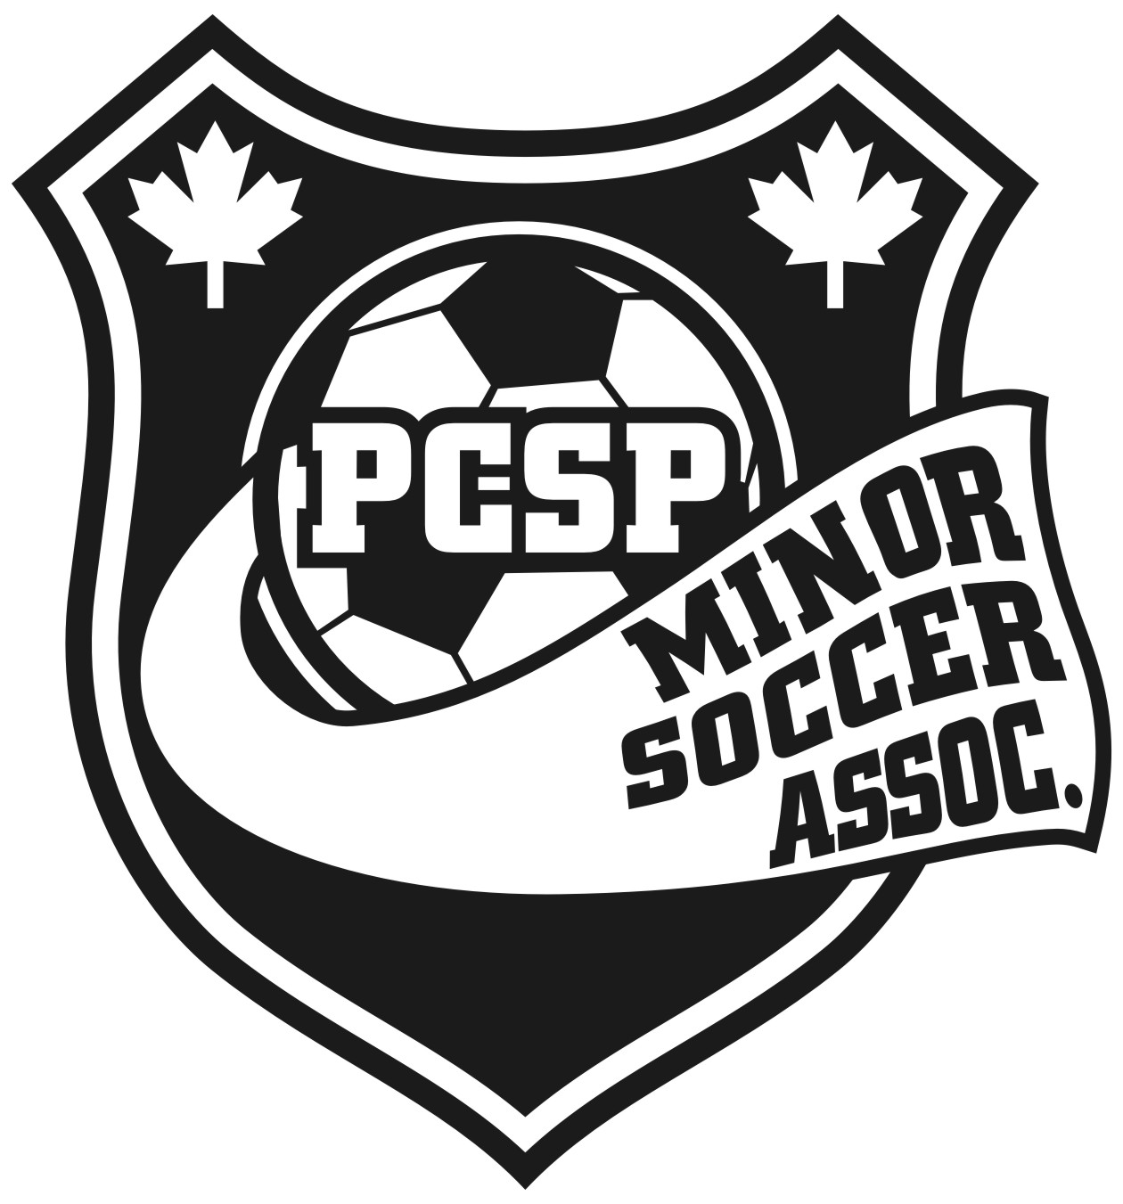

Referees (REF 1.0)
  - Eligibility for Officiating
Only referees fully certified through NLSA/CSA sanctioned training and registered as an official under PCSP Minor Soccer and the NLSA will be permitted to referee PCSP Minor Soccer house league and/or other matches as sanctioned under the metro league program or any other match sanctioned under the NLSA. Matches sanctioned under the NLSA include any house league games, metro league matches or any NLSA scheduled events such as jamborees/provincial tournaments. Referees may submit their name before the beginning of the season of their intent to referee in PCSP Minor Soccer house league games and/or exhibition matches throughout the year arranged by PCSP Minor Soccer staff and/or coaches. Referees that are currently active registered players in any PCSP Minor Soccer program (house league/all-star/competitive) will receive first opportunity to referee these matches. Referees are not permitted to officiate matches of their own age group or any age group above their age.

Individuals, upon completion of the CSA Youth Referee Course, are permitted to referee small sided matches (8 aside, etc.) up to and including Under 12. THIS COURSE DOES NOT PERMIT AN INDIVIDUAL TO REFEREE 11 ASIDE, FULL FIELD SOCCER NOR TO ACT AS AN ASSISTANT AT ANY LEVEL. The minimum age of eligibility to participate in this course is 12. Exceptions may be granted for those who are 11 nearing their 12th birthday. These exceptions must be approved by both the NLSA referee instructor and the director of referees for PCSP Minor Soccer. Consideration is given to an individual based on their maturity level.

The Entry Level Course is a 16 hour CSA-certified course designed to teach the Laws of the Game. The course is practically oriented and there is an examination. The minimum age a candidate may be presented for the Entry Level Course is 14 years. Candidates who do not reach the standard required by NLSA in the initial examination may not be presented for further examination until a period of 28 days has elapsed. Upon successful completion of the Entry Level course, an official may register as a District Level official, provided they have reached the age of 16 years. Referees between 14 and 16 years of age are registered as Youth Referees.

Referees shall be required to wear a uniform to all matches and must come FULLY prepared (stopwatch, whistle, pencil, paper, cards when applicable). This includes a black shirt (provided by PCSP Minor Soccer), black shorts, black socks and cleats. Referees will be remunerated as set by PCSP Minor Soccer for games officiated.

Application to referee at the metro league level (Metro Soccer League) for matches in this league must be made to the referee coordinator of the Metro Soccer League. PCSP Minor Soccer or any other NLSA sanctioned club does not govern the referee coordination of the Metro Soccer league.

  - Referee Assessments
Officials registered with PCSP Minor Soccer will be assessed by the director of referees/program coordinator on an ongoing basis. Assessments will be performed at the assigned referee’s match. All efforts will be exercised to assess referees prior to the beginning of a season in the form of exhibition matches. Periodic assessments will take place throughout the house league season. Referees will be assessed on their knowledge of the Laws of the Game, punctuality and attitude. The director of referees or program coordinator will complete a referee assessment form which will be made available to the referee shortly after the game he/she officiated. The assessment will form a review of both good points and areas of improvement for the official.

Officials will be given a period of time to improve on their referee skills. Officials must maintain a consistent mark of 80% or above on their assessments. Failure to maintain this mark may result in a referee receiving less assigned games until reassessment in which a satisfactory improvement is demonstrated or possibly suspension of referee duties.

As the Laws of the Game change from year to year, MANDATORY refresher training is required of ALL referees that will take place at a scheduled date and time prior to the start of the season each year. Referees who fail to participate in this will not be permitted to referee within the club.

Finance (FIN 2.0)
2.1 Refunds
Portugal Cove-St. Philip’s Minor Soccer Association will provide a 50% refund of registration costs (this does not include the cost of the monogrammed warm up suit for metro players) if the refund is requested before the start of the season (first official game).
Portugal Cove-St. Philip’s Minor Soccer Association will provide a 50% refund of registration costs after the start of the regular season only for medical reasons (with documentation by a physician) if the refund is requested before July 31st. No refunds will be granted after July 31st.
PCSP Minor Soccer will provide a refund of half the winter metro league training fee provided that the refund is requested before the date that the second payment of winter training fees are due. After this date, no refund will be granted.

