

Team Name Here

# 1 First & Last  
# 2 First & Last  
# 2 First & Last  
# 2 First & Last  
# 2 First & Last  
# 2 First & Last  
# 1 First & Last  
# 2 First & Last  
# 2 First & Last  
# 2 First & Last  
# 2 First & Last  
# 2 First & Last  
# 2 First & Last  
# 2 First & Last  
# 2 First & Last  
# 2 First & Last  
# 2 First & Last  
# 2 First & Last

Team Name Here

# 1 First & Last  
# 2 First & Last  
# 2 First & Last  
# 2 First & Last  
# 2 First & Last  
# 2 First & Last  
# 1 First & Last  
# 2 First & Last  
# 2 First & Last  
# 2 First & Last  
# 2 First & Last  
# 2 First & Last  
# 2 First & Last  
# 2 First & Last  
# 2 First & Last  
# 2 First & Last  
# 2 First & Last  
# 2 First & Last

Team Name Here

# 1 First & Last  
# 2 First & Last  
# 2 First & Last  
# 2 First & Last  
# 2 First & Last  
# 2 First & Last  
# 1 First & Last  
# 2 First & Last  
# 2 First & Last  
# 2 First & Last  
# 2 First & Last  
# 2 First & Last  
# 2 First & Last  
# 2 First & Last  
# 2 First & Last  
# 2 First & Last  
# 2 First & Last  
# 2 First & Last

Type Tournament level/division here

with tournament date.

**TOURNAMENT PROGRAM**

Insert Tournament

Logo Here

(if applicable)

Otherwise center

PMHA Logo & delete box.

Team Name Here

# 1 First & Last  
# 2 First & Last  
# 2 First & Last  
# 2 First & Last  
# 2 First & Last  
# 2 First & Last  
# 1 First & Last  
# 2 First & Last  
# 2 First & Last  
# 2 First & Last  
# 2 First & Last  
# 2 First & Last  
# 2 First & Last  
# 2 First & Last  
# 2 First & Last  
# 2 First & Last  
# 2 First & Last  
# 2 First & Last

Team Name Here

# 1 First & Last  
# 2 First & Last  
# 2 First & Last  
# 2 First & Last  
# 2 First & Last  
# 2 First & Last  
# 1 First & Last  
# 2 First & Last  
# 2 First & Last  
# 2 First & Last  
# 2 First & Last  
# 2 First & Last  
# 2 First & Last  
# 2 First & Last  
# 2 First & Last  
# 2 First & Last  
# 2 First & Last  
# 2 First & Last

Team Name Here

# 1 First & Last  
# 2 First & Last  
# 2 First & Last  
# 2 First & Last  
# 2 First & Last  
# 2 First & Last  
# 1 First & Last  
# 2 First & Last  
# 2 First & Last  
# 2 First & Last  
# 2 First & Last  
# 2 First & Last  
# 2 First & Last  
# 2 First & Last  
# 2 First & Last  
# 2 First & Last  
# 2 First & Last  
# 2 First & Last

Tournament Committee Greeting here!

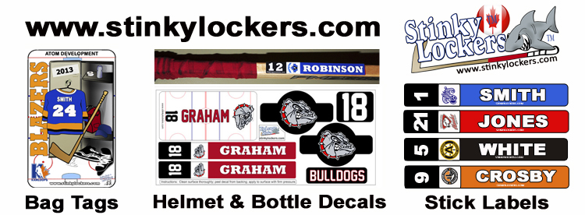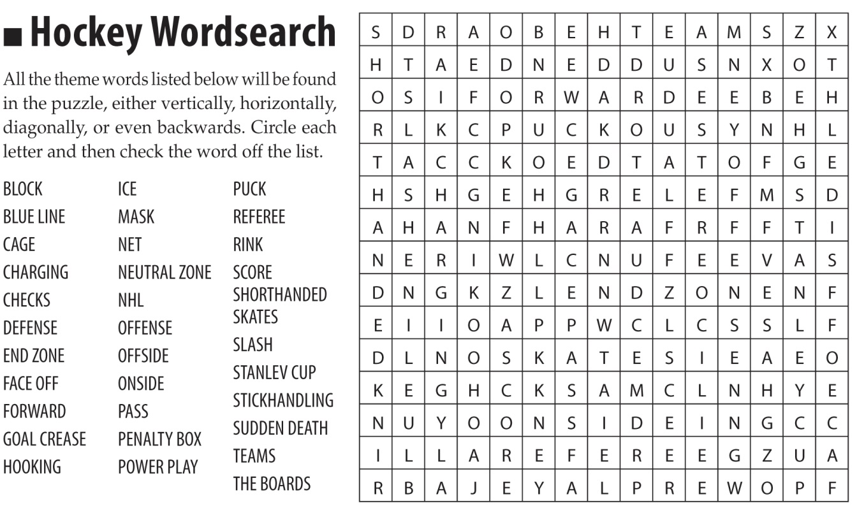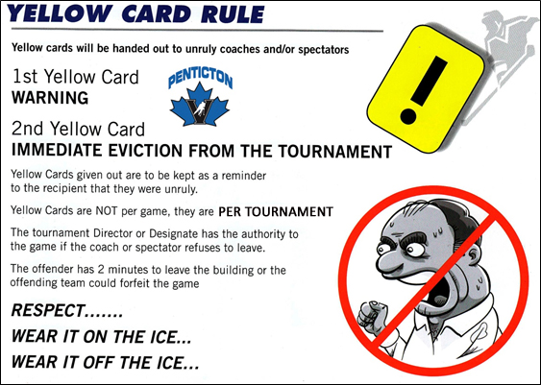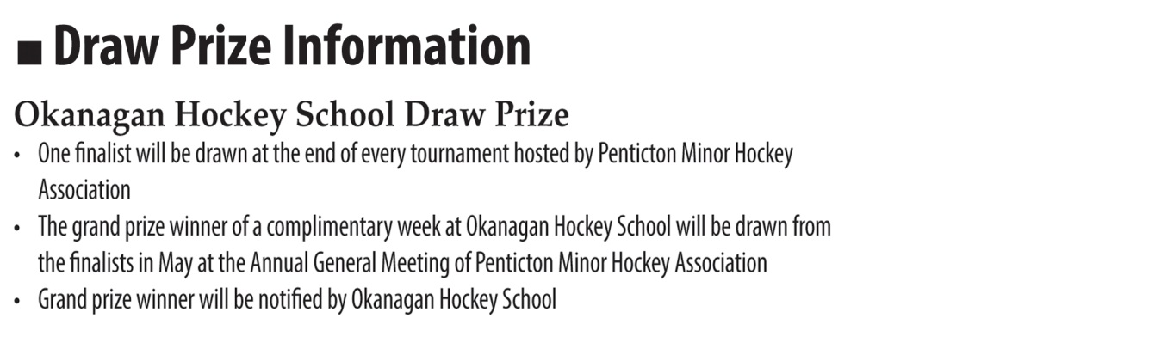

Team Name Here

# 1 First & Last  
# 2 First & Last  
# 2 First & Last  
# 2 First & Last  
# 2 First & Last  
# 2 First & Last  
# 1 First & Last  
# 2 First & Last  
# 2 First & Last  
# 2 First & Last  
# 2 First & Last  
# 2 First & Last  
# 2 First & Last  
# 2 First & Last  
# 2 First & Last  
# 2 First & Last  
# 2 First & Last  
# 2 First & Last

Team Name Here

# 1 First & Last  
# 2 First & Last  
# 2 First & Last  
# 2 First & Last  
# 2 First & Last  
# 2 First & Last  
# 1 First & Last  
# 2 First & Last  
# 2 First & Last  
# 2 First & Last  
# 2 First & Last  
# 2 First & Last  
# 2 First & Last  
# 2 First & Last  
# 2 First & Last  
# 2 First & Last  
# 2 First & Last  
# 2 First & Last

Team Name Here

# 1 First & Last  
# 2 First & Last  
# 2 First & Last  
# 2 First & Last  
# 2 First & Last  
# 2 First & Last  
# 1 First & Last  
# 2 First & Last  
# 2 First & Last  
# 2 First & Last  
# 2 First & Last  
# 2 First & Last  
# 2 First & Last  
# 2 First & Last  
# 2 First & Last  
# 2 First & Last  
# 2 First & Last  
# 2 First & Last

Team Name Here

# 1 First & Last  
# 2 First & Last  
# 2 First & Last  
# 2 First & Last  
# 2 First & Last  
# 2 First & Last  
# 1 First & Last  
# 2 First & Last  
# 2 First & Last  
# 2 First & Last  
# 2 First & Last  
# 2 First & Last  
# 2 First & Last  
# 2 First & Last  
# 2 First & Last  
# 2 First & Last  
# 2 First & Last  
# 2 First & Last

Team Name Here

# 1 First & Last  
# 2 First & Last  
# 2 First & Last  
# 2 First & Last  
# 2 First & Last  
# 2 First & Last  
# 1 First & Last  
# 2 First & Last  
# 2 First & Last  
# 2 First & Last  
# 2 First & Last  
# 2 First & Last  
# 2 First & Last  
# 2 First & Last  
# 2 First & Last  
# 2 First & Last  
# 2 First & Last  
# 2 First & Last

Team Name Here

# 1 First & Last  
# 2 First & Last  
# 2 First & Last  
# 2 First & Last  
# 2 First & Last  
# 2 First & Last  
# 1 First & Last  
# 2 First & Last  
# 2 First & Last  
# 2 First & Last  
# 2 First & Last  
# 2 First & Last  
# 2 First & Last  
# 2 First & Last  
# 2 First & Last  
# 2 First & Last  
# 2 First & Last  
# 2 First & Last

Team Name Here

# 1 First & Last  
# 2 First & Last  
# 2 First & Last  
# 2 First & Last  
# 2 First & Last  
# 2 First & Last  
# 1 First & Last  
# 2 First & Last  
# 2 First & Last  
# 2 First & Last  
# 2 First & Last  
# 2 First & Last  
# 2 First & Last  
# 2 First & Last  
# 2 First & Last  
# 2 First & Last  
# 2 First & Last  
# 2 First & Last

Team Name Here

# 1 First & Last  
# 2 First & Last  
# 2 First & Last  
# 2 First & Last  
# 2 First & Last  
# 2 First & Last  
# 1 First & Last  
# 2 First & Last  
# 2 First & Last  
# 2 First & Last  
# 2 First & Last  
# 2 First & Last  
# 2 First & Last  
# 2 First & Last  
# 2 First & Last  
# 2 First & Last  
# 2 First & Last  
# 2 First & Last

Team Name Here

# 1 First & Last  
# 2 First & Last  
# 2 First & Last  
# 2 First & Last  
# 2 First & Last  
# 2 First & Last  
# 1 First & Last  
# 2 First & Last  
# 2 First & Last  
# 2 First & Last  
# 2 First & Last  
# 2 First & Last  
# 2 First & Last  
# 2 First & Last  
# 2 First & Last  
# 2 First & Last  
# 2 First & Last  
# 2 First & Last

Team Name Here

# 1 First & Last  
# 2 First & Last  
# 2 First & Last  
# 2 First & Last  
# 2 First & Last  
# 2 First & Last  
# 1 First & Last  
# 2 First & Last  
# 2 First & Last  
# 2 First & Last  
# 2 First & Last  
# 2 First & Last  
# 2 First & Last  
# 2 First & Last  
# 2 First & Last  
# 2 First & Last  
# 2 First & Last  
# 2 First & Last

Team Name Here

# 1 First & Last  
# 2 First & Last  
# 2 First & Last  
# 2 First & Last  
# 2 First & Last  
# 2 First & Last  
# 1 First & Last  
# 2 First & Last  
# 2 First & Last  
# 2 First & Last  
# 2 First & Last  
# 2 First & Last  
# 2 First & Last  
# 2 First & Last  
# 2 First & Last  
# 2 First & Last  
# 2 First & Last  
# 2 First & Last

Team Name Here

# 1 First & Last  
# 2 First & Last  
# 2 First & Last  
# 2 First & Last  
# 2 First & Last  
# 2 First & Last  
# 1 First & Last  
# 2 First & Last  
# 2 First & Last  
# 2 First & Last  
# 2 First & Last  
# 2 First & Last  
# 2 First & Last  
# 2 First & Last  
# 2 First & Last  
# 2 First & Last  
# 2 First & Last  
# 2 First & Last

List your division   
tournament sponsors  
or logos here!

**DIVISION TOURNAMENT SPONSORS**

Complete entry on reverse and deposit in draw box at raffle table!

Insert your

Tournament schedule

here.

Copy & paste your

Tournament rules here

and adjust font size to fit.

**TOURNAMENT RULES**

**TOURNAMENT SCHEDULE**