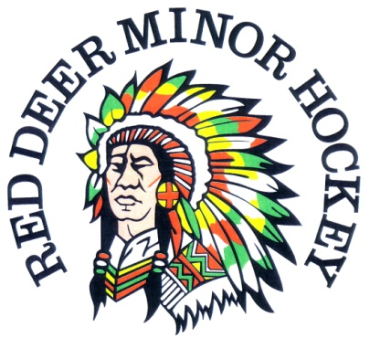
RDMH GOLF CLASSIC
HISTORY

The Beginning
This tournament started four years ago with an idea of some sort of an event that we could bring together people who have a direct connection to RDMH. We wanted to do something that we could raise money for RDMH and enjoy a day or two of fellowship and fun .
With this in mind we decided to host a golf tournament at the RDG&CC with a Social the night before. With all of our connections we were able to secure enough Sponsors year 1 to make the tournament happen. We only allowed teams of 4 to enter and with that we have been at 120 players for the past 4 years.
Nothing happens without a great committee , the following people have been on the committee over the last 4 years ; Dallas Gaume , Al Sim , Dave Kalinowski , Terry Nieth , Todd Thiessen , Ken Frame, Dion Zukiwsky , Terry Coutts , Brian Dawes , Kevin Smyth , Stan Krawiec & Kevin Sandquist.
Funding
Through the last 4 years we have been able to raise over $100,000 and we have put the money to work at RDMH , the following list the items or projects we have funded through the years :
- Player Development
- Coaching Development
- High River Minor Hockey ( year of the flood )
- Arena Coaches room upgrade
- Rink Boards for 1/2 ice
- Steva Video Equipment
- Steva Software upgrade
- Washer & Dryer for the Arena
- Kinex Player bench upgrade
- Kinex sliding door between dressing rooms 2 & 3
We will continue to use Golf Tournament monies to help with any purchases OR improvements we feel would make RDMH better.
Moving Forward
We are in a good position moving forward and have 95% of our sponsors return each year , with 2017 being no exception. We are even in a better position this year with two additional major sponsors wanting to join the event, with this in mind we may have to increase the size of our tournament this year to 128 players.
The good thing each year is that our Signage expense budget is relatively low based on returning Sponsors.
Tournament Highlights
1. Sunday Night Social - All players are invited to this evening with drinks and appy's included.
2. Million $ Shootout - 5 players are sold to participate in the Million $ Shootout Monday morning. 80% of the funds raised are paid out to the Closest to the Pin winner. As we know this is the highest % given back to the player in all Million $ Shootouts across the province.
3. Food & Beverage - We have 3 food stations on the golf course and at least 2 Drink stations.
4. Calcutta - We have a Calcutta that is sold on the Sunday night - One is a Verified handicap Calcutta and One is a Non- Verified handicap Calcutta. With the Verified there is no limit to what the teams are sold for and with the Non - Verified it is a $400.00 buy in, if the team chooses to . Pay - out on the Calcutta's is in cash and is - 50% - 1st - 30% - 2nd - 20% - 3rd. 20% of the amount raised is retained by the tournament.
5. 1st Tee Give - Away - We have given some great items over the years - Shoes - Travel bags - Golf Balls- Shorts - Shirts - Pullovers and will continue to provide an item that has a perceived valve over $100 when the players arrive.
6. Sponsorship - It has always been our goal to give the sponsors great value for their $'s and we believe we have done that right from the start. When things changed in the economy in 2016 , we decided to drop the Sponsorship levels across the board by 20% and have left them at those levels for the 2017 Tournament. We were still able to make a profit from the event .

