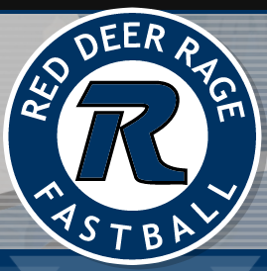

Coaches: Heather Chatwood / Lyle Hansen

B. Donison
D. DeRuyter
D. LeBlanc
D. Rusnak
E. Meraw
G. Hodgson
H. Dickson
K. Hansen
L. Domoney
P. Simpson
R. Cruickshanks
R. Kusk

Congratulations on making the U16A roster!

