2017-2018 Season
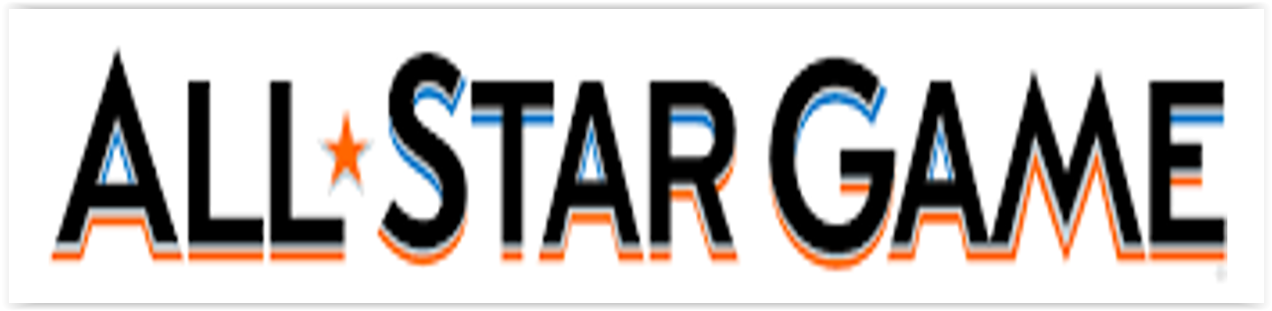
Jan 7, 2018
3:30 pm @ the Sherwood Park Shell

Food Bank Donation appreciated
Hosted by your SPKAC 15 AA Senators
Come cheer on your SPKAC players!
