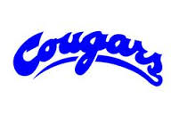
SGDMFA 2017 AGM – Proxy Vote Form

I, ______________________________________, a member of the Spruce Grove & District
Minor Football Association (SGDMFA), do hereby appoint
______________________________________, of the SGDMFA, (or failing him/her,
______________________________________, of the SGDMFA), as my proxy vote for my
person and on my behalf at the 2017 Annual General Meeting of the SGDMFA to be held on
March 5, 2018 in the gym at Millgrove School, Spruce
Grove, Alberta.
Signature: ______________________________________
Dated: March ________, 2018

