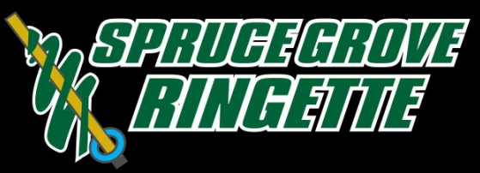

EXECUTIVE COMMITTEE MEETING
Wednesday, August 30, 2017 at 7:00 p.m.
Border Paving Athletic Center- Lodgepole Room

- WELCOME AND CALL TO ORDER
Leanne Couves called the meeting to order at 7:06 pm with the following in attendance:
Lynda Snider, Director of Ice Acquisition and Allocation
Barb Hoffman, Director of U10 Step 2 and Step 3
Bonnie Feakes, Director of U12
Adam Penno, Coordinator of Referee Scheduling
Krista Wood, Representative to BGL
Allyson Zellisko, Coordinator of Special Event
Stu Becker, Director of U16
Rhonda Kew, Coordinator of Website and Communication
Brian Pedlar, VP and Director of Operations
Jacinda Rolph, Director of U18+
Nancy Bechard, Director of Player Development and Assessment
Dana Cyrenne, Director of U10 Active Start and Step 1
Dillon Elliott, Director of Coaching Development and Assessment
Heather Murray, Director of Finance
Trish Lemoine, Coordinator of Publicity and Promotions
Sherry Stypula, Director of Officiating and Officiating Development

- CREDENTIALS REPORT – ESTABLISH QUORUM
Established quorum, 10 voting members in attendance.

- ADOPTION OF AGENDA
Barb Hoffman moved to adopt the agenda. Stu Becker seconded.
All in favor.

- ADOPTION OF MINUTES
Brian Pedlar moved to adopt August 17, 2017 minutes. Sherry Stypula seconded.
All in favor.

- DIRECTOR AND COMMITTEE REPORTS
Dave from Snipers Skate Sharpening may be changing the way they do fundraising for skate sharpening. Leanne Couves will email Michelle Viney to look into it.
Allyson Zellisko is giving out Galaxyland tickets. We have 287 registered players and will have a $9,975 profit for base sales. There will be only cash sales for extra tickets. Allyson is going to check into using square.

- FINANCIAL REPORT
Nothing to report.

- NEW BUSINESS

- Updates of Evaluation Process
Evaluation process will be uploaded to the SGRA website Friday.
We will have UAA documents at the registration for parents.
We have 16 girls to help with UAA.

- Approve Updated Policies

Motion:
Krista Wood moved to approve the updated Tournament Policy August 30,2017.
Sherry Stypula seconded. 8 in favor, 2 abstained. Motion carried.
Motion:
Stu Becker moved to approve the updated Code of Conduct Policy August 30,2017.
Brian Pedlar seconded. All in favor. Motion carried.
Motion:
Stu Becker moved to approve the updated Affiliation Policy August 30,2017.
Barb Hoffman seconded. All in favor. Motion carried.
Motion:
Dillon Elliott moved to approve the updated Registration Policy August 30,2017.
Brian Pedlar seconded. All in favor. Motion carried.
Motion:
Stu Becker moved to approve the updated Team Formation Policy August 30,2017.
Sherry Stypula seconded. All in favor. Motion carried.

The appeals, complaints and discipline policies are still a work in progress and we will continue updating policies via email.

- BGL and RAB critical dates
Critical dates are on the BGL website.

- PRESIDENT’S REPORT
Leanne Couves is checking Residency Policy as we may be getting import players from Edmonton. There have been political discussions regarding ice. If members want anything added or changed in the Coaches or Managers Handbooks let Leanne know as she is updating them.

- ROUND TABLE DISCUSSIONS
Oilers

- ADJOURNMENT
Leanne Couves adjourned the meeting at 9:12 pm.

