2018 Provincials
U16A
U19A
Open A
Coaches/Manager Package
March 2nd – 4th, 2018

Provincial Contact Information
Tournament Chair – Karen Clark 780-910-5933
Communications & Ceremonies Coordinator- Angela Hewlett 780-686-0247 & Cara Lizee 780-966-8392
Operations Coordinator – Kari Baker 780-974-2037
Financial Coordinator – Kristine Gullickson 780-719-2616
Rosters
Please email: tckc@telus.net your team roster including jersey numbers – marking Captains (C), Assistant Captains (AC), Goalies (G), Head Coach (HC), Assistant Coach (AC), Trainers, Managers, and Affiliates (AP, AG)
Head Coach & Manager Cell Numbers & Email Address
Please email cell phone numbers & Email Address for your Head Coach and Manager to: tckc@telus.net
Team Photo
Please email a team photo to sandies3@telus.net
Hotel Information
We have blocked off groups of rooms at the following hotels please contact them for your specific arrangements.
- Nisku Inn and Conference Centre, 1101 – 4 Street, Nisku, AB, 780 955 7744,
Group Block Code LEDRI
80 Standard Rooms Blocked – 2 Queens, Mini Fridge & Free Wi-Fi
Guest Room Rate is $89 + taxes per room per night
Complimentary Breakfast
Location is currently under MAJOR construction, no pool or hot tub available
Location of Banquet March 2, 2018
February 15, 2018 – Booking Cutoff

- Holiday Inn & Suites, 1100 – 4 Street, Nisku, AB, 780 979 0839
Email: selena@shiringroup.ca
Managers can contact Selena Martin direct and she will ensure they are booked in, along with giving each team an online booking link so all participants in their group can easily book their own rooms.
50 Standard Rooms Blocked
2 Queen Beds, Mini Fridge, Free Wi-Fi, Stand Up Showers Only, Pool, Hot Tub & Fitness Room
Hot Breakfast buffet will be included maximum 1-4 guests per room
Location of Coaches Meeting, March 1, 2018 – 730 PM
Guest Room Rate is $115.00 + taxes per room per night.
FEBRUARY 18, 2018 Booking Cutoff

- Hilton Garden Inn Edmonton Intl Airport, 8208 – 36th Street, Leduc, AB, 780 612 2350
Email: keerthi.suranga@hilton.com
Managers can contact Keerthi Suranga direct and he will ensure teams are booked in, along with giving each team an online booking link so all participants in their group can easily book their own rooms.
Blocked off 50 Standard Rooms
2 Queen Beds, Mini Fridge, Free Wi-Fi, Pool and Fitness Centre
$89.99+ taxes per room per night (room only)
$123.99+taxes per room per night, including the breakfast (Maximum 04 guests in each room)
Please note** Guest who are booking without breakfast (Room only), can order restaurant breakfast at $14.95 per person
FEBRUARY 18, 2018 Booking Cutoff

- Paradise Inn & Suites Signature, 7118 Sparrow Drive, Leduc, AB 780 769 0280
Email: sfreeman@paradiseinnandsuites.ca
Managers can contact Sylvester Freemann direct and he will ensure teams are booked in, along with giving each team an online booking link so all participants in their group can easily book their own rooms.
20 Rooms Blocked Off
2 Queen Beds, Mini Fridge, Microwave, Free Wi-Fi and Fitness Centre
Includes Complimentary Breakfast
Guest Room Rate is $89 + taxes per room per night
FEBRUARY 18, 2018 Booking Cutoff

- Wingate by Wyndham Edmonton Airport, 7120 Sparrow Drive, Leduc, 780 769 0079
Email: gm@wingateedmonton.com
Managers can contact John Mayne direct and he will ensure teams are booked in, along with giving each team an online booking link so all participants in their group can easily book their own rooms.
23 Standard Rooms with 2 Queen beds, 8 Junior Suites(with pullout), 9 Standard King beds, 4 Executive Rooms Blocked
Mini Fridges, Free Wi-Fi and Fitness Centre
Includes Complimentary Breakfast
Guest Room Rate is $89 + taxes per room per night. Rate applies for all Room Types
FEBRUARY 15, 2018 Booking Cutoff

Opening Ceremony, Banquet & Entertainment Tickets – U16A & U19A Only
The banquet will be at the Nisku Inn Ballroom – Friday, March 2, 2018 – Doors 6:00 PM– Dinner 7:00 PM – Entertainment 8:30 PM – Finished at 9:30 PM – Tickets are $40.00 Each – This event is for U16A & U19A – Players, Coaches & Families Only, OPEN will have games at this time - Deadline For Purchase February 19, 2018 – We want to make 2018 a memorable event, please note there will be NO U16A or U19A games played this evening, all games will be completed prior to 5:00 PM on March 2, 2018 - please see below for some additional information:
Team Procession
We would ask that each team begin to line up in the hallway next to the ballroom starting at about 6:45 PM, we will introduce and welcome each team as they enter the ballroom, each team will have their own table reserved for their players. The tables will be marked with your team name and division.
Meal
We will be serving a wonderful buffet meal consisting of Dinner Rolls w/ Sweet Butter, Pickles, Olives & Crisp Relishes, Tossed Greens with Assorted Dressings (Gluten Free) Classic Potato Salad, Creamy Pasta Salad, Herb Roasted Chicken (Gluten Free), Roasted Garlic Mashed Potatoes (Gluten Free), Gravy (Gluten Free), 2 Pastas, Marinara Sauce, Alfredo Sauce, Chefs Seasonal Vegetable (Gluten Free), Assorted Dessert Selections, Coffee & Tea and Pop Complementary for Minors this function is Licensed so there will be bar service available.
Entertainment
Will be Blaze ‘n Days – Musical/Interactive/Comedy Variety Duo, there will also be an area where the teams can take photos, the 50/50 will be available for purchase and the silent auction items will be available to bid on.
Tickets
Pre-sale ONLY for the banquet, e transfer can be sent to leducringette.treasurer@gmail.com , the etransfer question can be : What is this For? The Answer: Provincials
Dress Code
We would like to keep the banquet casual and are requesting the dress code to be Jeans and Black Tops, keeping it Classy & Casual

Photographer
There will be a photographer on site Friday night, Saturday and Sunday.

Game Schedule
The game schedule will be sent out as soon as Alberta Ringette approves it and all teams have finished play downs.

Coaches Meeting
The coaches meeting will be held on Thursday, March 1, 2018 at 7:30 PM at the Holiday Inn Suites, 1100 – 45 Street, Nisku, AB, Please make sure to bring your ID. All welcome kits, banquet tickets and hoodies will be handed out at this time.

Box Workers
ALL TEAMS, U16A, U19A and OPEN will be required to SUPPLY BOX WORKERS for all games EXCLUDING the Gold and Bronze Medal Games, Home Team supplies Shot Clock, Game Sheet and Penalty Box, Away Team supplies Time Clock and Penalty Box, these position assignments can change if everyone in the box agrees. Open Teams may supply 2 & 2 if both teams agree.

Leduc Canadian Brewhouse – Open Only
The Open Teams have the opportunity to contact Colin via email at the Leduc Canadian Brewhouse, they have offered to supply each of the Open A Teams with 4 Large Pizzas and Unlimited Pop, Free of Charge, o make these arrangements please contact Colin at colin.ferster@thecanadianbrewhouse.com prior to February 27, 2018 to schedule a time that will work for your team.
Game Sheet Stickers
All teams must bring their own GAME SHEET STICKERS, and check in at the desk to complete the game sheet as per Ringette Alberta Rules.

Team Track Warm Up
Prior to your games you will have the opportunity to do a warm up on the Leduc Recreation Center Track, these warm up slots have been scheduled for you because the Leduc Recreation Center will only allow 2 teams on the track at any given time. These will be handed out when the schedule is released.

Skate Sharpening/Skates/Ring Jet Sticks & Equipment – 5025 – 50 Ave Leduc
We have partnered with Evolution Sporting Goods in Leduc for all of your Ringette needs, each player will receive a complimentary skate sharpening. They have a full selection of Skates, Equipment and Ring Jet Sticks. They are open Friday 1000 AM – 800 PM, Saturday 800 AM – 600 PM and Sunday 1000 AM – 600 PM.

Results
The results boards will be located in the Arena and updated on the Leduc Ringette Website as well: http://www.leducringette.com/tournament/384

Silent Auction, Raffle and 50/50
We will have a Silent Auction, Booze Raffle and 50/50 set up at the arena throughout the weekend, the Silent Auction, Booze Raffle and 50/50 will close Saturday night at 9:30 PM. Silent Auction items can be paid for by cash or email transfer.

Hospitals – With X-Ray
Leduc General Hospital - 4210 – 48 Street, Leduc, AB
Grey Nuns Hospital – 1100 Youville Drive W, Edmonton, AB
University Of Alberta Hospital - 8440 – 112 Street NW, Edmonton, AB
Banquet & Hoodie Order Forms
The order form will be attached for both Banquet Tickets and Hoodies – Deadline is February 19, 2018, please email the completed form to tckc@telus.net
Provincial Hoodies
These will be Black Hoodies with the Provincial Logo in the middle on the front of the hoodie, $45.00 Each – Deadline for Purchase is February 19, 2018
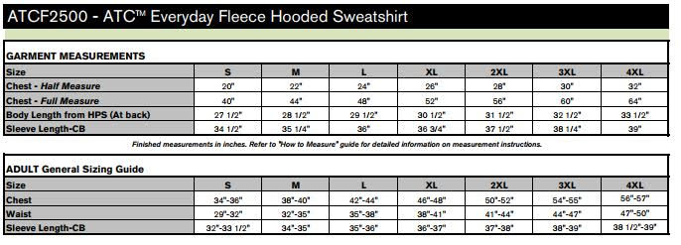
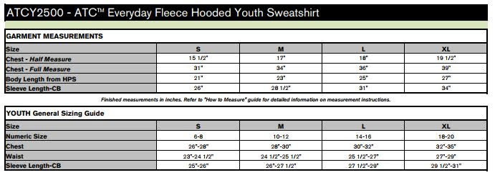
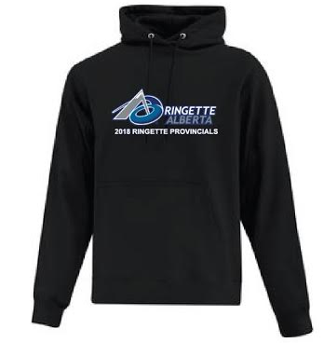

2018 Alberta Ringette Provincial Checklist

- Email Team Roster w/ Names & Numbers to Karen Clark tckc@telus.net

- Email Coach & Manager Contact Information to Karen Clark tckc@telus.net

- Email Team Picture to Angela Hewlett sandies3@telus.net

- Book Hotels if Needed

- U16A & U19A - Order Banquet Tickets $40.00 Each – Deadline February 19, 2018 Email Karen Clark tckc@telus.net

- E-transfer $ Banquet Tickets leducringette.treasurer@gmail.com Question: What is this for? Answer: Provincials

- Order Hoodies $45 .00 Each – Deadline February 19, 2018 Email Karen Clark tckc@telus.net

- E-transfer $ Hoodies: leducringette.treasurer@gmail.com Question: What is this for? Answer: Provincials

- Coaches Meeting – March 1, 2018 – 7:30 – Holiday Inn Suites, 1100 – 45 Street, Nisku, AB – Bring Identification

- Open Teams to book Pizza at Leduc Canadian Brewhouse

- Assign Box Workers – 3 for Home Team, 2 for Away Team, Open Teams can be 2 Home Team and 2 Away Team

- Bring Game Sheet Stickers for ALL Games to be Played

