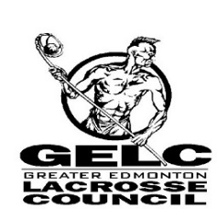

Members,
As the season comes to an end and playoffs are quickly approaching, I am writing this letter to remind everybody of the expectations for behavior while spectating minor lacrosse in Edmonton. There will be zero tolerance for inappropriate actions, vocabulary or unruly fans.
I will also remind all that the head coach is responsible for the conduct of his fans and it is the role of the spectator liaison to keep their teams fans in check.
Behavior that is a detriment to the game include, but not limited to;
- Any use of profanity
- Any attempts to intimidate officials through shouting, banging on glass/boards or whistling
- Any attempts to intimidate opposing team players, bench staff or fans through taunting, shouting or excessive celebration
For your reference, the code of conduct is listed below;
10.01.01 CODE OF CONDUCT
All Persons, Members, Players, Coaches, Managers, Trainers, officials and members of Members shall: (a) attempt at all times to work toward the goals and objectives of the GELC and the game of Lacrosse, and towards the betterment of its members;
(b) strive to heighten the image and dignity of the GELC and the sport of Lacrosse as a whole, and to refrain from behavior which may discredit or embarrass the GELC or the Game;
(c) always be courteous and objective in dealings with other members;
(d) except when made through proper channels, refrain from unfavorable criticism of other members or representatives of the GELC;
(e) strive to achieve excellence in the sport while supporting the concepts of Fair Play and a Drug-Free sport;
(f) show respect for the cultural, social and political values of all participants in the sport;

You have been advised that the GELC Executive and discipline committee will exercise their full authority to sanction members whom fail to keep their behaviour in the stands in check.
Govern Yourself Accordingly,

Sean Aggus
GELC President

