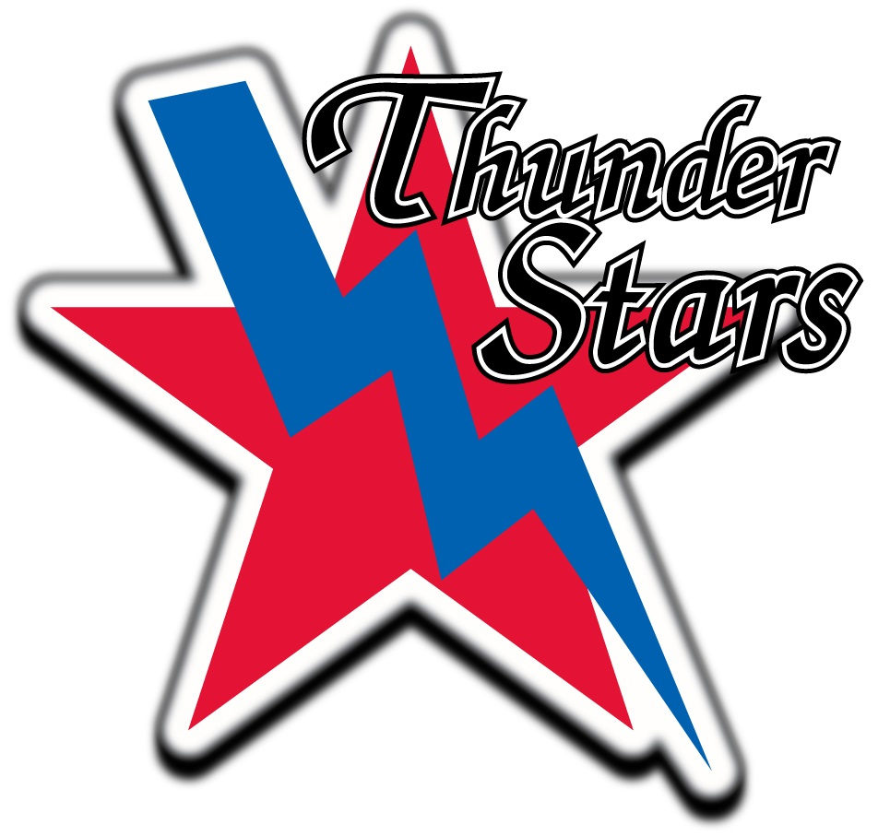

I, _____________________________ have been made aware that ThunderStars Minor Hockey Association and/or Hockey Alberta will not be providing any insurance to me while I am skating on the ice at any given practice during ______ hockey season. I will take full responsibility if I suffer any injuries while on the ice at any of the practices that I may participate in. I am also aware that I am not registered with Hockey Canada and therefore cannot be on the bench at any of the games.

Signature:__________________________________ Date:_______________________
Managers Signature:___________________________________ Dare:_______________________

