Tournament Hosting Guide
City of Spruce Grove and Area

Tri Area Warriors Volleyball Club

“You Go Girl” 2019
U14 Female Tournament
#1 February 23, 2019
St. Thomas Aquinas Catholic School
395 Grove Drive, Spruce Grove

#2 May 4, 2019
Living Waters Christian Academy
5 Grove Drive West, Spruce Grove

Welcome to Spruce Grove!

Have a great time exploring the various attractions and amenities.

www.sprucegrove.org

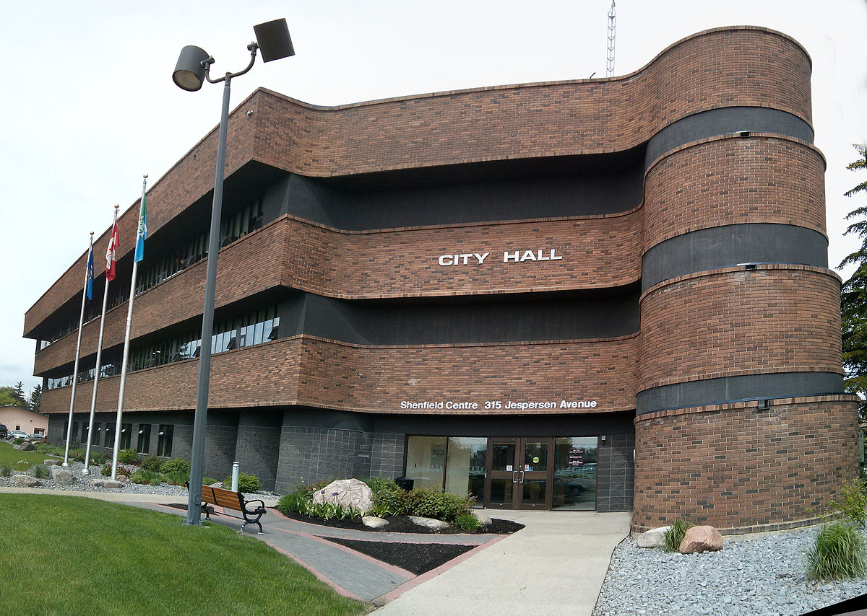

The purpose of this tournament hosting guide is to provide guest’s visiting the City of Spruce Grove for tournament or events a quick snapshot of local businesses, services and things to do. We hope you enjoy your visit to the City of Spruce Grove and plan to come back soon!

CONTENTS:

Page 3 - Tournament Information

Page 4 - Important Contact Information
    - Tournament Phone Numbers 780-554-9039 - Brenda
    - City of Spruce Grove Departments

Page 5 - Accommodations
- Hotels - Spruce Grove
- Hotels - Stony Plain
- Campgrounds - Spruce Grove
- Campgrounds - Stony Plain

Page 5 - Restaurants

Page 6 - Attractions + Things To Do
    - Spruce Grove + Area
    - Edmonton

Page 6 - Outdoor Activities

Page 7 - Pharmacies, Medical Drop In Clinics, Hospitals

Page 7 - Grocery Stores, Shopping

Page 8 - Banks

Page 8 - Bus + Taxi Information
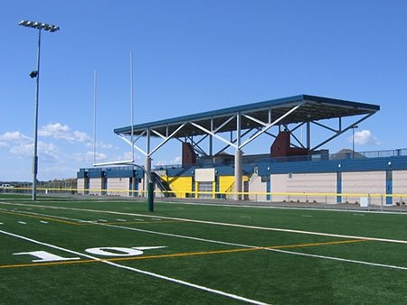
Page 8 - Visitor Centre

TOURNAMENT INFORMATION
Tri Area Warriors Volleyball Club Hosts
“You Go Girl” 2019 U14 #1 & #2 Female Tournaments
Date: February 23, 2019 & May 4, 2019
Time: 8:30 am – 6 pm
Location: St. Thomas Aquinas & Living Waters Christian Academy
Tickets: Free - Limited space, please register early for your spot!

Important Information:
On-Site Activities: Concession with Subway 6” sub’s and more
Possible Silent Auction!

IMPORTANT CONTACT INFORMATION

“You Go Girl” U14 Female Tournament
Name | Role in Tournament | Email | Phone Number
Brenda Heisz | Lead | triareawarriors@gmail.com | 780-554-9039

City of Spruce Grove Departments

Department | Address | Email | Phone Number
Agrena - Curling Rink, Grant Fuhr Arena, Stu Barnes Arena | 9 Agrena Road | recreation@sprucegrove.org | 780-962-2031
Border Paving Athletic Centre  Recreation Services | 9 Tri Leisure Way | recreation@sprucegrove.org | 780-962-7632
City Hall  City of Spruce Grove | 315 Jespersen Avenue | info@sprucegrove.org | 780-962-2611
Enforcement Services  Community Peace Officers | 410 King Street | enforcement@sprucegrove.org | 780-962-7586
Family and Community Support Services | Queen Street Place  105 - 505 Queen Street | fcss@sprucegrove.org | 780-962-7618
Fire Hall  Fire Services + EMS | #120, 410 King Street | info@sprucegrove.org | 780-962-4496
Fuhr Sports Park  Artificial Turf | 9 Tri Leisure Way | recreation@sprucegrove.org | 780-918-2326
City Hall Ticket Centre  Box Office | 315 Jespersen Avenue | hstage@sprucegrove.org | 780-962-8995
RCMP  Spruce Grove Detachment | 410 King Street |  | Complaint Line 780-962-2222  Emergency Only  Dial 911
Specialized Transit Service | Pioneer Centre  301 Jespersen Avenue | Sts.bonnie@shaw.ca | 780-962-2456

ACCOMMODATIONS

Hotels
Spruce Grove
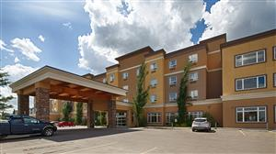
Holiday Inn Express
Travelodge Inn & Suites
Spruce Grove Area Bed and Breakfasts

Stony Plain
Ramada Stony Plain Hotel & Suites
Travelodge Stony Plain
Best Western Sunrise Inn & Suites
Motel 6 Stony Plain

Campgrounds
Spruce Grove
Diamond Grove RV Campground

Stony Plain
Camp ‘n Class
Stony Plain Lions RV Park and Campground

For a full list of other accommodations in the region, please visit: Tri Region Tourism

RESTAURANTS

Spruce Grove
Boston Pizza - Lunch + Supper - Family Restaurant - 205 Jennifer Heil Way - OR 201 Calahoo Road
Grill at the Links Golf Course - Breakfast, Lunch + Supper - 100 Links Road
Rainbow Palace Restaurant - Breakfast, Lunch + Supper - 93 McLeod Avenue
Ricky’s All Day Grill - Breakfast, Lunch + Supper - 70 McLeod Avenue
Sandy View Farms - Breakfast + Lunch - 155 South Avenue
Smitty’s - Breakfast, Lunch + Supper - 16 Nelson Drive
State and Main - Breakfast, Lunch + Supper - 300, 151 Century Crossing
Sunset Grill - Breakfast + Lunch - 214, 141 Century Crossing
Tutti Frutti - Breakfast + Lunch - 210, 205 Jennifer Heil Way

For a list of restaurants in Spruce Grove, please visit: Spruce Grove Restaurants

ATTRACTIONS + THINGS TO DO
Spruce Grove + Area
Aerials Gymnastics - Drop in and group rates available.
Grain Elevator Museum - Open May – September.
Heritage Grove Park Trails - Offers over 40 km of all-weather trails through Spruce Grove.
Horizon Stage - Various performances and shows.
Landmark Cinemas - Catch the latest films.
Melcor Cultural Centre - Literary and visual art displays.
Spruce Grove Parks & Recreation - Trail systems, splash pad and Spray Park (seasonal), and much more.
Spruce Grove Public Library - Offers diverse programs, book rentals and drop-in.
Stony Plain Attractions - Cultural heritage, festivals and events, parks and trails, and much more.

For more ideas, please visit: City of Spruce Grove Events and Attractions

Edmonton
Breakout Entertainment - Interactive escape room games.
Edmonton Corn Maze - Offers many activities, including the corn maze, bouncy games and petting zoo.
Edmonton Oilers - NHL hockey games (seasonal).
Fort Edmonton Park - Take a trip back in time!
Jubilations Dinner Theatre - Shows & entertainment.
Jump 360 Trampoline Park - Trampoline park & dodge ball.
Paint Nite - Instructed painting. Various locations in Edmonton & Spruce Grove.
Rock Jungle - Indoor climbing gym.
Speeders - Indoor pro karts.
TELUS World of Science - Exhibits, IMAX, and observatory.
West Edmonton Mall - Shopping, mini golf, indoor waterslides, zip line, bowling, and amusement rides.

For more ideas, please visit: Explore Edmonton

OUTDOOR ACTIVITIES

Spruce Grove + Area
Central Park - 450 King Street, Spruce Grove
Dog Off-Leash Parks - 50 Marlboro Drive, Spruce Grove & 51 Century Close, Spruce Grove
Heritage Grove Park - Trail System
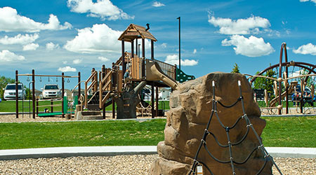
Jubilee Park - 510 Grove Drive, Spruce Grove
Spruce Grove Skate Park - 450 King Street (Central Park), Spruce Grove

For more recreation information: please visit City of Spruce Grove Recreation
For more parks information: please visit City of Spruce Grove Parks
For Parkland County lakes and trails: please visit Parkland County Natural Areas

PHARMACIES

Spruce Grove
Walmart Pharmacy - 90 Campsite Road, Spruce Grove - 780-962-9053
Shoppers Drug Mart - 131 Century Crossing #100, Spruce Grove - 780-962-3555
Rexall - 505 Queen Street, Spruce Grove - 780-962-2757
Loblaw Pharmacy - 10, 110 Jennifer Heil Way, Spruce Grove - 780-960-7435

MEDICAL DROP IN CLINICS AND HOSPITALS

Spruce Grove
Queen Street Medical Clinic - 505 Queen Street #102a, Spruce Grove - 780-960-4102
Primacy Symphony Medical Clinic - 110 Jennifer Heil Way, Spruce Grove - 780-960-1125
Tri Wellness MD Centre - Suite 100, 7 Tri Leisure Way, Spruce Grove - 587-853-0451

Stony Plain
Stony Plain Hospital - 4405 S Park Drive, Stony Plain – 780-968-3600

Devon
Devon General Hospital - 101 Erie Street S, Devon - 780-987-8200

GROCERY STORES

Real Canadian Superstore – 110 Jennifer Heil Way, Spruce Grove
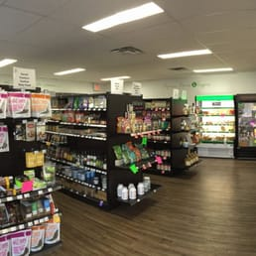
Sobeys – 11 Westway Road, Spruce Grove
Save-on-Foods – 121 Century Crossing, Spruce Grove
Safeway – 94 McLeod Avenue, Spruce Grove
Walmart Supercentre – 90 Campsite Road, Spruce Grove
Freson Bros (24 hours) – 4416 48 Street, Stony Plain

SHOPPING

Westland Market Mall – 70 McLeod Avenue, Spruce Grove
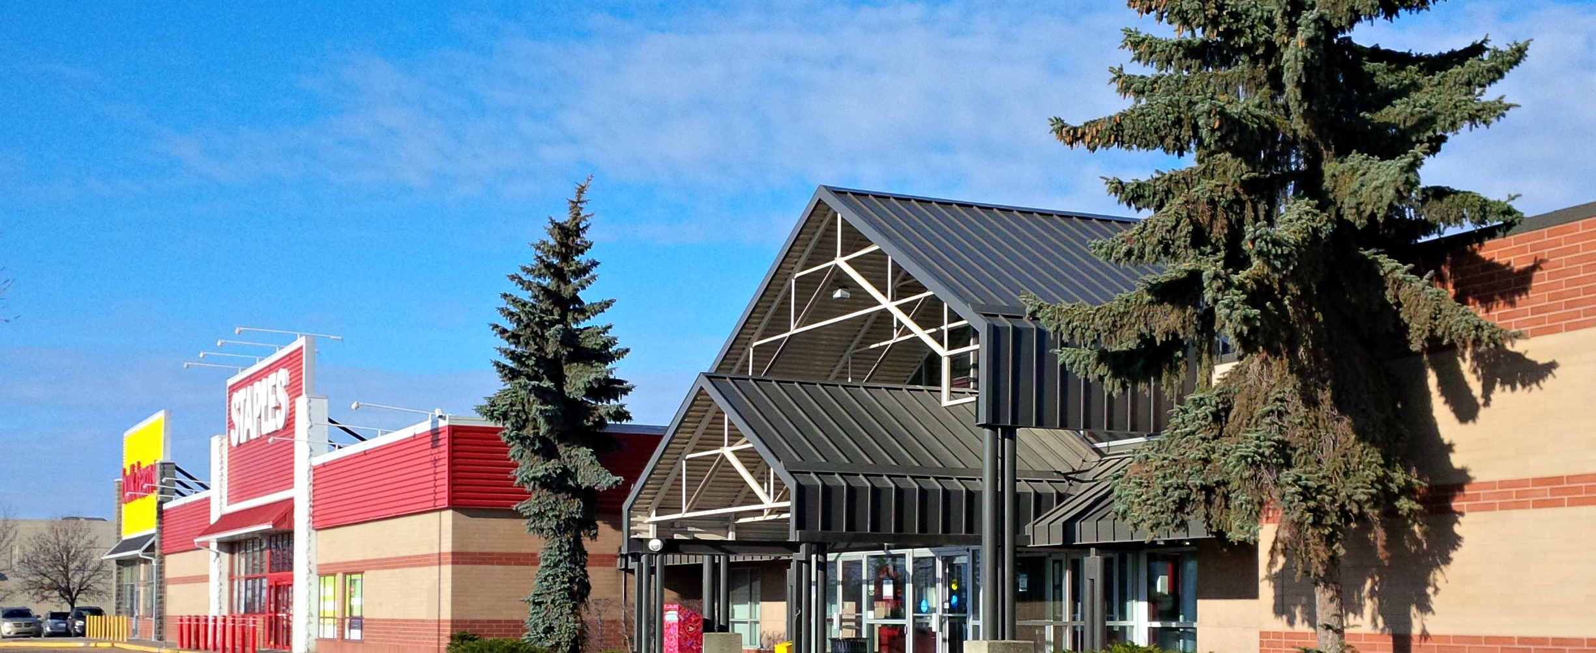
West Edmonton Mall – 8882 170 Street NW Edmonton
Southgate Centre – 5015 111 Street NW Edmonton
Kingsway Mall – 109 Street & Kingsway, Edmonton
South Edmonton Common – 1978 99 Street NW, Edmonton
Edmonton City Centre – 10025 102A Avenue, Edmonton

BANKS

TD Canada Trust – 10 100 Jennifer Heil Way, Spruce Grove
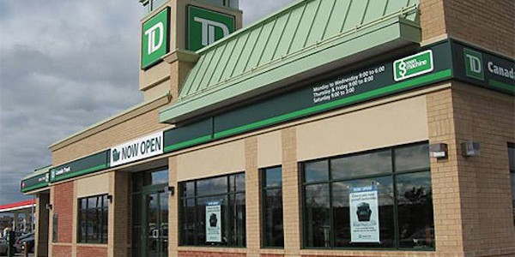
Royal Bank of Canada – 4 McLeod Avenue, Spruce Grove
ATB Financial – 400-141 Century Crossing, Spruce Grove
BMO Bank of Montreal – 16 Westway Road, Spruce Grove
Scotiabank – 201 Frist Avenue, Spruce Grove
CIBC – 100 McLeod Avenue, Spruce Grove

TRANSPORTATION

Bus Service
Spruce Grove Commuter Transit – ETS Routes 560, 561, and 562 along with ETS Plan Your Trip
Specialized Transit Service (STS) - Phone 780-962-2456
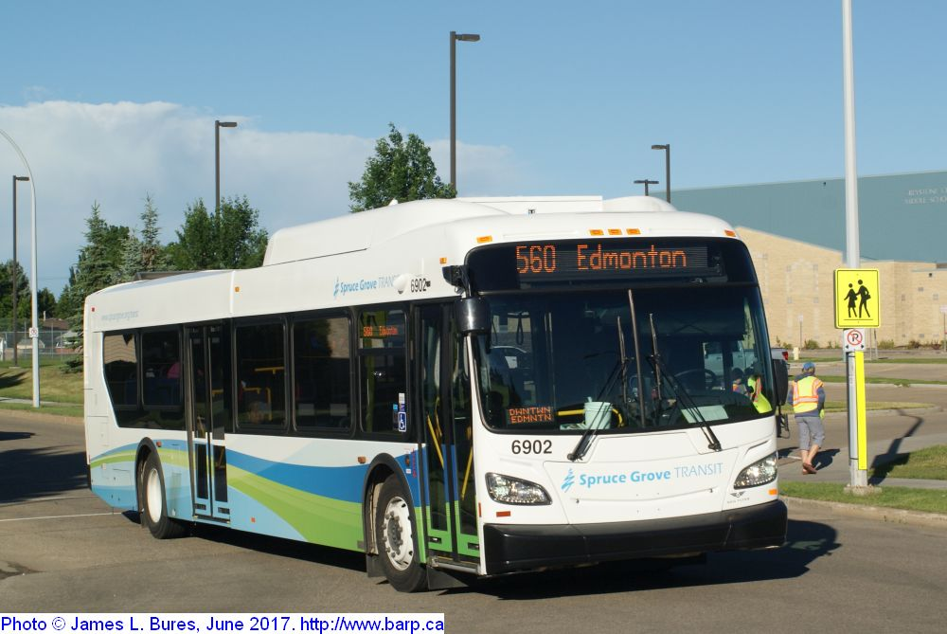

Taxi Information
Grove Taxi - 780-850-0183
M&M’z Taxi - 780-962-3256

VISITOR CENTRE

Spruce Grove Visitor Information Centre – 99 Campsite Road, Spruce Grove
Stony Plain Visitor Information Centre – 4815-44 Avenue, Stony Plain

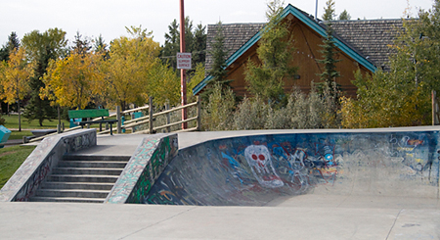
Thank you for visiting Spruce Grove!
Hope you have a great time exploring the various attractions and amenities.

Cheers,

The City of Spruce Grove team +
Tri Area Warriors Volleyball Club

