Tournament Hosting Guide
City of Spruce Grove and Area

Tri Area Warriors Volleyball Club

“Dare To Soar” 2019
U15 Female Tournament
March 2, 2019
St. Thomas Aquinas Catholic School
395 Grove Drive, Spruce Grove

Welcome to Spruce Grove!

Have a great time exploring the various attractions and amenities.

www.sprucegrove.org

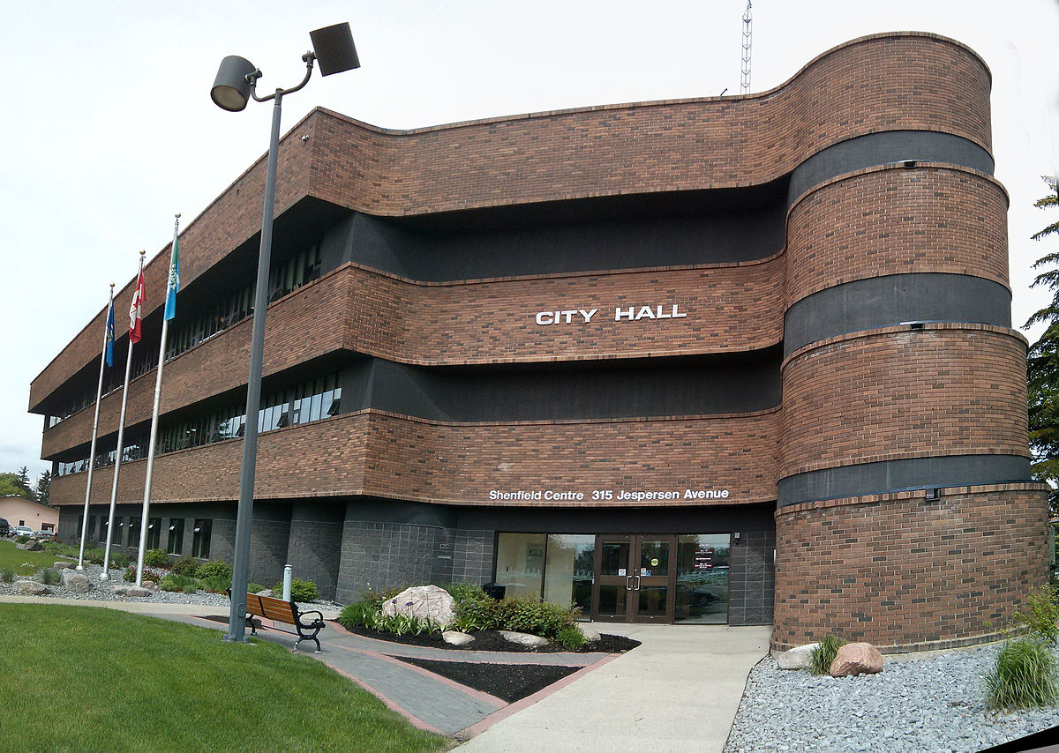

The purpose of this tournament hosting guide is to provide guest’s visiting the City of Spruce Grove for tournament or events a quick snapshot of local businesses, services and things to do. We hope you enjoy your visit to the City of Spruce Grove and plan to come back soon!

CONTENTS:

Page 3 - Tournament Information

Page 4 - Important Contact Information
    - Tournament Phone Numbers 780-554-9039 - Brenda
    - City of Spruce Grove Departments

Page 5 - Accommodations
- Hotels - Spruce Grove
- Hotels - Stony Plain
- Campgrounds - Spruce Grove
- Campgrounds - Stony Plain

Page 5 - Restaurants

Page 6 - Attractions + Things To Do
    - Spruce Grove + Area
    - Edmonton

Page 6 - Outdoor Activities

Page 7 - Pharmacies, Medical Drop In Clinics, Hospitals

Page 7 - Grocery Stores, Shopping

Page 8 - Banks

Page 8 - Bus + Taxi Information
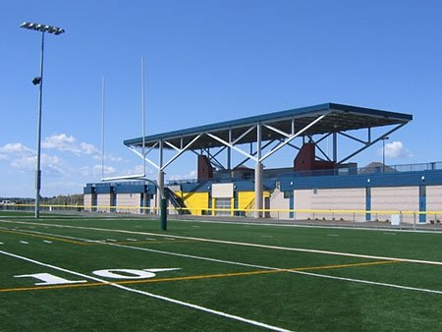
Page 8 - Visitor Centre

TOURNAMENT INFORMATION
Tri Area Warriors Volleyball Club Hosts
“Dare To Soar” 2019 U15 Female Tournament
Date: March 2, 2019
Time: 8:30 am – 6 pm
Location: St. Thomas Aquinas Catholic School – 395 Grove Drive, Spruce Grove
Tickets: Free

Important Information:
On-Site Activities: Concession with Subway 6” sub’s and more
Possible Silent Auction!

IMPORTANT CONTACT INFORMATION

“You Go Girl” U14 Female Tournament
Name | Role in Tournament | Email | Phone Number
Brenda Heisz | Lead | triareawarriors@gmail.com | 780-554-9039

City of Spruce Grove Departments

Department | Address | Email | Phone Number
Agrena - Curling Rink, Grant Fuhr Arena, Stu Barnes Arena | 9 Agrena Road | recreation@sprucegrove.org | 780-962-2031
Border Paving Athletic Centre  Recreation Services | 9 Tri Leisure Way | recreation@sprucegrove.org | 780-962-7632
City Hall  City of Spruce Grove | 315 Jespersen Avenue | info@sprucegrove.org | 780-962-2611
Enforcement Services  Community Peace Officers | 410 King Street | enforcement@sprucegrove.org | 780-962-7586
Family and Community Support Services | Queen Street Place  105 - 505 Queen Street | fcss@sprucegrove.org | 780-962-7618
Fire Hall  Fire Services + EMS | #120, 410 King Street | info@sprucegrove.org | 780-962-4496
Fuhr Sports Park  Artificial Turf | 9 Tri Leisure Way | recreation@sprucegrove.org | 780-918-2326
City Hall Ticket Centre  Box Office | 315 Jespersen Avenue | hstage@sprucegrove.org | 780-962-8995
RCMP  Spruce Grove Detachment | 410 King Street |  | Complaint Line 780-962-2222  Emergency Only  Dial 911
Specialized Transit Service | Pioneer Centre  301 Jespersen Avenue | Sts.bonnie@shaw.ca | 780-962-2456

ACCOMMODATIONS

Hotels
Spruce Grove
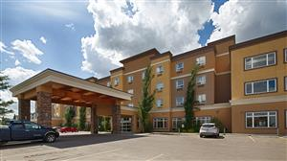
Holiday Inn Express
Travelodge Inn & Suites
Spruce Grove Area Bed and Breakfasts

Stony Plain
Ramada Stony Plain Hotel & Suites
Travelodge Stony Plain
Best Western Sunrise Inn & Suites
Motel 6 Stony Plain

Campgrounds
Spruce Grove
Diamond Grove RV Campground

Stony Plain
Camp ‘n Class
Stony Plain Lions RV Park and Campground

For a full list of other accommodations in the region, please visit: Tri Region Tourism

RESTAURANTS

Spruce Grove
Boston Pizza - Lunch + Supper - Family Restaurant - 205 Jennifer Heil Way - OR 201 Calahoo Road
Grill at the Links Golf Course - Breakfast, Lunch + Supper - 100 Links Road
Rainbow Palace Restaurant - Breakfast, Lunch + Supper - 93 McLeod Avenue
Ricky’s All Day Grill - Breakfast, Lunch + Supper - 70 McLeod Avenue
Sandy View Farms - Breakfast + Lunch - 155 South Avenue
Smitty’s - Breakfast, Lunch + Supper - 16 Nelson Drive
State and Main - Breakfast, Lunch + Supper - 300, 151 Century Crossing
Sunset Grill - Breakfast + Lunch - 214, 141 Century Crossing
Tutti Frutti - Breakfast + Lunch - 210, 205 Jennifer Heil Way

For a list of restaurants in Spruce Grove, please visit: Spruce Grove Restaurants

ATTRACTIONS + THINGS TO DO
Spruce Grove + Area
Aerials Gymnastics - Drop in and group rates available.
Grain Elevator Museum - Open May – September.
Heritage Grove Park Trails - Offers over 40 km of all-weather trails through Spruce Grove.
Horizon Stage - Various performances and shows.
Landmark Cinemas - Catch the latest films.
Melcor Cultural Centre - Literary and visual art displays.
Spruce Grove Parks & Recreation - Trail systems, splash pad and Spray Park (seasonal), and much more.
Spruce Grove Public Library - Offers diverse programs, book rentals and drop-in.
Stony Plain Attractions - Cultural heritage, festivals and events, parks and trails, and much more.

For more ideas, please visit: City of Spruce Grove Events and Attractions

Edmonton
Breakout Entertainment - Interactive escape room games.
Edmonton Corn Maze - Offers many activities, including the corn maze, bouncy games and petting zoo.
Edmonton Oilers - NHL hockey games (seasonal).
Fort Edmonton Park - Take a trip back in time!
Jubilations Dinner Theatre - Shows & entertainment.
Jump 360 Trampoline Park - Trampoline park & dodge ball.
Paint Nite - Instructed painting. Various locations in Edmonton & Spruce Grove.
Rock Jungle - Indoor climbing gym.
Speeders - Indoor pro karts.
TELUS World of Science - Exhibits, IMAX, and observatory.
West Edmonton Mall - Shopping, mini golf, indoor waterslides, zip line, bowling, and amusement rides.

For more ideas, please visit: Explore Edmonton

OUTDOOR ACTIVITIES

Spruce Grove + Area
Central Park - 450 King Street, Spruce Grove
Dog Off-Leash Parks - 50 Marlboro Drive, Spruce Grove & 51 Century Close, Spruce Grove
Heritage Grove Park - Trail System
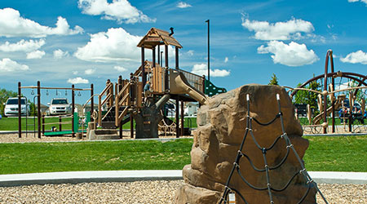
Jubilee Park - 510 Grove Drive, Spruce Grove
Spruce Grove Skate Park - 450 King Street (Central Park), Spruce Grove

For more recreation information: please visit City of Spruce Grove Recreation
For more parks information: please visit City of Spruce Grove Parks
For Parkland County lakes and trails: please visit Parkland County Natural Areas

PHARMACIES

Spruce Grove
Walmart Pharmacy - 90 Campsite Road, Spruce Grove - 780-962-9053
Shoppers Drug Mart - 131 Century Crossing #100, Spruce Grove - 780-962-3555
Rexall - 505 Queen Street, Spruce Grove - 780-962-2757
Loblaw Pharmacy - 10, 110 Jennifer Heil Way, Spruce Grove - 780-960-7435

MEDICAL DROP IN CLINICS AND HOSPITALS

Spruce Grove
Queen Street Medical Clinic - 505 Queen Street #102a, Spruce Grove - 780-960-4102
Primacy Symphony Medical Clinic - 110 Jennifer Heil Way, Spruce Grove - 780-960-1125
Tri Wellness MD Centre - Suite 100, 7 Tri Leisure Way, Spruce Grove - 587-853-0451

Stony Plain
Stony Plain Hospital - 4405 S Park Drive, Stony Plain – 780-968-3600

Devon
Devon General Hospital - 101 Erie Street S, Devon - 780-987-8200

GROCERY STORES

Real Canadian Superstore – 110 Jennifer Heil Way, Spruce Grove
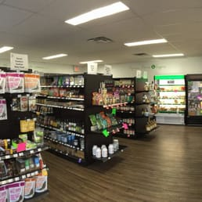
Sobeys – 11 Westway Road, Spruce Grove
Save-on-Foods – 121 Century Crossing, Spruce Grove
Safeway – 94 McLeod Avenue, Spruce Grove
Walmart Supercentre – 90 Campsite Road, Spruce Grove
Freson Bros (24 hours) – 4416 48 Street, Stony Plain

SHOPPING

Westland Market Mall – 70 McLeod Avenue, Spruce Grove
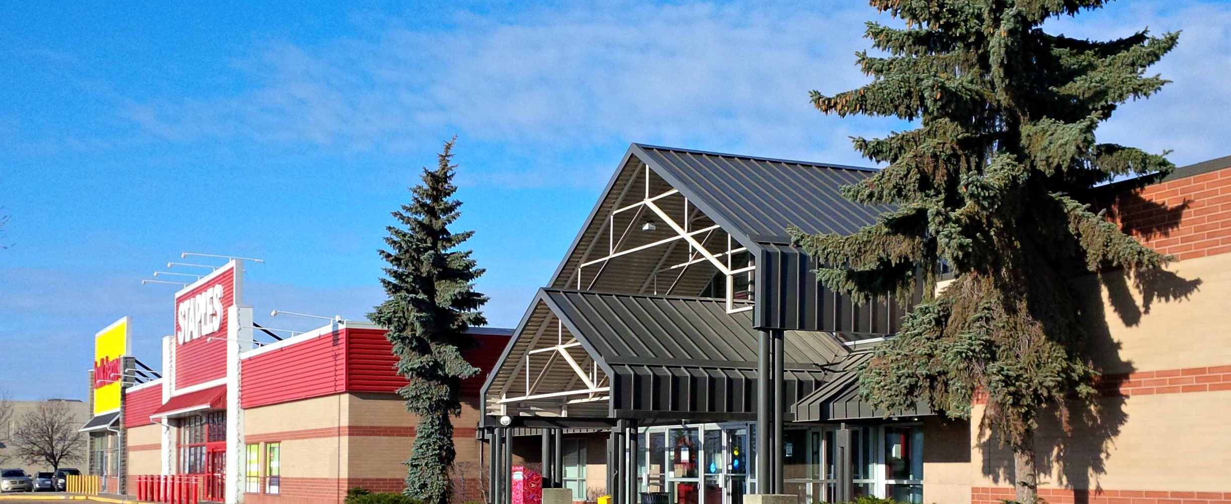
West Edmonton Mall – 8882 170 Street NW Edmonton
Southgate Centre – 5015 111 Street NW Edmonton
Kingsway Mall – 109 Street & Kingsway, Edmonton
South Edmonton Common – 1978 99 Street NW, Edmonton
Edmonton City Centre – 10025 102A Avenue, Edmonton

BANKS

TD Canada Trust – 10 100 Jennifer Heil Way, Spruce Grove
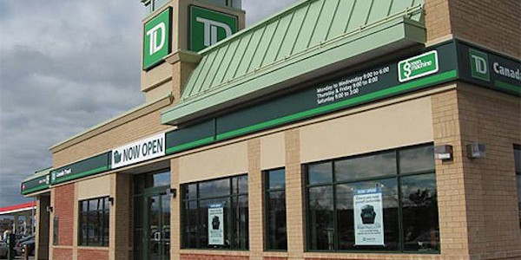
Royal Bank of Canada – 4 McLeod Avenue, Spruce Grove
ATB Financial – 400-141 Century Crossing, Spruce Grove
BMO Bank of Montreal – 16 Westway Road, Spruce Grove
Scotiabank – 201 Frist Avenue, Spruce Grove
CIBC – 100 McLeod Avenue, Spruce Grove

TRANSPORTATION

Bus Service
Spruce Grove Commuter Transit – ETS Routes 560, 561, and 562 along with ETS Plan Your Trip
Specialized Transit Service (STS) - Phone 780-962-2456
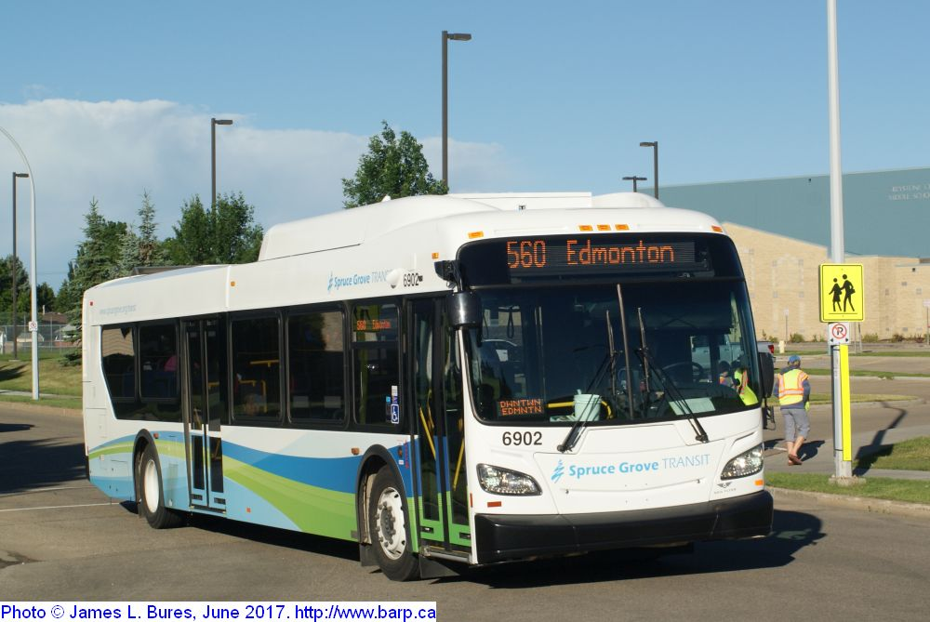

Taxi Information
Grove Taxi - 780-850-0183
M&M’z Taxi - 780-962-3256

VISITOR CENTRE

Spruce Grove Visitor Information Centre – 99 Campsite Road, Spruce Grove
Stony Plain Visitor Information Centre – 4815-44 Avenue, Stony Plain

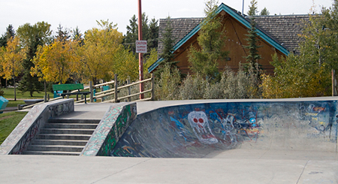
Thank you for visiting Spruce Grove!
Hope you have a great time exploring the various attractions and amenities.

Cheers,

The City of Spruce Grove team +
Tri Area Warriors Volleyball Club

