Vulcan District Minor Hockey Association
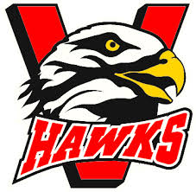
Conduct Agreement
Dear Parent and Player,
As a representative of Vulcan and District Minor Hockey Association during games and practices, the members of this association expect players and parents to act in an appropriate manner. They must follow direction given by their coaches and/or adults while in the area.
Unbecoming behaviour and conduct is something that Vulcan and District Minor Hockey is not prepares to tolerate. This applies equally to players and their parents. PLEASE GO OVER THE FOLLOWING POINTS WITH YOUR CHILD as this is an example of the type of conduct that will not be tolerated.
- SWEARING
- ABUSIVE LANGUAGE (to teammates, adults and opponents)
- DISPRESPECT OF COACHES OR ADULTS- ON OF OFF THE BENCH
- SLAMMING OF STICK (on the ice, against the boards, on the bench)
- UNSPORTSMANLIKE CONDUT (on or off the ice- at any arena)
Coaches will have the authority to discipline players that violate these rules or any other rules the coach may have set down. For example, players may be required to miss a shift or a period, do extra laps or get dressed and go home.
If necessary, further action may be taken by the discipline committee on behalf of the Vulcan and District Minor Hockey Executive. Penalties to the offenders will include suspensions, probations or a combination of both.
Yours Truly,
Vulcan Minor Hockey Executive

Date:_______________________
Parent Name: ____________________________Parent Signature:_______________________________
(Please Print)

Player Name:_____________________________Player Signature:_______________________________
(Please Print)

