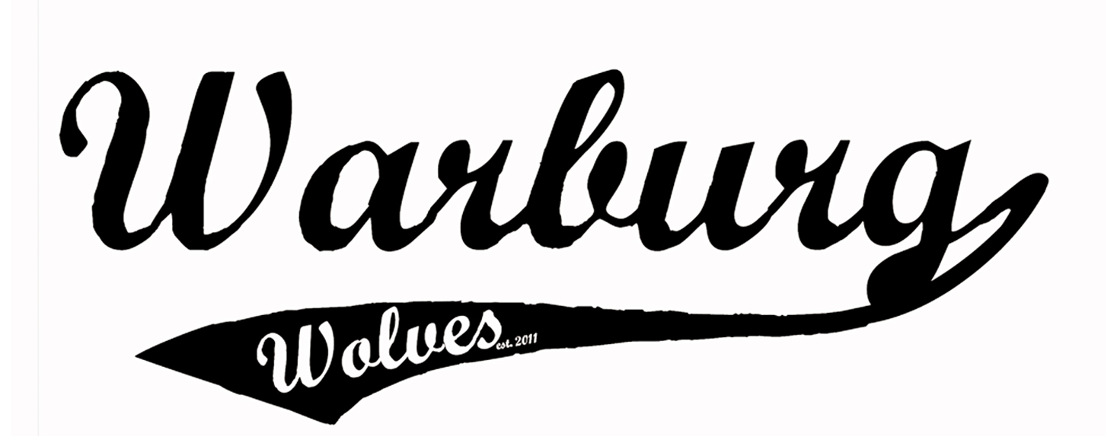
Warburg Wolves
Coach Application
Form

CONTACT INFORMATION:

Name: ______________________________________________ Phone (Preferred): __________________________

Address: ___________________________________________ Phone (Other): __________________________
___________________________________________

Email: _____________________________________________________________________________________________________

TEAM APPLICATION:
Please indicate your preference(s) by numbering your order of preference

 | ATOM | PEEWEE | BANTAM | MIDGET
HEAD COACH
ASSISTANT COACH

COACH EXPERIENCE:

S SEASON(S) | CLUB/  ASSOCIATION | DIVISION | POSITION HELD  (HC OR AC)

NOTES: (Include any other information you would like to share with us here)
__________________________________________________________________________________
________________________________________________________________________________________________
________________________________________________________________________________________________
Warburg Wolves

Coaches Pledge

It is the intention of this pledge to promote proper behaviour and respect for all participants within the Association. All coaches must sign this pledge before being allowed to participate in hockey and must continue to observe the principles of Fair Play.

CODE OF CONDUCT FOR COACHES

  - I will be reasonable when scheduling games and practices remembering that young athletes have other interests and obligations.
  - I will teach my athletes to play fairly and to respect the rules, officials, opponents and teammates.
  - I will understand and accept that often the team selection process has been completed prior to receiving my team roster.
  - I will ensure all athletes receive equal instruction, discipline, support and appropriate, fair playing time.
  - I will not ridicule or yell at my athletes for making mistakes or for performing poorly. I will remember that children play to have fun and must be encouraged to have confidence in themselves.
  - I will make sure that equipment and facilities are safe and match the athletes ages and ability.
  - I will remember that children need a coach they can respect. I will be generous with praise and set a good example.
  - I will follow the proper chain of communication as set forth by WMHA, the league in which my team is participating (ex. RMFHL) and Hockey Alberta.
  - I will obtain proper training and continue to upgrade my coaching skills.
  - I will respect and show appreciation for the volunteers who give their time to hockey for my child.
I agree to abide by the principles of this CODE as set and supported by Warburg Minor Hockey Association.
I also agree to abide by the rules, regulations and decisions as set for Warburg Minor Hockey Association.

Print Name: __________________________________ Date: ________________________

Signature: ____________________________________Team:________________________

