A - ELECTRONIC SCORESHEET - CONNECTIVITY ISSUES

Note : This information is accurate whether we have a dedicated access point or not.

In order to function properly, the Electronic Scoresheet needs to be connected to WIFI one time per day for about 1 minute. Keep in mind that even though the application supports one full day without a WIFI connection (offline mode), IT IS NOT IDEAL.

A - In case there is NO CONNECTION at the arena : Before the day starts, the tablet absolutely needs a connection to be working during that day. The tablet will indicate if you are not connected and show a message indicating :

‘’Connect to a WIFI network in order to use The Electronic Score Sheet’’

We suggest you use your cellular phone and create a Hotspot (Tethering) or find any other locations where you have a working WIFI connection then Synchronisation will happen and a message will appear on the tablet : Synchronisation Completed for ‘’date’’ - From there, you are good to use the tablet for that ‘’date’’ even there is no connection at the arena.

****** Instructions to connect to a WIFI network with the tablet - see below******

B - In case there is low WIFI signal in some spots of the arena : Before the day starts, find a spot where the signal is better and if you don’t refer back to A.

****** Instructions to connect to a WIFI network with the tablet - see below******

C - In case there is good connection at the arena : no need to for Synchronisation and the application will work in real time and will still work if connection problems occur during that day.

****** Instructions to connect to a WIFI network with the tablet - see below******

D - In case there is good connection at the arena but the WIFI you are selecting is password protected and you don’t know that password : At the arena, find another network that is either open or that you know the password, if you don’t refer back to A

****** Instructions to connect to a WIFI network with the tablet - see below******

B - INSTRUCTIONS TO CONNECT TO WIFI - ELECTRONIC SCORESHEET

- If you land on the login page (see below), you then have to Select the ‘’Back Button’’

- You either already are on home landing screen or you will after you have executed # 1 and then Select “Settings’’

- You will be prompted with 2 options at the bottom of the screen and Select WIFI Settings

- Select a network or any other network that you can get CONNECTION.

- You will be prompted to enter a password if you are on a Secured WIFI Network

- If there is no indication of a wrong password or any other error message, you should be connected to the WIFI Network. A way to verify is to execute # 2, # 3 and # 4 and look if the Network is under “Connected”.
- When the full synchronisation for the day is completed, you will have a message indicating : “Synchronisation Completed for <date>”, it is now safe to use the Electronic Scoresheet for the <date>. From that point on, you will be able to use the tablet for scorekeeping whether you have connection or not.

C - iPHONE - Personal Hotspot Instructions

Personal Hotspot is a feature of iOS that lets iPhones running iOS 4.3 and higher share their cellular data connection with other nearby devices via Wi-Fi, Bluetooth, or USB. This feature is generically known as tethering. When using Personal Hotspot, your iPhone acts like a wireless router for the other devices, transmitting and receiving data for them.

Personal Hotspot Requirements
In order to use Personal Hotspot, you need:
- An iPhone 4 or newer
- iOS 4.3 or higher
- A data plan that supports tethering/Personal Hotspot
- A USB cable, if you want to connect devices that way.

How to Turn On Personal Hotspot for Wi-Fi
On your iPhone, go to Settings > Personal Hotspot and make sure that it's on. Then verify if you have a Wi-Fi password set up, if not we suggest you create one. Make sure you identify the name of your Hotspot on your iPhone. Stay on this screen until you’ve connected The Electronic Scoresheet device to your Personal Hotspot Wi-Fi network you just activated.
On the Electronic Scoresheet device that you want to connect, go to page 2 and follow instructions #2, #3 and #4 of the “INSTRUCTIONS TO CONNECT TO WIFI - ELECTRONIC SCORESHEET”

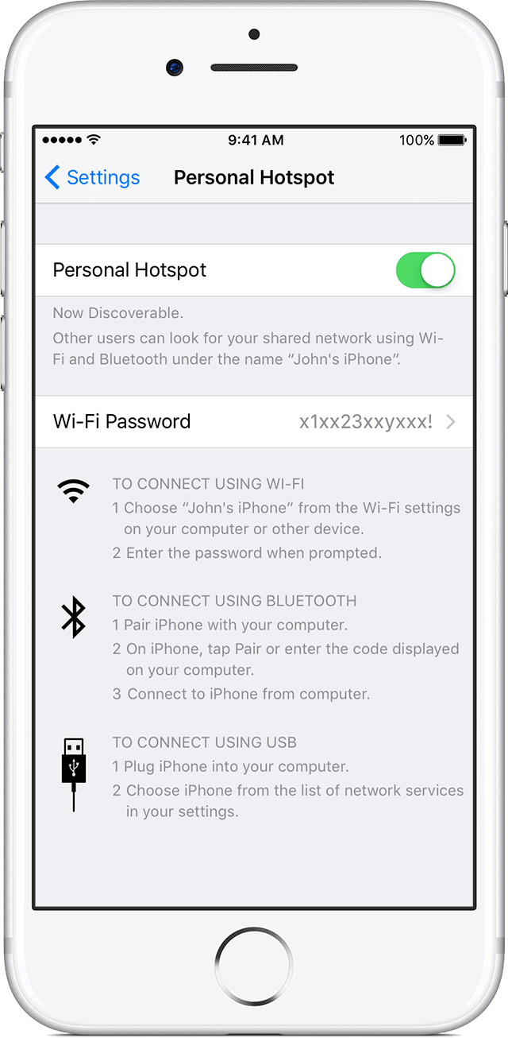

D - MOST ANDROID PHONES - Personal Hotspot Instructions

- Go to Settings on your Android phone. You can get there by pressing the menu button on your device when you're on the home screen, then tapping "Settings".
- At the Settings screen, tap the "Wireless & networks" option.
- You should see an option for "Portable Wi-Fi hotspot". Click the check mark beside it to turn on the hotspot and your phone will start acting like a wireless access point. (You should see a message in the notification bar when it's activated.)
  - To adjust and check the settings for the hotspot, tap the aptly named "Portable Wi-Fi hotspot settings" option. You'll need to do this if you don't know the default password that will be created for your hotspot so you can make a note of it for connecting your other devices.
  - You can change the default password, security level, router name (SSID), and also manage users connected wirelessly to your phone in the Wi-Fi hotspot settings.

Stay on this screen until you’ve connected The Electronic Scoresheet device to your Personal Hotspot Wi-Fi network you just activated.
On the Electronic Scoresheet device that you want to connect, go to page 2 and follow instructions #2, #3 and #4 of the “INSTRUCTIONS TO CONNECT TO WIFI - ELECTRONIC SCORESHEET”

E - MICROSOFT OS PHONES - Personal Hotspot Instructions

Create a mobile hotspot with your Windows 10 Mobile phone to share your cellular data connection with other devices. This uses cellular data and depends on your phone plan. Here's how to share your cellular data connection over Wi-Fi.
- On Start , swipe over to the All apps list, then select Settings > Network & wireless > Mobile hotspot.
- For Share my cellular data connection over, choose Wi-Fi.
- Select Edit > type a new network name and password > Save.
- Turn on Share my cellular data connection with other devices. Wi-Fi can’t be used when mobile hotspot is turned on﻿.
- To connect on the other device, go to the Wi-Fi settings on that device, find your network name, select it, enter the password, and then connect.
Stay on this screen until you’ve connected The Electronic Scoresheet device to your Personal Hotspot Wi-Fi network you just activated.
On the Electronic Scoresheet device that you want to connect, go to page 2 of this document and follow instructions #2, #3 and #4 of the “INSTRUCTIONS TO CONNECT TO WIFI - ELECTRONIC SCORESHEET”

