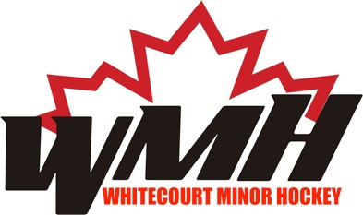
W.M.H.A Executive Meeting
November 1, 2017

Attendees:
Alan Deane
Marcus Ryan
Chantelle Detert
JoLyn Pashko
Ian Martinot
Bonni Christie
Tricia Faulkner

Meeting called to order @ 7:01pm by Alan

Motion made by Jolyn to accept amended agenda. Motion carried

Motion to adopt minutes from October 4, 2017 meeting made by Ian. Motion carried

Visitors & Delegates:

- N/A
Agenda Additions:

- New Business
5. Ice Scheduler
6. Player development Camp
Old Business:

- Criminal record Check Policy
- Ian to draft a policy regarding criminal Record Checks
- Discussion ensued on what we should do with the documents once they have been received. Decision to add this to the policy
Defer item to next meeting under old business
- R&R Memorial Fund Website
  - Person to develop website?
    - Alan has approached Dana Tartal to develop the website, Nothing to happen until we get direction from Tracy Stark
Presidents Report:

VP1 Report:

VP2 Report:

Secretary report:

Registrar report:

Treasurer report:

Public relations report:

RIC Report:

Game & Conduct Report
Ian motioned to accept all committee reports. Motion carried.

New Business:

- Maple Leaf Old Timers fundraiser
- Email inquiring whether WMH would like to host such an event. They would like us to put up $25000.00- discussion ensued and we are not interested

- Website Current Events
- Instructed JoLyn to update website to show meeting minutes for the past two years
- Ensure that all forms are the current ones we are using
- Check archives to find the sponsor letter that was developed

- Website Celebration of Success
- VP’s directed to send an email to all team managers to send information to Public Relations so these can be posted on WMH website

- SemCam’s Donation Application
- Alan was approached by Joe Spivak from SemCam’s that they would be interested in sending a donation to our association. Alan informed Joe that if money was to come forward that we would direct the funds to our player development program. Alan asked for $8000.00

- Ice Scheduler
Motion made by Ian, as per our bylaws that we shut down for the Christmas break starting December 21, 2017 until January 2, 2018. Last day for practices is December 20th and the first day of practice will be January 3rd. Motion carried

- Discussion ensued on if we could allow girls team an extra exhibition game since their league schedule does not start until mid-November
Motion made by Bonnie to allow the extra exhibition game. Motion carried
- Player Development
- Discussion ensued on what number we should cap each division at, totals are as follows
- Initiation- 25
- Novice-35
- Atom-35
- Pee Wee/Bantam/Midget and Girls-25

Next meeting: December 13th @ 7pm, Arena Meeting room
Meeting adjourned @ 7:57pm.
Minutes taken by Ian Martinot, and prepared by Lyndsay Perkins

