Wilmot Softball Association 2020 Pitching and Catching Clinic
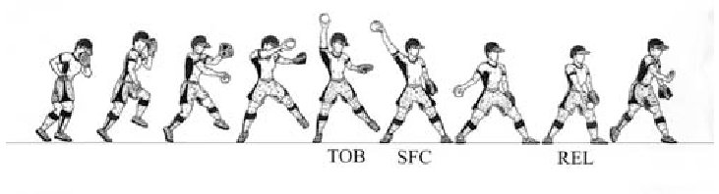
Continuing in 2020, WSA is hosting a pitching and catching clinic, similar to what has been provided in past years. This is a first come first serve event, that said we will be accepting up to approximately 45 pitchers and 45 catchers. There will be a total of 6 sessions, each session will run for around 55 min including warm up. Groups are subject to change depending on numbers. All Pitchers will be expected to supply their own catcher.
Pitching Instructor: Tyler Randerson Catching Instructor: Carson Hammer
All sessions will run from 9:00am – 12:00pm and will be held at Waterloo-Oxford DSS. (Enter around the back of the school).
Dates: February 1, 8, 22, 29 March 28 April 4
Pitchers
Junior 9:00 – 9:55am No experience to 2 years experience
Intermediate 10:00 – 10:55am 3-4 years experience
Advanced 11:00 – 11:55am 5 years or more experience.

Catchers
Junior 9:00 – 9:55am No experience to 2 years experience
Intermediate 10:00 – 10:55am 3-4 years experience
Advanced 11:00 – 11:55am 5 years or more experience.
*times may vary depending on numbers*
COST PER PITCHER/CATCHER - $40
Pricing helps offset the cost of our instructors, equipment and rental of the facility.
Any questions please contact John Vleeming (Player Development) above email or Cell: 519-616-4044

Sign-up form on back
COST PER PITCHER/CATCHER - $40
Please fill out and return with payment
Name of player registering: ________________________________________________________

Age of player:___________________________________________________________________

Number of years pitching/catching _________________________________________________

Registering for (Circle One) Pitching Catching

Email address: _________________________________________________________________

Phone number: ________________________________________________________________

I hereby permit my son /daughter to participate in softball under the supervision of the Wilmot Softball Association. I also release and discharge the Wilmot Softball Association and its members from any suits and/or debts which may occur as a result of said person engaging in playing softball for said association.
I agree to provide my son/daughter with a personal caged baseball helmet, understanding that any player without a personal helmet will not be permitted to participate in the clinic.
Please email this form (Scan or Pic) to players@wilmotsoftballassociation.com (John Vleeming) and please make payment by cheque or cash at the first session.
Registrations must be received by January 28th and are open to WSA players
Parent’s Signature: X ________________________________ Dated: ___________________

