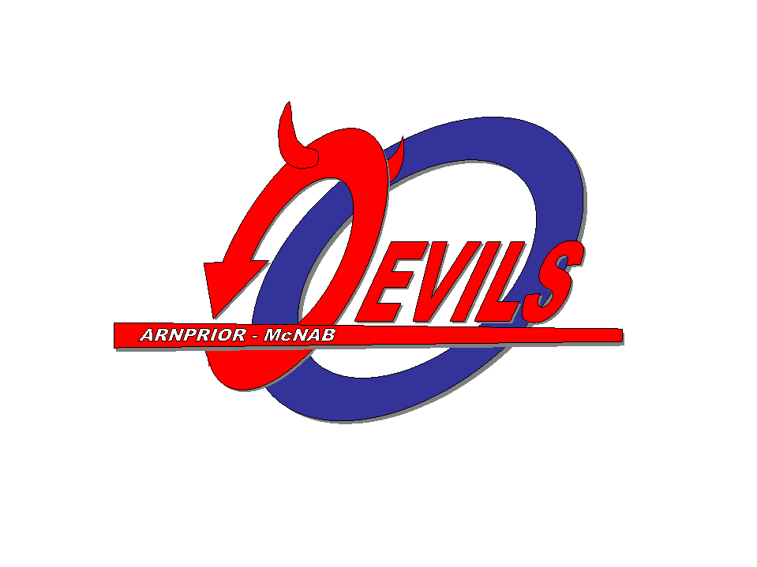
Arnprior/McNab Ringette Association

Dear Sir/Madame;
The Arnprior McNab Ringette Association is a volunteer run association and is part of NCRRL, ERRA as well as RO.

Arnprior McNab Ringette Association and NCRRL, ERRA and RO requests that all coaches and bench staff have a policy that anyone that volunteers over the age of 18 and has contact with children must have a complete the Vulnerable Sector Check for the 2022 – 2023 season.
This letter recognizes _______________________________ volunteers their time as a coach, trainer or manager for this association.

We appreciate your time and effort.

Thank You

Christyl Fenton
Arnprior McNab Ringette Association
President
cell: 613-795-8591

www.arnpriorringette.ca

