**Macintosh HD:Users:Dawes:Desktop:Logo Files Final 2 for Copies:Full Color Logo:AARingette_Full_Color.pdf**

**AA TEAM RED: Winnipeg Itinerary**

**Manitoba AA Ringette Voyageur**

**Tournament – January 28-31, 2016**

Team **RED** tournament schedule, maps, itinerary, and all other team information

**Coach / Manager/Tournament Coordinator**

*Head Coach Name*: (403)

*Manager Name*: (403)

*Tournament Coordinator Name*: (403)

**Accommodations**

Comfort Inn South

3109 Pembina Hwy

(204) 269-7390

*Breakfast Hours: 6:30-9:30am*

**Group Flights**

Departing Flight WS 132 9:35am (arriving 12:29pm)

Return Flight WS 551 6:15pm (arriving 7:28pm)

**DIRECTIONS**

Winnipeg International Airport (2000 Wellington Avenue)

to Comfort Inn South (3109 Pembina Hwy)

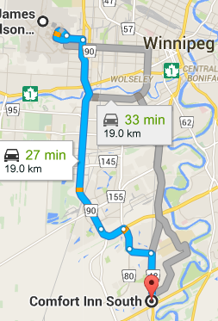

Head northwest

21 m

Continue onto Wellington Avenue

2.2 km

Turn right onto King Edward Street South/Route 90 South

Continue to follow Route 90 South

10.3 km

Continue straight onto Bishop Grandin Blvd/Route 165

1.5 km

Turn right onto Waverley Street/Route 80 South

1.2 km

Slight left onto Bison Drive (signs for Bison Drive/University of Manitoba)

1.2 km

Turn right onto Pembina Hwy/Route 42 North

Destination will be on the right

2.5 km

**SCHEDULE**

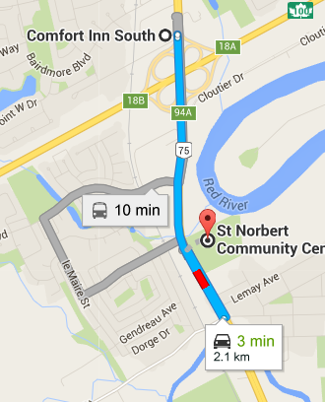

**LIGHT PRACTICE**

**Thursday, January 28, 3:40-4:40pm**

St. Norbert Arena

3450 Pembina Hwy

**RR GAME 1**

**Friday, January 29, 9:30-10:30am**

**vs. Eastman Flames**

Southdale – East Arena

254 Lakewood Blvd

**RR GAME 2**

**Friday, January 29, 3:00-4:00pm**

**vs. Manitoba Wild**

East End – Arena 2

517 Pandora Ave E

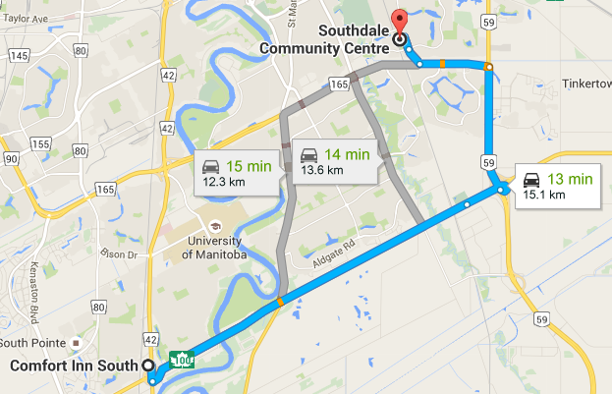**RR GAME 3**

**Saturday, January 30, 9:50-10:50am**

**vs. Winnipeg Angels**

St. Norbert Arena

3450 Pembina Hwy

**RR GAME 4**

**Saturday, January 30, 6:15-7:15pm**

**vs. Manitoba Magic**

Southdale – East Arena

254 Lakewood Blvd

**BRONZE FINAL (3rd vs. 4th)**

**Sunday, January 31, 11:05-12:05pm**

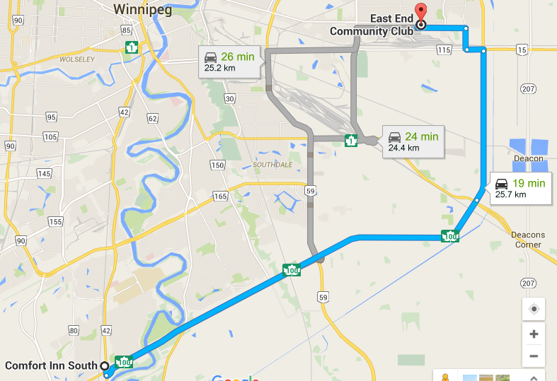Southdale – East Arena

254 Lakewood Blvd

**GOLD FINAL (1st vs. 2nd)**

**Sunday, January 31, 2:10-3:10pm**

Southdale – West Arena

254 Lakewood Blvd

**ITINERARY**

**THURSDAY:**

* **THURSDAY 7:45AM** - Meet at airport (departures level near WestJet counter); Flight departs at 9:35am
* **THURSDAY 12:30 PM** - Arrive at Winnipeg airport; pickup rental cars
* **THURSDAY PM** - Arrive at hotel; lunch to immediately follow in hotel breakfast room
* **THURSDAY 3:40-4:40PM** – Light practice @ St. Norbert Arena (3450 Pembina Hwy)

Depart hotel for arena at 3:05pm

Snack available for players in team room at hotel if desired

* **THURSDAY SUPPER (5:30PM)** – Team supper in hotel breakfast room at 5:30pm
  1. Free time until team time/snack
* **THURSDAY 8:30PM** – Quick team time/snack for players & coaches in team room
* **THURSDAY 9:00PM** – Lights out & phones off: bedtime for players

**FRIDAY:**

* **FRIDAY BREAKFAST** - Hotel breakfast for players & parents. *Finish by 7:35am*

Players: please make healthy choices this weekend (cereal - not sugar coated; waffle – very little syrup or maybe peanut butter instead, 2 slices of bacon instead of 8, etc.)

* **FRIDAY - Game #1: 9:30-10:30am** (arrive at 8:25am) at Southdale Arena

Depart hotel for arena at 7:55am

Snack in dressing room after game 1

* **FRIDAY 11:15AM-12:30PM** - Winnipeg Royal Canadian Mint guided tour (520 Lagimodière Blvd)
* **FRIDAY LUNCH (12:45-2:00PM)** - Lunch in Upper Hall at East End Arena at 12:45pm
* **FRIDAY - Game #2: 3:00-4:00pm** at East End Arena

Snack in dressing room after game 2

* 1. Free time until supper
* **FRIDAY SUPPER (5:30PM)** – Supper in hotel breakfast room at 5:30pm
  1. Free time until team time/snack
* **FRIDAY 8:30PM** - team time/snack for players & coaches in team room
* **FRIDAY 9:30PM** - Lights out & phones off: bedtime for players

*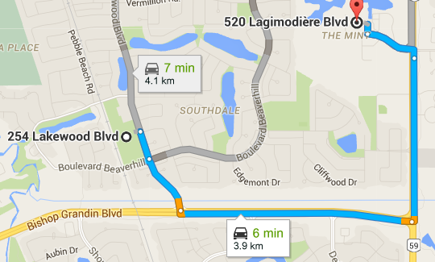Southdale Arena to Royal Canadian Mint: 6 mins Royal Canadian Mint to East End Arena: 14 mins*

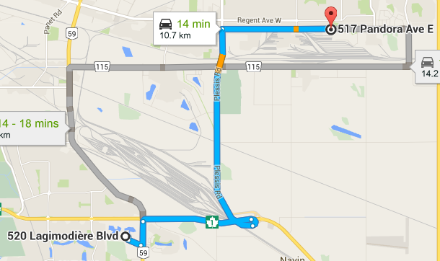

**SATURDAY:**

* **SATURDAY BREAKFAST** – Hotel breakfast for players & parents. *Finish by 8:20am*
* **SATURDAY - Game #3: 9:50am-10:50am** (arrive at 8:45am) at St. Norbert Arena

Depart hotel for arena at 8:40am

Snack in dressing room after game 3

* **SATURDAY LUNCH (11:45AM)** - Lunch in team room/ hotel breakfast room at 11:45am
* **SATURDAY –** Sightseeing at The Forks [www.theforks.com](http://www.theforks.com)

Depart hotel at 12:30

* **SATURDAY SUPPER (4:00PM)** - Supper in hotel breakfast room at 4:00pm
* **SATURDAY - Game #4: 6:15-7:15pm** (arrive at 5:10pm) at Southdale Arena

Depart hotel for arena at 4:50pm

Snack in dressing room after game 4

Free time until team time/snack

* **SATURDAY 9:00PM** - team time/snack for players & coaches in team room; snack for parents to follow
* 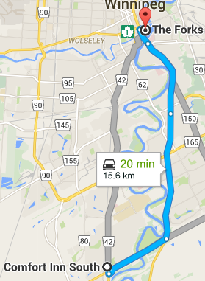**SATURDAY 10:00PM** - Lights out & phones off: bedtime for players

**SUNDAY:**

* **SUNDAY BREAKFAST** – Hotel breakfast for players & parents. *Finish by 9:00am*
* **SUNDAY AM** - Pack belongings and checkout of room

**BRONZE FINALS – 11:05AM-12:05PM** (arrive at 10:00am) at Southdale Arena

* Depart hotel for arena at 9:40am
* Snack in dressing room after game 5
* Depart arena for airport; return rental cars
* Lunch at airport; TBD
* Flight WS 551 departs at 6:15pm (arriving 7:28pm)

**GOLD FINALS – 2:10PM-3:10PM** (arrive at 1:05pm) at Southdale Arena

* Lunch; TBD
* Depart hotel for arena at 12:45pm
* Snack in dressing room after game 5
* Depart arena for airport; return rental cars
* Supper at airport; TBD
* Flight WS 551 departs at 6:15pm (arriving 7:28pm)

**GO RED!!**