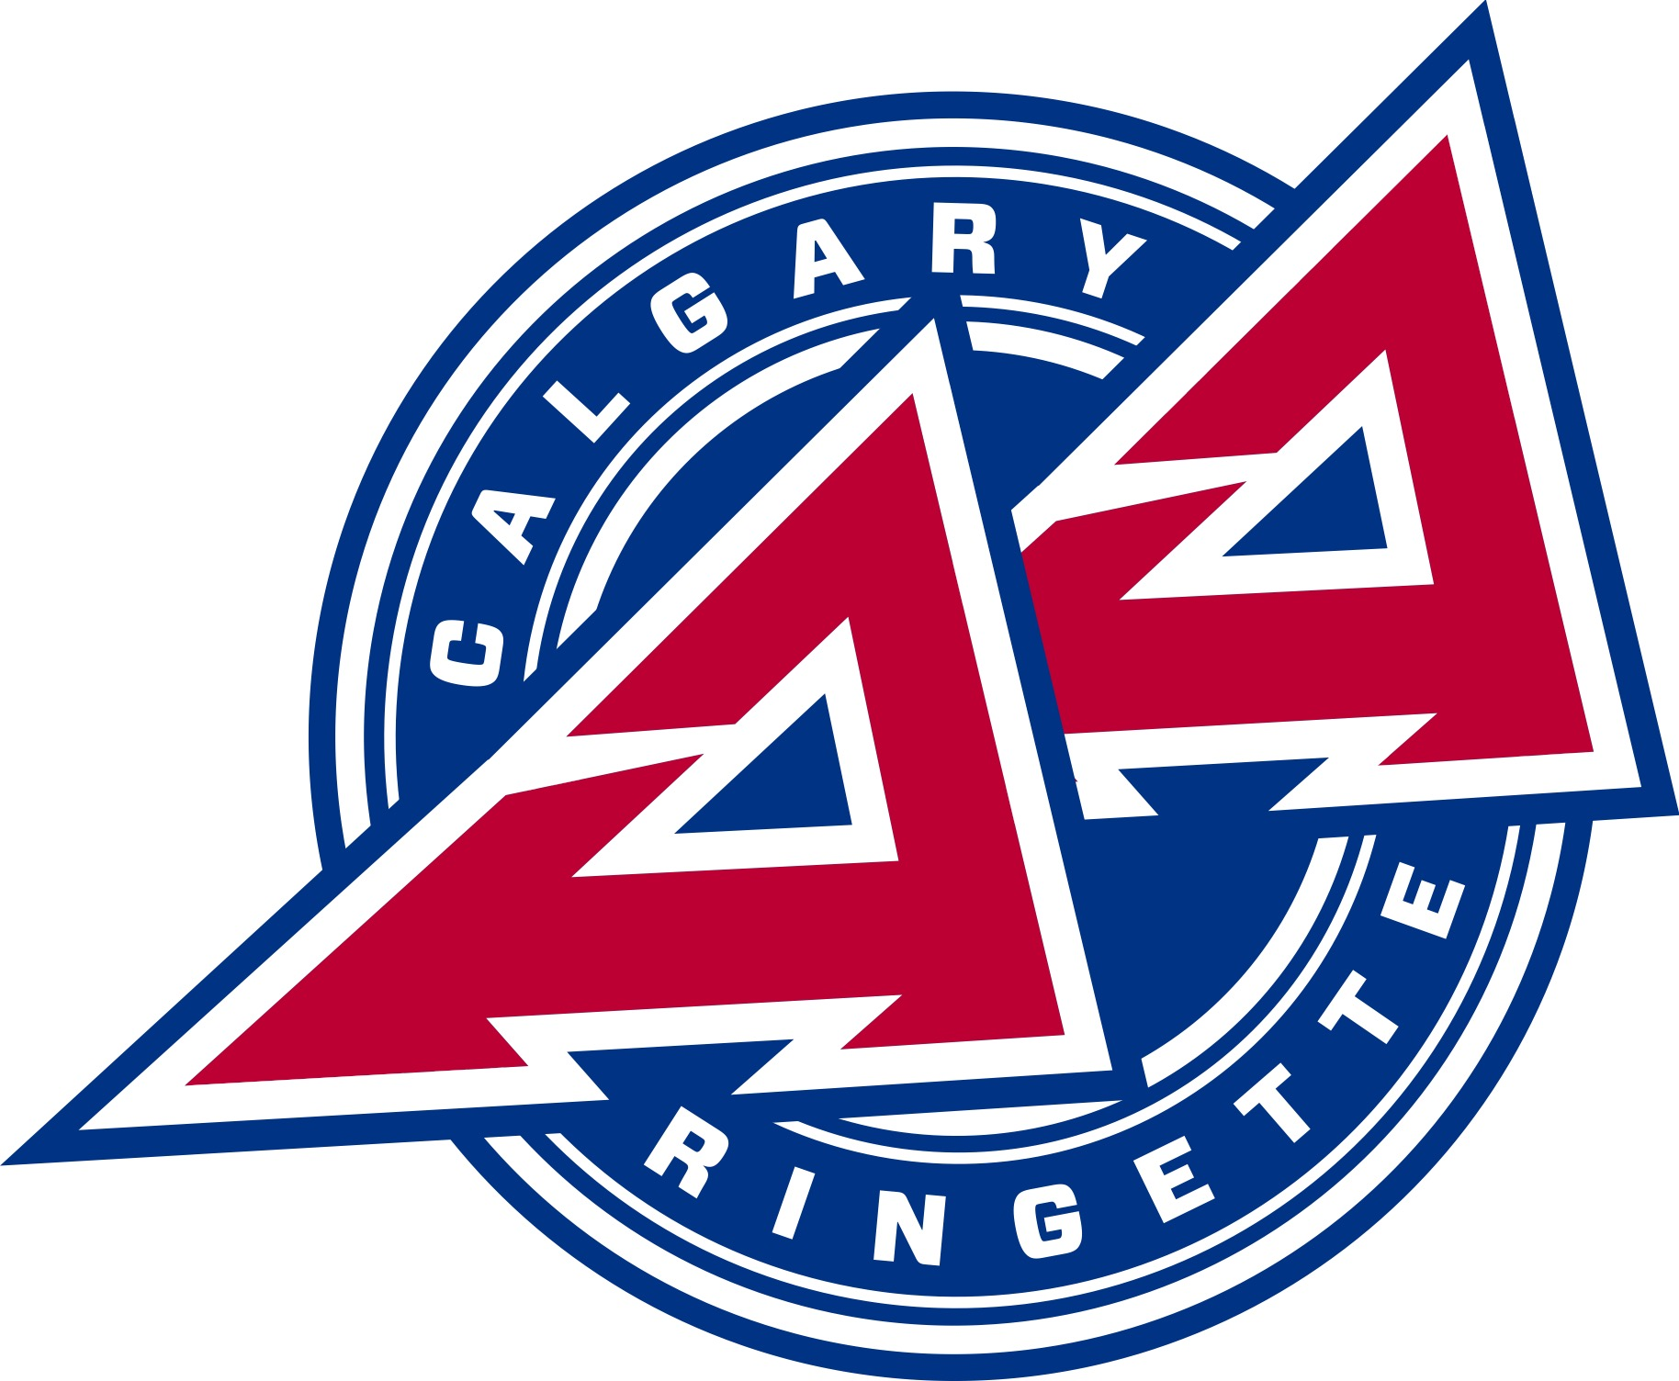 | Coach Application Form for the 2024-2025 Season  Submit your application and all required documentation to:  president@aaringettecalgary.ca  Deadline: May 31, 2024

Contact Information
Name
Email
Cell Number
NCCP Number

Desired Coaching Role (indicate all that your are interested in, and order of preference)
Role | Preference Order (1st choice, 2nd choice etc.)
U14AA Head Coach
U14AA Assistant Coach
U16AA Head Coach
U16AA Assistant Coach
U19AA Head Coach
U19AA Assistant Coach

Association Coaching Experience, Last 5 Seasons
Year | Association  (e.g., AA, SCRA, NWR, BVRA) | Age Division and Tier  (e.g., U14AA) | Team Name | Role (HC, AC)
2023-2024
2022-2023
2021-2022
2020-2021
2019-2020

Non-Association Coaching Experience, Last 5 Seasons
Year | Governing Body or Private Organization (e.g. RAB, RCda) | Event (e.g., AWG, CWG, U18 Development Camp, WRC, RAB Cup, RAB Challenge) |  | Role (HC, AC)
2023-2024
2022-2023
2021-2022
2020-2021
2019-2020

Coaching Agreement: Initial to confirm you agree with the following
I understand that the primary goal of minor sports is the development of the individual athlete’s skills and character in a team setting.

It is my responsibility to demonstrate by example and to teach the athletes how to accept a loss, as well as a win, in a sportsmanlike manner and to benefit from either result.

I accept the responsibility to show and teach respect for the athletes on the other team, all coaches, spectators, officials, and volunteers who make the ringette season possible.

Each athlete in my charge will be given equal opportunity and consideration in all situations and contexts.

I understand that as a Coach, I occupy a position of trust with the athletes and will do my best to set a positive example at all times.

I agree to abide by the rules and regulations of AA Ringette Calgary, Ringette Calgary, Ringette Alberta, and Ringette Canada.

I will promote AA Ringette Calgary in a positive manner and be an ambassador for the association and the sport of ringette.

I understand that failure to uphold this agreement could result in the forfeiture of my coaching privileges for the remainder of this season, as well as future seasons.

I confirm that I have read and agree to abide by the Coach Code of Conduct.

I agree that AA Ringette Calgary can access my coaching certification transcript.

I consent to allowing AA Ringette Calgary to contact other associations I have coached for to confirm past disciplinary action and coaching evaluations.

I understand that the decision of the Head Coach Selection Committee is final and cannot be appealed.

Applicant Checklist

All of the following must be submitted by the application deadline date (May 31, 2024) to president@aaringettecalgary.ca

Coach Application Form
If applying as a Head Coach, responses to the ‘Head Coach Questions’
Coaching Certifications NOT Listed on the NCCP Transcript
Police Information Check with Vulnerable Sector Screening (completed within past 3 years, or proof of application)

Screening Disclosure Form (if Police Information Check >1 year old)
Coach Code of Conduct Pledge

Signature: Date:

