Roster checklist

* **Step 1 - Complete the** [**Roster Form**](https://docs.google.com/document/d/1fW3PKSHOL5LeR9u4Vo8P384H6Rq0iEwGLBxJNTeh-44/edit?usp=sharing) **and send it to** [**cgharegistrar@gmail.com**](mailto:cgharegistrar@gmail.com)

Please open and then save your own version of the Roster Form (File - Make a copy). Rename the copy to your team name/OWHA number (i.e. U15-1 #2377) for ease of reference.

Note:

* A maximum of 5 bench staff are included for insurance purposes. Additional bench staff will be charged to the team at $60/pp.
* All individuals participating in on-ice activities or who want to be on the bench need to be on the team’s approved roster. At minimum, a team must have a coach and a trainer (one of which must be a female).
* If the manager is not on the roster, he/she will not receive email notifications if call up requests are done in RAMP. There is no way to force the system to do this other than being on the roster identified as a manager (notifications will go to the coach in the absence of a rostered manager).
* **Step 2 - Have all team staff (head coach, assistant coaches, trainer, assistant trainer, manager, and dressing room monitors/staff)** [**register on RAMP**](http://cornwallgha.rampregistrations.com/)

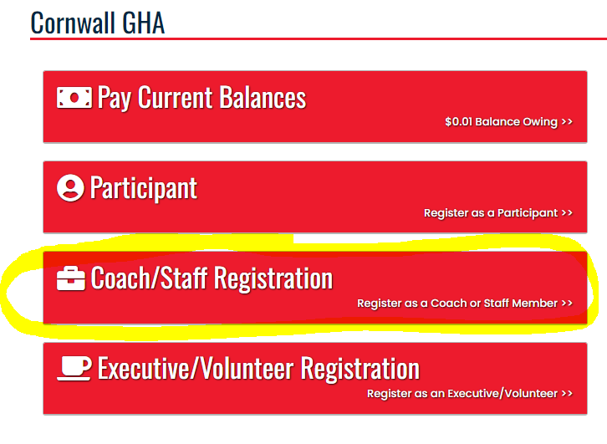

* **Step 3 - Ensure all coaches and trainers have completed the appropriate training courses**

Refer to OWHA’s [Team Official Qualifications Requirements](https://cloud.rampinteractive.com/whaontario/files/Coaches/Qualifications%20Requirement%20%2823-24%20season%29.pdf) for additional info.

* **Step 4 - Have all team staff (head coach, assistant coaches, trainer, assistant trainer, manager, and dressing room monitors/staff) apply for a Vulnerable Sector Check (if needed)**

Note: Vulnerable Sector Checks are valid for 3 years. If one is expiring during the 2024/2025 season, a new one must be requested from your local detachment, either the [Cornwall Police Service](https://cornwallpolice.ca/en/record-services/police-record-check.html) (if you reside in the city of Cornwall) or the [Ontario Provincial Police](https://www.opp.ca/index.php?id=147&lng=en).

* **Step 5 - Have all team staff (head coach, assistant coaches, trainer, assistant trainer, manager, and dressing room monitors/staff) upload a PDF copy of their VSS (or proof that they have applied) to the** [**Screening Submission Portal**](https://www.ohf.on.ca/risk-management/vulnerable-sector-checks-vsc/)**.**

Full details on how to upload your documentation is available on the last page of the [Coach Manager Manual](https://docs.google.com/document/d/1EkDzxXkfqIaTf685SSkXPHXYIOCa6J8NtDXEUPoqp1Q/edit?usp=sharing).

* **Step 6 - Once the manager can confirm that all of the above steps have been completed successfully by all team staff, advise the** [**Registrar**](mailto:cgharegistrar@gmail.com) **that your roster can be submitted to OWHA for approval.**

Only when your team receives an approved roster from OWHA can games commence. The head coach will be copied on OWHA’s approval/denial of your roster.