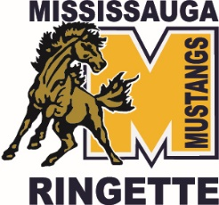 MRA Non-Player Members

For the purpose of our By-laws, the designated positions will be considered non-player members for the purpose of Article II, paragraph 2.1 b) are as follows:
- Coaching Coordinator
- Equipment Manager
- Fun1/Fun2 Program Convenor
- GLRL Representative
- Head coach of each team. For clarity, there will be one vote per team. If there are co-head coaches, they will need to decide which person will exercise the vote
- House League Convenor
- LORL Representative
- On and Off ice Attire Manager
- Referee-in-Chief
- Registrar
  - Assistant Registrar
- Scheduler
  - Assistant Scheduler
- Tournament Chair. For clarity, there will be one vote for this role. If there are co-chairs, they will need to decide which person will exercise the vote.
- Webmaster

