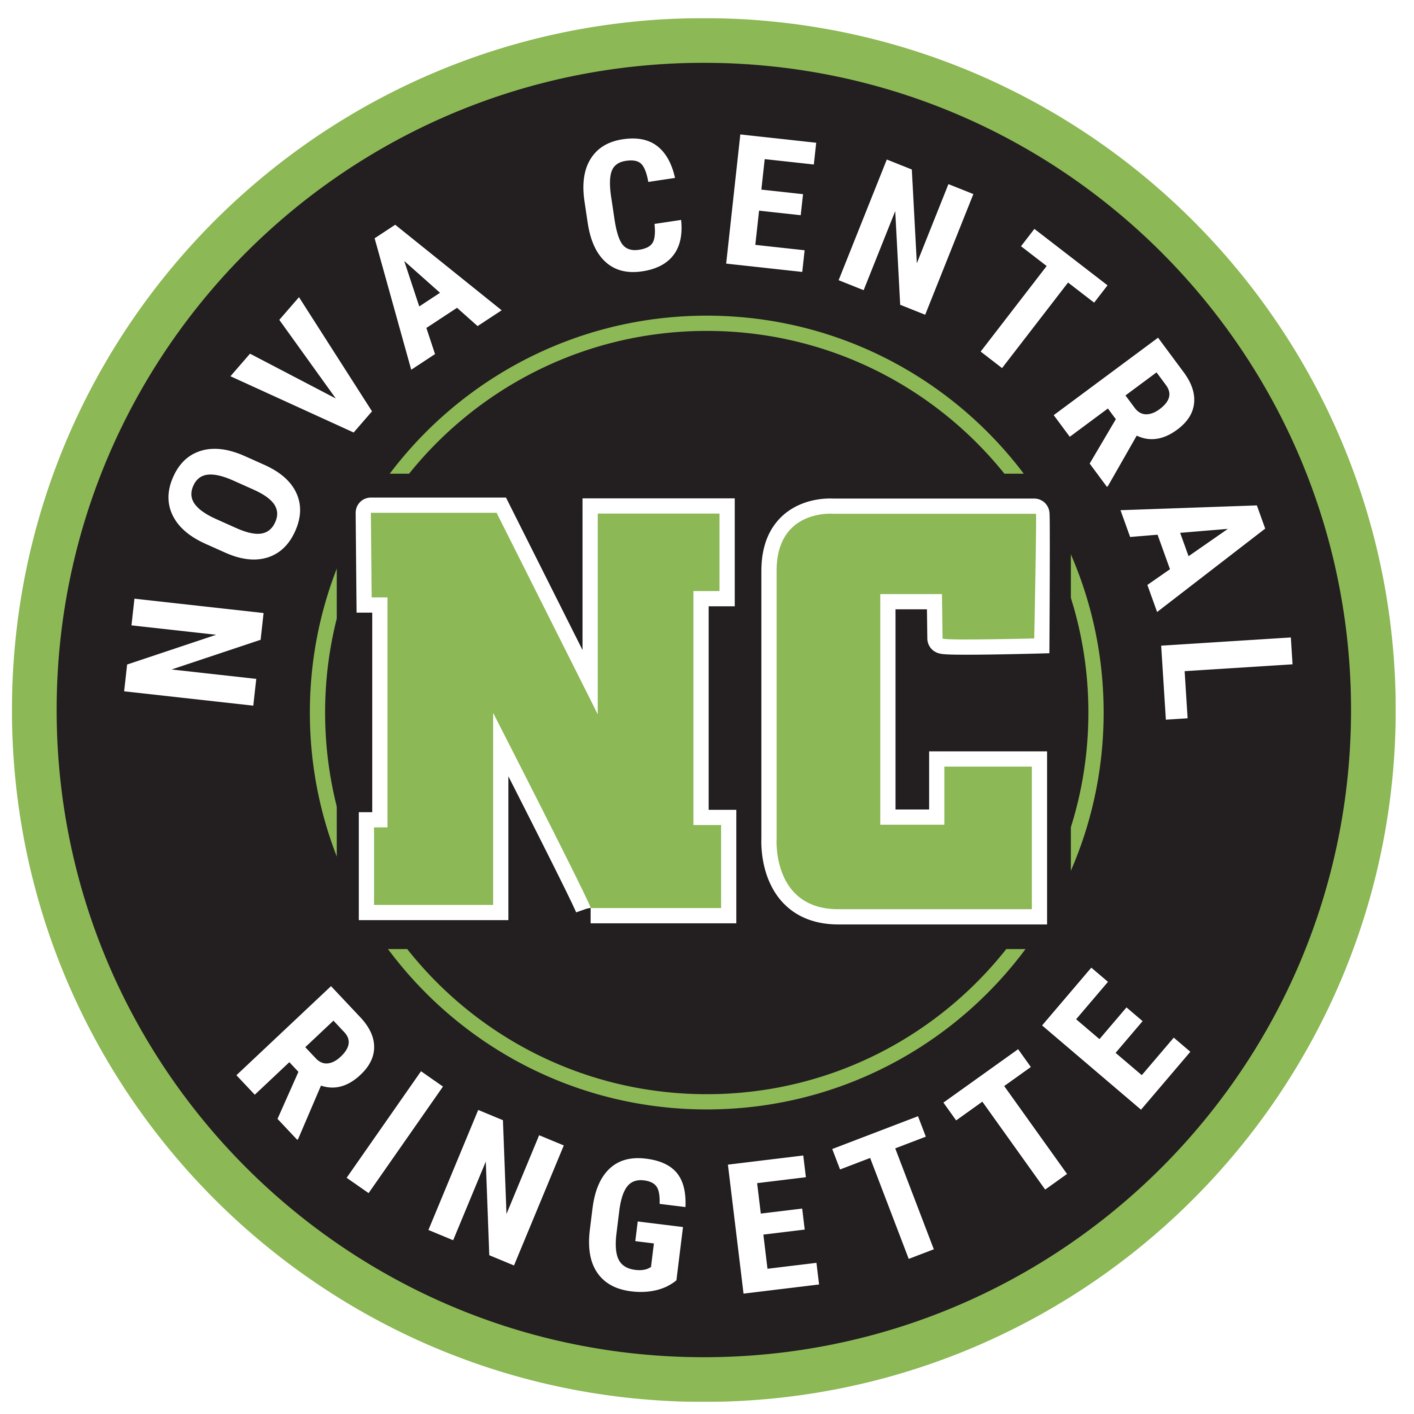

October 2022

To a valued supporter of ringette:
The insert years Season for the Nova Central insert division & team name Ringette team has begun and once again we are competing in the Central Region Ringette League.
We are asking for your support to help with the costs of running our team by sponsoring a player’s jersey. Typical sponsorship can be between $200-$500, however we are appreciative of whatever support you can provide. $_________
A name bar displaying your company name will be displayed on the back of their jersey below their number, worn at games, team events and fundraisers throughout the season.
Participation in sport plays an important role in youth development. Involvement in sport provides a positive way for children to focus their energies, build relationships, learn respect for peers and fellow players as well as build confidence so that they become strong community leaders.
We would sincerely appreciate any assistance you could offer for this ringette season. Should you decide to support our team, please make your cheque payable to insert name cheque should be made out to.
The youth of our association thank you in advance for your consideration of this request.

Yours in Ringette,

player name
insert division & team name
Nova Central Ringette Association

