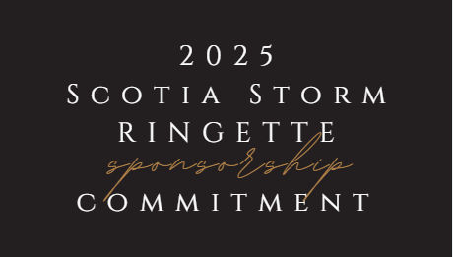

Shape

If you are ready to commit to sponsorship please complete and return this form via email to [communications@scotiastormringette.com](mailto:communications@scotiastormringette.com) or mail to 41 Crestfield Drive, Hammonds Plains, NS B4B 1E8. **Please submit a high-resolution file of your company’s logo with your email.**  
   
Name of Business: ______________________________________________________________

Contact Person Name and Phone Number: __________________________________________

Contact Email: __________________________________________________________________

Team You are Sponsoring (U10, U12A, U12B or U14): ____________________­­______________

Check box for type of sponsorship:

* Platinum Sponsor ($3,000 +)
* Gold Sponsor ($1,000 - $2,999)
* Silver Sponsor ($500 - $999)
* Bronze Sponsor ($100 - $499)

Select one:

* Cash/Cheque Payment (make cheque payable to Scotia Storm Ringette and send to

41 Crestfield Drive, Hammonds Plains, NS B4B 1E8)

* E-transfer to treasurer@scotiastormringette.com
* Send invoice to contact person

Select one (for Platinum, Gold & Silver Sponsors):

* Would like to receive sponsor plaque of team picture
* Do not wish to receive sponsor plaque of team picture

Would you like to receive a receipt of your sponsorship for tax purposes?

* Yes
* No

*Questions? Please email our Director of Communications at communications@scotiastormringette.com or call (902) 240-9055.*