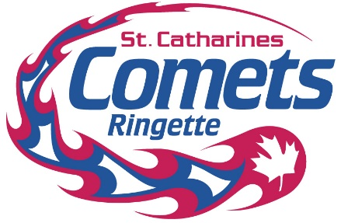

**REFUND POLICY**

This policy provides details on the St. Catharines Ringette Association Refund Policy.

**Refunds for Regional Players**

No refund will be issued without the approval of the St. Catharines Ringette Association executive.

The refund request must be in writing and a **$50 administration** charge will be levied if the refund is granted.  No refund will be issued after **November 1st of the current season.**

**Season Ending Medical Refund**

For a Season Ending Medical Circumstance-Requests will be dealt with on a case-by-case basis. Medical refund requests must be in writing and accompanied by supporting medical documentation from a licensed medical professional indicating that the injury is "Season Ending", for a refund request to be considered after November 1st of the current season. If approved, the refund will be prorated (minus a $50.00 admin fee and a $62.25 Ringette Ontario (RO) Membership dues & insurance fee) at the sole discretion of the SCRA executive members, and will solely be based on the date the written request is received by the SCRA office. Once a refund has been issued, the player will not be allowed to return to any form of RO sanctioned play for the refunded season.

Reviewed Aug 2024