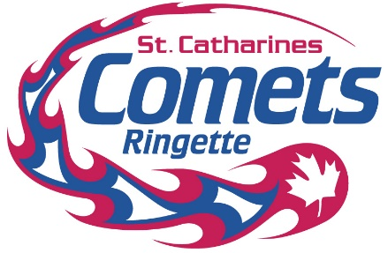

**LOGO POLICY**

**Purpose**

1. St. Catharines Ringette Association logos are the property of S.C.R.A. The purpose of this Policy is to ensure the protection of the logos and provide guidance on correct logo usage. This Policy does not imply any rights or endorsement on the part of any user.

**Application**

2. This Policy applies to staff, Directors, Members, committee members, and third parties wishing to use the logos.

**Use of the Logos**

3. S.C.R.A. reserves the right to use and grant permission to use the logos in any way it deems appropriate and reserves the right to request other parties cease usage of the logos in instances where S.C.R.A., at its own discretion, deems the usage inappropriate, misleading or in violation of this policy and any law or regulation.

4. The logo, will not be reproduced or used without the written permission from S.C.R.A.

5. Requests to use the logos must be submitted in writing to the S.C.R.A. Board of Directors at least fifteen (15) day prior to the expected use or reproduction of the logos. Submissions must include a sample and/or explanation of the proposed use or reproduction and be sent via email to scringette@gmail.com.

6. S.C.R.A. will provide written permission or denial within 14 business days of receipt of the request. This decision is not appealable.

7. Only the official logos may be used. Hand-drawn or altered versions are not permitted.

8. The logo will not be used in any way that could be interpreted as:

a) Harmful to the reputation or image of S.C.R.A. or its events;

b) A false or implied endorsement, sponsorship, approval of S.C.R.A.’s support of the user’s products, services, events or other related activities; and

c) A violation of any law, regulation, public policy or the rights of others.

9. In consideration of the acceptance of a third party use of the logos, the third party agrees as follows:

a) To abide by this policy and other directions provided by S.C.R.A. related to logo use;

b) That all information provided to S.C.R.A. is accurate and correct;

c) That S.C.R.A. reserves the right to revoke the third party’s use of the logos; and

d) Acceptance of the third party’s use of the logos is confirmed in writing by the Chair.

*Reviewed and revised Aug 2024.*