Andrew Ryan Memorial Scholarship
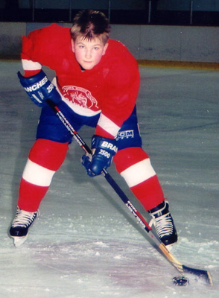

THE AWARD
- One (1) scholarship of $1,500 will be awarded each year
- Awarded to a full-time undergraduate student entering his/her first year of studies at MUN
- Must have played minor hockey in Newfoundland and Labrador

ABOUT ANDREW
Andrew Ryan was a young hockey player with SJMHA who lost his battle with cancer on August 27, 2003. In addition to being an all-star hockey player, Andrew was also a Wish Child and traveled to Australia in the months prior to his passing. In Andrew's memory SJMHA hosted an annual peewee tournament from 2004 to 2013. Over the 10 year history of the tournament, through the generous support of the hockey community, $160,000 was donated to the Children's Wish Foundation.
To continue to honor Andrew's memory, the scholarship was established by a generous donation from the St. John's Minor Hockey Association.

ADMINISTRATION
This scholarship will be awarded by the Senate Committee on Undergraduate Scholarships, Bursaries and Awards.

ELIGIBILITY REQUIREMENTS
- candidates must meet the minimum academic requirements for a scholarship
- candidates must be a full-time undergraduate student entering his or her first year of any academic program at Memorial University of Newfoundland
- must have participated in minor hockey in Newfoundland and Labrador

APPLICATION PROCEDURE
- submit a completed application which is available at the Scholarships and Awards Office website at www.mun.ca/scholarships

