**TWIN RINKS EMERGENCY EVACUATION PLAN**

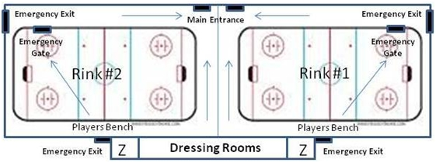

In the event of an emergency the building fire alarm system will operate, including both a siren and flashing lights.  Players, coaches, officials and spectators will exit the building as described below.

Spectators must exit the building through the **main entrance**.  Spectators on the mezzanine level will proceed downstairs in an orderly manner, no running.  Spectators are not to carry objects with them (clothing, food, drinks, hockey equipment, etc.) as they exit the building as these may present a tripping hazard.

Teams occupying the dressing room area must exit the building through the **main entrance**.  Players and coaches are not to carry objects with them (sticks, hockey equipment, etc.) as they exit the building as these may present a tripping hazard.  Coaches are to check the washroom area and ensure all players have left the dressing room before proceeding to the main entrance.  If fire blocks the route to the main entrance take the emergency exit next to the Zamboni room.

During a practice session the teams on the ice must head to the **emergency gate** to the far end of the ice surface.  The assistant coaches are to head immediately to the **emergency exit** and have the players form 2 lines, one line at each of the exit doors.  The head coach(es) will be the last person to exit the ice surface and take up a position at the rear of the lines.  At the direction of the head coach, the assistant coaches will open the **emergency exit** doors and the players will exit the building in an orderly fashion.  At no time will players and coaches on the ice surface attempt to return to the dressing room or exit the building through the **main entrance**.

In the event of an emergency during a game the referee will immediately blow their whistle and direct players to their respective benches.  The scorekeeper and linesmen will proceed immediately to the **emergency exit**.  The referee will position themselves at the **emergency gate**.  The home team players and coaches will then proceed to the emergency gate, exit the ice surface and form a line in front of an exit door being manned by a linesperson, assistant coaches in front and head coach in the rear.  When the home team exits the ice surface, the visiting team will proceed to the exit gate, exit the ice surface, and form a line similar to the home team.  Players and coaches are not to take items (water bottles, spare sticks, etc.) with them as they may present a tripping hazard.  The referee will be the last person to leave the ice surface and signal the linespersons to open the exit doors so the teams may exit the building. At no time will players and coaches on the ice surface attempt to return to the dressing room or exit the building through the **main entrance**.

**During emergency drills players and coaches in skates will not exit the arena.**