

SUDBURY DISTRICT GIRLS HOCKEY ASSOCIATION

HOUSELEAGUE COACHING APPLICATION
2025-2026 COACH APPLICATION

Return completed application to houseleague@sdgha.ca and president@sdgha.ca
Deadline for applications is August 30 , 2025.

You will receive a confirmation email once your application is received. Only those selected to move forward in the selection process will be contacted for an interview.
LATE APPLICATIONS WILL NOT BE ACCEPTED

SECTION 1: CONTACT INFORMATION

Name
D.O.B.
Phone #
Email Address
Address
(City) (Postal Code)

SECTION 2: TEAM APPLICATION
I wish to apply as Head Coach for the following team:

U18 | U15 | U13 | U11 | U9 | U7

Please note that the association reserves the right to postpone or cancel tryouts for a team if there aren’t enough players registered in that age group.

Our teams will have at minimum the following: Head Coach, 2 Assistant Coaches, Team Trainer, Manager. List below any people you are considering for part of your coaching staff. This section can be left blank if staff has not been selected yet.
We encourage you to have a female as a part of your coaching staff. Coaching staff must be approved by the SDGHA coach selection committee.

Name | Position | Highest NCCP coach level (i.e. Coach1, Coach 2)
SECTION 3: EXPERIENCE/QUALIFICATIONS

Please provide details of prior coaching positions held:

TEAM/ASSOCIATION | CATEGORY | POSITION | Year
What is your NCCP Coach Level?

Please list any additional coaching certifications that will help the coach selection committee gain a better understanding of your qualifications.

Coaches 1 |  | Yr. Attended |  | Certification #
Coaches 2 |  | Yr. Attended |  | Certification #
Initiation
Speak Out |  | Yr. Attended |  | Certification #
Trainers |  | Expiry Date |  | Certification #
Body Checking |  | Yr. Attended |  | Certification #

NOTE: ALL COACHES AND STAFF MUST COMPLETE AND SUBMIT ANY OUTSTANDING CERTIFICATIONS BY November 30, 2025 PLEASE DO NOT DELAY IN SIGNING UP FOR A COURSE OR YOUR TEAM/STAFF WILL NOT BE ABLE TO BE ROSTERED.

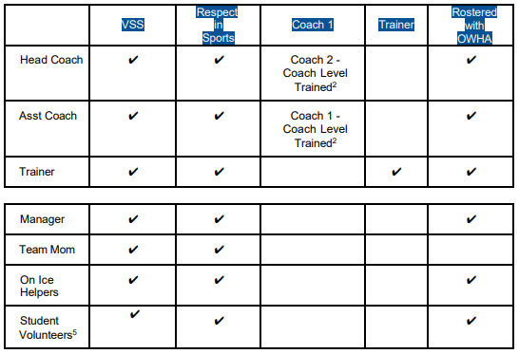

SECTION 4: REFERENCES

Coaching
Name
Phone #
Email Address
Address
(City) (Postal Code)
Non-coaching
Name
Phone #
Email Address
Address
(City) (Postal Code)

General Information Guidelines

I agree to ensure staff (including managers) obtain a Police Vulnerable Sector Check (Police Check) and be approved by the Coaches Selection Committee. If staff have submitted a Police Check to SDGHA dated 2023, 2024 or 2025, they will not be required to submit a new one, however, they must notify the Risk Management Committee should they have committed an offense since their previous check. By accepting a position with SDGHA, they declare that there have been no changes to their previous check.

I acknowledge and agree to the above-named references being contacted. I am aware that other persons and organizations may also be contacted. I give permission to these persons/organizations to provide information about myself to the SUDBURY DISTRICT GIRLS HOCKEY ASSOCIATION (SDGHA) for purposes of this application.

If accepted to a coaching position with SDGHA, I agree to uphold and abide and promote any rules and regulations as set forth by the Association, the SDGHA Constitution and the goals and philosophies of the Association as well as those of the OWHA.

I further understand and agree that as Head Coach I bear ultimate responsibility for any and all team staff conduct or lack of performance in their duties. It is also understood that all signing parties are subject to discipline or suspension at the SDGHA Board of Directors discretion.

I understand that my coaching staff and I will be required to support in other team tryouts and skill development clinics throughout the year.

You will be responsible for returning all equipment and sweaters to the league at the end of season.
They must be returned as they were.

Please forward any questions to houseleague@sdgha.ca and cc president@sdgha.ca

 I AGREE to all terms and conditions.

Name: Signature: 

Thank you for taking time to apply with the Sudbury Lady Wolves!

