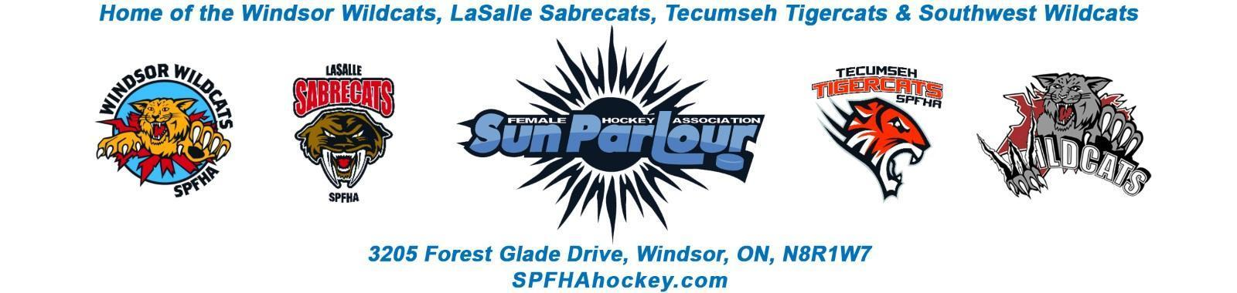

Sun Parlour Female Hockey Association
MEETING MINUTES
April 4, 2022
6:00 pm – Zoom

Present: Adam Dagenais, Maria Lloyd, Jim Stamatiadis, Stacie Lobzun-Howe, Steve St. Louis, Rob Poisson, Jen Soullierre, Glen Powney, Mike Martin, Gary Quenneville, Lorie Gregg, Francine Stadler, Aaron Anson , Katie Doe

Late:
Regrets: Mike Martin/Paula Stamatiadis

Meeting called to order at 7:04 pm

Approval of Agenda: Motion to approve agenda of April 4, 2022 by Stacie , seconded by Aaron. Approved
Approval of Minutes:

Motion to Approve of Minutes as amended from March 9 , 2022 by Stacie and seconded by Jim. Approved

Amendment to the minutes of March 9, 2022– Refund $80 per player refund to be amended.

Old Business - None
.

New business:
- Finance Update – LG -
March Info
Cash out flows -$8,401
Cash in flows - $27,675.24

Cash Balance at March 31, 2022 - $34,398

- AGM – FS – A few positions with no nominees. These Positions will be opened up at the AGM. We need to look for a larger room at our facilities.

Motion to keep the AGM in person with no food and mandatory mask by Francine and seconded by Lorie. Approved

- Bursary Selection – FS

Ella Hopper to receive the bursary.

- Award Selection – FS

A. House League Player of the year - Ava Zajac

B. House League Coach of the Year - Katie Doe

C. House League Trainer of the Year – Tracie Roberts

D. Fan in the Stands – Turner Willar

E. Travel Player of the Year - Ashley Quenneville

F. Travel Coach of the Year – Scott O ‘Halloran

G. Travel Trainer of the Year – Monica St. John

H. Young Volunteer of the Year - Silia Gregg

- 2021-22 Travel Player Refunds – SSL Travel players will get $80 returned as well as house league players.

- HL timekeepers reports have been submitted to Lorie for final payment – MM

- Tryouts week of April 18 – Tryout packages – SSL

- 2022-23 Registration – ML – No info from OWHA on registrations.

- Roundtable
Maria - Appreciation Dinner tomorrow night - 45 people attending. Thanked everyone for the Days of Champions. Interlock day of champions was as well.
Jen – We should be proud at what we accomplished this year as a board.
Glen – Motion to go in camera at 8:01 By Glenn -seconded by Lorie.
Motion to go out of camera at 8:09 PM seconded by Jen.
Glen – U11 tryouts are later in the fall so we will have to coordinate jersey procurement.
Francine – thanked the board members who are not returning.

Next meeting – AGM April 13, 2022 – 7 PM - Holiday Inn – 1855 Huron Church Road Windsor, Ontario

Motion to adjourn by Francine at 8:13 PM

