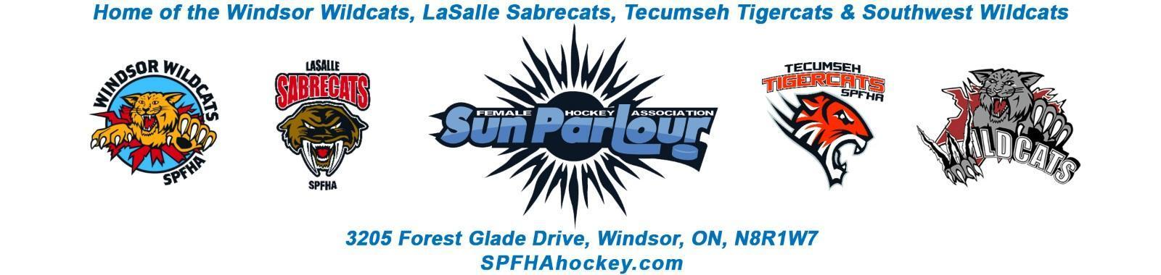

Sun Parlour Female Hockey Association
MEETING MINUTES
August 16, 2022
7:00 pm

Present: Stephanie Bell, Steve St. Louis, Rob Poisson, Francine Stadler, Jen Soulliere, Katie Doe, Lorie Gregg, Mike Martin, Kevin Bell, Gary Quenneville, Maria Lloyd, Stacie Lobzun-Howe, Monica St.John- Illman

Late:
Regrets: Glenn Powney,

Meeting called to order at 7:02 pm

Approval of Agenda:

Motion to approve August 16, 2022 by Stephanie , seconded by Lori. Approved

Approval of Minutes:

Motion to Approve of Minutes from June 14 , 2022 by Jen and seconded by Steve. Approved

Old Business - None
.

New business:

- Finance -LG

June – Cash out – $16,240.15 Cash in - $70,197.50
July – Cash out – $3,182.15, Cash in – $5,938.57
Aug. 16 Bank Account - $191,242.09

Budget presented for discussion. Items to be adjusted and retuned at next meeting.

- Registration -ML

Registration numbers – 340 as of August 16, 2022
School advertising program in September
Rosters – travel rosters sent in for approval. House league rosters to be finalized next week and then will be sent in for approval.

Motion to go in camera by Jen at 7:28 PM seconded by Stephanie – Approved
Motion to go out of camera by Jen at 7:42 PM seconded by Steve - Approved

- Goalie Incentives
Motion by Jen to put the $100 goalie rebate on hold due to the new goalie initiative for the 2022-23 season. Seconded by Lorie
Motion by Kevin to apply the house league goalie incentive to goalies who play of 80 % of eligible games will receive a 75 % reduction in registration fees for the 2022-23 season re-imbursed at the end of the season. Seconded by Steve. Motion carried.

- Vacant Positions
Monica St.John-Illman is the webmaster for the 2022-23 season.
Skills Development is open. Tuesday 6:10 – 7 PM on the bowl at WFCU. September 27 start. 13 skilled sessions.
- Discipline Committee
Katherine Foglia is our non board discpline committee member.
- Equipment Update
Status of Orders with Brian's Source for Sports:
Timbits Jerseys (U9) - have been delivered to my house.
AtoMc Jerseys (U11) - anticipated delivery is early September.
House League - Getting screened throughout the next week. Should be done before Labour Day.
Travel - Everyone except for U15AA has picked up game jerseys.
U13B - Tracksuits and practice jerseys in queue to get decorated (~2wks) - Coaches Soft shells + Hoodies + Long sleeves ordered and waiting on delivery.
U13AA - Tracksuits in queue to get decorated (~2wks)
U15A - Tracksuits in queue to get decorated (~2wks), just waiting on decoration confirmation from Aaron - Hats are ready for pickup - Hoodies ordered and waiting on delivery (missing 3 sizes but we have ordered stock sizes and we can fill in from that)
U15AA - Tracksuits in queue to get decorated (~2wks)
U18A - Cancelled Tracksuit order, UA Hoodies are in-store for sizing
U18AA - Roots jackets in queue to get decorated (potentially done this week - practice jerseys ready for pick up - pants/shells sizing tonight and Wednesday.
Brian's Stock - Bags, pants, gloves due in store at the start of October. New Era flex fit hats available in s/m, m/l, l/xl. Toques available. Backpacks available. Hoodies available in ~2wks.
SPFHA Equipment Inventory:
I will be organizing the SPFHA equipment over the next few weeks, prior to the return of hockey

- Travel Update
Open Registration for U11 Tryouts. 35 spots to be bumped to 40 spots available. Pre-conditioned skates are scheduled.
Bib replacement – Motion to buy 16 sets of bibs for travel travel tryouts by Jen seconded by Stephanie - Approved
- Roundtable
Francine – sanction for April Play for a Cure Tournament to be applied by Steve/Katie
Mike – referees – Jessica Modestino is the new referee in chief replacing Jody Myers. Social media blast and email blast for training dates. Mike will send info.
Stacie – please send pictures so that we can post. Comment on posts will help.
Katie – Tournament flyer and update flyer in development –January 6 -8th, 2023.
Motion to setup tournament email for e-transfer for tournament registrations by Katie seconded by Lorie. Approved
Rob – House league head coaching positions going well.

Motion by Maria to adjourn at 8:32PM and seconded by Lorie

Next meeting September 21, 2022.

