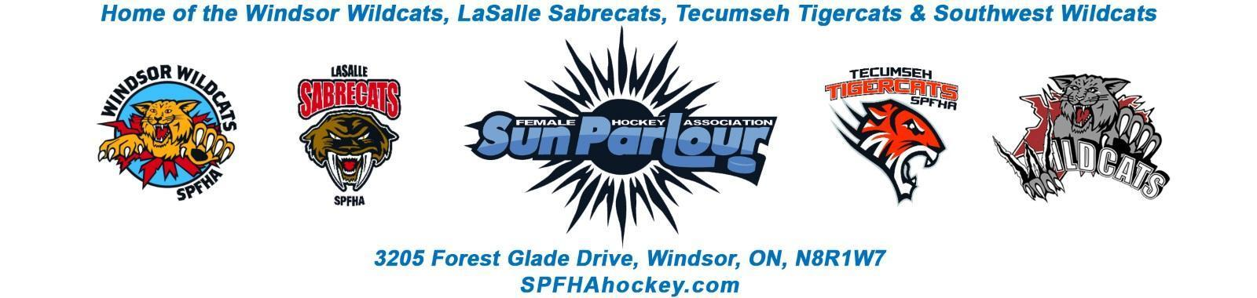

Sun Parlour Female Hockey Association
MEETING MINUTES
February 16, 2022
6:00 pm – Zoom

Present: Adam Dagenais, Maria Lloyd, Jim Stamatiadis, Stacie Lobzun-Howe, Steve St. Louis, Rob Poisson, Jen Soullierre, Glen Powney, Mike Martin, Gary Quenneville, Lorie Gregg,

Late:
Regrets: Francine Stadler, Paula Stamatiadis, Aaron Anson, Katie Doe

Meeting called to order at 6:04 pm

Approval of Agenda: Motion to approve agenda by Stacie , 2nd by Maria Carried
Approval of Minutes:

Motion to Approve of Minutes from January 27, 2022 by Jim and 2nd
by Jen . Carried

Old Business
.

New business:

- Finance Update – LG

Cash out flows -$29,382
Cash in flows - $3,665
Tournament costs finalized and submitted. Cash out were predominantly refunds for the tournament.

- Referees/timekeepers/Arbiter – MM

Mike gave a summary of the current referee situation. Referees would rather do timekeeping instead. There were U18 AA, U15 AA cancelled and 3 House league interlock changes on week of February 7-13. Steve asked if we can lockout the timekeeping slot and only leave the referee slots to be filled and have the teams take care of the timekeeping. Mike to look into this. There may be some ice time shuffles as well to facilitate referees and timekeepers. We may need to do our own timekeeping skills.

- Ice Allocation – LG –
Credit ice allocation – Ice invoices in December had the full credit. One invoice coming with partial new credit up to December and second invoice will come with a second credit to true up the remainder of credit later in the season. Initial invoice from December will be cancelled.

- House League Update – AA

- 2022 – 23 Travel Coach Selection Committee - SSL

Coaching interviews will happen in the beginning of March. Coach selection Committee is Steve St. Louis, Francine Stadler, Paula Stamatiadis, Gary Quenneville, Jen Soulliere and external rep is Chris Racine.

Motion by Maria to approve the committee. Seconded by Adam. Carried.

Tryouts Start April 18. Sun Parlour only skates may be considered before April 18.

6. Tryouts / Coach Application Update – SSL

- Nomination email for 2022 AGM nominees – SSL

Nominations email to be set up for the AGM. Steve to setup the email. We need two people to access the emails and file the names. Francine and Maria to have access to email and will monitor. Communication to be setup to announce open positions for 2022 AGM notification
- Travel socks -SSL
As an association – can we get our own inventory of travel socks and supply our own teams ? Discussion to be done at next meeting.

9. 2022-23 Registration – ML

Day of Champs is March 26. Maria wants to setup registration dates early and setup a table at day of champs to collect their money in full or installment of three payments. Registration will open in March. We need to finalize costs at next board meeting.

- SPFHA Bursary Application – JH

Bursary discussion can go to the next meeting. Jen will circulate an email prior to next meeting.

11. March Meeting - Should we move to March 9 due to March break ? It is currently scheduled for March 16.

Agreed to move the Next board meeting to March 9th.

Next Meeting will be March 9, 2022 at 6:00 PM

Meeting to adjourn by Lorie at 6:59 PM

