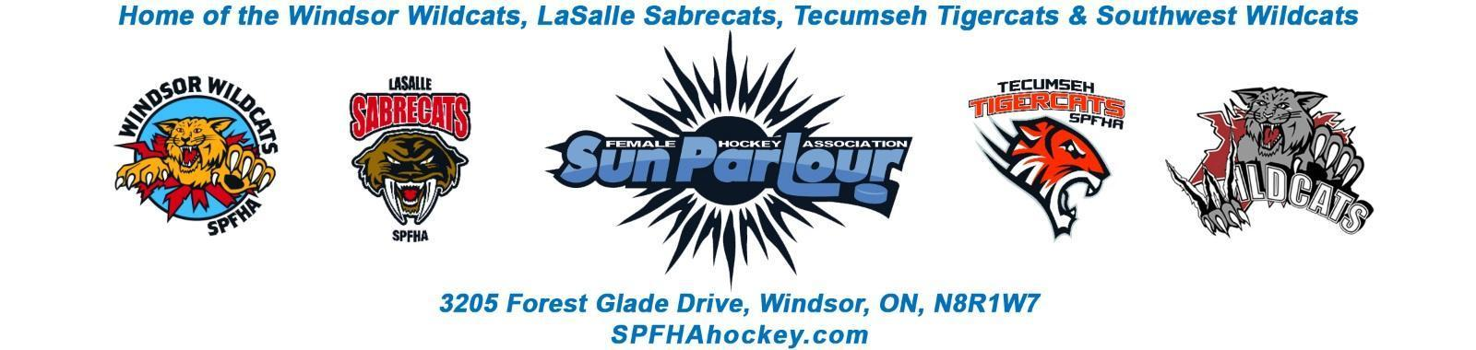

Sun Parlour Female Hockey Association
MEETING MINUTES
January 27, 2022
6:00 pm – Zoom

Present: Adam Dagenais, Maria Lloyd, Francine Stadler, Paula Stamatiadis, Jim Stamatiadis, Steve St. Louis, Stacie Lobzun-Howe, Rob Poisson, Jen Soullierre, Katie Doe, Glenn Powney, Mike Martin, Aaron Anson, Lorie Gregg, Gary Quenneville

Late:
Regrets:

Meeting called to order at 7:02 pm

Approval of Agenda: Motion to approve amended agenda by Maria, 2nd by Adam Carried
Approval of Minutes:

Motion to Approve of Minutes from December 15 , 2021 by Aaron and 2nd
by Stacie. Carried

Old Business
.

New business:
- Update from OWHA – FS - Francine has said we are expecting to go back to practices and games next week. Games start on Wednesday for SPFHA. Coaches to keep attendance on ice. City of Windsor Dressing rooms to 50 % capacity and two parents per skater. Screening still required at Windsor arenas. QR code for vaccination required.

- Rowan’s Law – FS – Francine sent out Rowan’s Law document. To be posted on the website. To be sent to coach’s to use the rest of the season.

Motion by Francine to approve the document by association by Fracine. Seconded by Laurie. Carried

- Tournament Update – KD - Katie has 17 boxes of tournament materials to be stored in our room . room needs to be cleaned to accommodate the boxes. Refunds have been issued for teams. Katie is writing thank you cards to sponsors. Tournament/SPFHA promo video was scheduled. Katie looking at trying to come up with a way to get a video for SPFHA use.

Motion by Katie to get $400 gift card to pay for videographer time for a SPFHA Promotional video. Seconded by Aaron. Carried

- Heritage Outdoor Classic Request – GP – U22 Outdoor game at Lanspeary Park on Scotia Day hockey day in Canada is cancelled for Saturday January 29, 2022. Game is rescheduled to Family day weekend February 20.

Motion by Glen to have SPFHA sponsor hot chocolate for the event $135 for the day. Seconded by Gary. Carried.

- House League Update – AA – Templates sent out to coach’s to schedule their games by Sunday January 30, 2022. Hospice tournament is looking for U9/U13 teams.

- Travel Update – SSL – No update.

New Business:
- Ice invoices sent out in December . Invoices will be adjusted for the shutdown.
- There have been 7 sessions of skills missed due to the shutdown. Skill sessions will start the week of February 7.
- Thanks to Jim for setting up the zoom meetings for Southwest workouts.
- Glen talked about a company that rents equipment to players and will reach out to Aaron to see if there is any value for SPFHA.

Next Meeting will be February 16, 2022 at 6:00 PM

Meeting to adjourn by Francine at 7:56 PM

