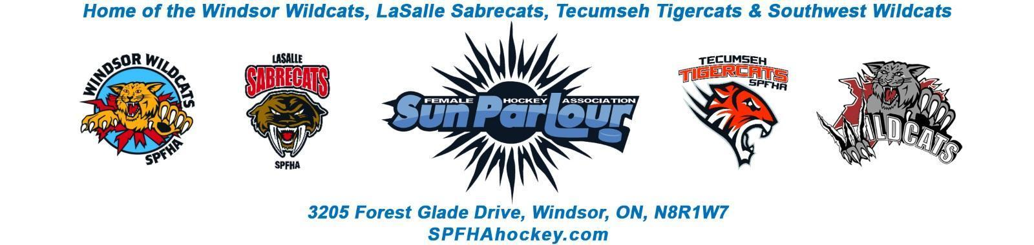

Sun Parlour Female Hockey Association
MEETING MINUTES
June 14, 2022
7:00 pm –

Present: Stephanie Bell, Steve St. Louis, Rob Poisson, Francine Stadler, Jen Soulliere, Katie Doe,Lorie Gregg, Mike Martin, Glenn Powney, Kevin Bell

Late:
Regrets: Gary Quenneville/Katie Doe/Maria Lloyd/Stacie Lobzun-Howe

Meeting called to order at 7:09 pm

Approval of Agenda:

Add Discipline committee and remove coaching staff approval
Motion to approve amended agenda of June 14, 2022 by Stephanie , seconded by Lori. Approved
Approval of Minutes:

Motion to Approve of Minutes from May 3 , 2022 by Rob and seconded by Jen . Approved

Old Business - None
.

New business:

- Finance -LG

Lori – Finance . . . hand out and review draft of budget
714PM Jeff Casey arrived to present idea of SPFH partnering with Play for a cure to add on girls clinics while there are women professional players in town.
Motion by Kevin to go in camera at 7: 30 PM in camera seconded by Steve

Motion by Jenn to go out of camera 7:47PM seconded Rob
Francine to contact OW to find out if we can partner for the clinics before we have more discussion.

Lori – continue to review 22/23 draft budget, come ready to vote at the next meeting.

- Registration -ML – Maria sent update by email

Registration is at 295 - Hopefully pass the 400 mark for registration for the season
Pre-Covid season 2019-2020 we were at
a total of 451 for the season

Travel rosters will be submitted for approval this week

First HL payment dates June 20 & 21
I will have 2 more . One at end of July and another 3rd week of Aug
July & Aug payment dates will only have 3 check option so I will ask Jim to fix the website after the June payment

- Open Positions
Francine- Vacant position Monica St Johns showed interest in both open positions, Francine told her to read the by-laws see what one best fits and Francine will talk to her over the weekend

- Travel Update
Steve – Travel update Roster filed this week; everyone has paid on the travel side.
Motion by Jen to go in camera at 8:07PM seconded by Lori
Motion by Francine to go out of camera at 8:17PM seconded by Stephanie
Motion by Steve to Approved coaches as presented . Seconded by Jen.
Corporate sponsor / Jersey sponsor / to team ½ to child. Not something SPFHA has done, it would need to be approved at the parents meeting. Something we will discuss next year prior to parent meetings
Jenn – We should create a showcase that 8-9 of the Travel coaches are former players – do a spotlight on social media, we should draw attention to show the mentorship SPFHA has.
- Canada Day Parade
Stephanie to order Banner from Vista Print with PNG files.
- U9 can wear SPFHA practice red jersey Rob has – Coaches can bring extra Jerseys.
- Candy is ordered
- Email to go out to coaches
- Bell Truck to be used, decorations are purchased, found a generator to run speaker. Will create a playlist.

- Stipend
Francine- Stipend
Motion by Stephanie to go In Camera at 8:43PM and seconded by Lori
Motion by Glenn to go Out of camera 8:51PM seconded by Steve
We will revisit in the future.

- General Administration
Motion by Jen that there will be JR/SR player of the year in house league and travel seconded by Francine. Motion passed

Director of hockey operations – At end of year should create a spreadsheet develop and rate players

Glenn presented jersey RFP.
Motion by Lori to move forward with Brian’s and seconded by Kevin. Motion Passed
Glenn to find out color combinations for 7400 and 6600

- Roundtable

Steve- fundraising Approval 3x3
Mike – Asked ref assoc. about Ref training online, rec’d no response. Will keep an eye on it and update when possible.
Rob- Q&A zoom meeting for new coaches.
1st shift – need to advertise that they go into SPFHA after 1st shift. Looking to get 2 programs of first shift next year.
Lori: FYI – U18 leadership retreat camping 2-3 days team building and bonding not in team budget, paying outside of fees. Will make sure that any adults attending have police clearance etc.

Francine :
-Need to recognize SPFHA players going to Ontario Summer games ( 4 or 5) . . . confirm names of everyone and make social media posts for players/coaches.

Motion by Lori to adjourn at 9:31PM and seconded by Rob

Next meeting Aug. 16, 2022.

