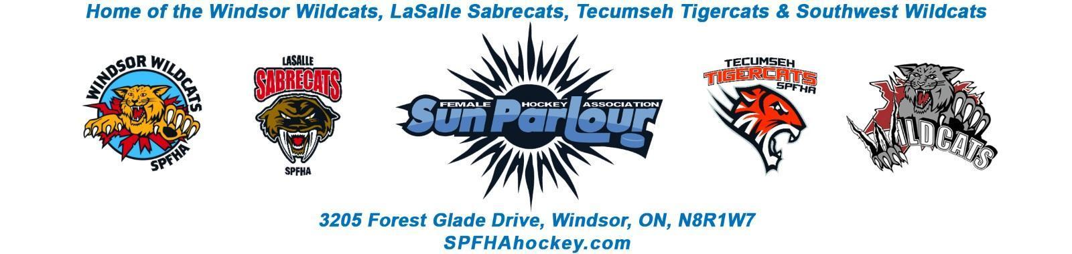

Sun Parlour Female Hockey Association
MEETING MINUTES
March 9, 2022
6:00 pm – Zoom

Present: Adam Dagenais, Maria Lloyd, Jim Stamatiadis, Stacie Lobzun-Howe, Steve St. Louis, Rob Poisson, Jen Soullierre, Glen Powney, Mike Martin, Gary Quenneville, Lorie Gregg, Francine Stadler, Aaron Anson,

Late:
Regrets: Katie Doe, Paula Stamatiadis

Meeting called to order at 6:03 pm

Approval of Agenda: Motion to approve amended agenda of March 9,2002 by Maria , seconded by Aaron. Approved
Approval of Minutes:

Motion to Approve of Minutes with Financials pending from February 16, 2022 by Jen and seconded by Aaron. Approved

Old Business - None
.

New business:

- AGM – FS - Four positions nominations received. Awards and bursary applications coming in. Meeting will be in person on April 13 at 7 pm Holiday Inn. Steve to contact Rob M to get the room booked. Annual Package will be put together by Gary with a summary from everyone on the board due April 1. Need an agenda and elected positions summary put on each table. No emails on constitution changes as of yet. Maria needs help at the front table at the AGM. Coach’s appreciation night to be reviewed. Need a room for 70-80 people. Adam to look into a location and date.

- Day of Champions – FS –Increased budget for awards due to increase in costs. Maria gave an update on the event. We are getting some good support from vendors.

Motion by Lorie to approve $1200 budget for Days of Champions seconded by Stacie. Approved.

- Regional Discussion – Motion to go in camera at 6:17 pm by Lorie seconded by Jenn. Approved

Motion by Jen to go out of camera at 6:34 pm seconded by Lorie

- Travel Coach Evaluations and Approvals – SSL – Coach evaluations have not been done in a couple of years. 2021-22 Coaching evaluations sent out last week. 35 % have responded so far. Results have been very good to date. Aaron will look at house league evaluations. Coaching Approvals -
Motion to go in camera by Aaron at 6:37 pm by Aaron and seconded by Maria.

Motion by Aaron to go out of camera at 6:49 pm and seconded by Maria.

All applicants interviewed discussed.
U11 Team 1 – Kyle Voy – Motion by Jenn to approve and seconded Maria - Approved
U13 Team 1 - Matt Debruyn – Motion by Jenn to approve seconded by Lorie – Approved
U18 – Team 1- Mary Fehr – Motion by Jenn to approve seconded by Maria – Approved
U18 Team 2 – David Norris – Motion by Jenn to approve seconded by Mike - Approved

- Tryouts week of April 18 – Tryout packages being prepared by SSL. Tryout plan is to have 3 tryouts the week of April 18 for each of U18/U15/U13. Steve is preparing a document to get posted. RAMP will be used for registration. Need trainer and administration support that week.

- Summer Program – RP – Summer program is difficult to run due to restrictions with SPFHA. Motion by Jenn to go in camera at 6:57 PM seconded by Lorie.
Motion by Adam to go out of camera at 7:00 seconded by Maria.

- Tyke Division – RP – There has been a question about 4 year olds playing in U8 division. Advice is to join the Canskate program. Rob will look into the interest of a future tyke program.

- U9 Registration – RP – U9 registration is the same time as all age groups.

- 2022-23 Registration – ML – no date yet for registration waiting from OWHA.

Motion by Aaron to approve $80 refund for missed ice time and that returning players will be credited for their registration and refund cheques will be issued in September for non-returning players seconded by Maria. Approved

Motion by Maria for 2022 registration to be $695 for each player except U9 which is $595 and first time OWHA players is $420 and seconded by Aaron. Approved

- School Flyer – FS – Stephanie Bell put together a flyer together to send to schools with SPFHA registration. Modifications to be made and sent to all school boards.

- Thank you letter to be sent to Rob and Jess Modestino as thank you in helping with our referee and timekeeper situation. Motion to approve $50 gift card for Jess Modestino.
- Glenn – RFP for jerseys to be developed and investigated at future board meeting.
- Need to meet as a board to discuss bursaries, awards and AGM on April 4 at 6:00pm Zoom meeting.

Motion to adjourn by Francine at 7:42 PM

