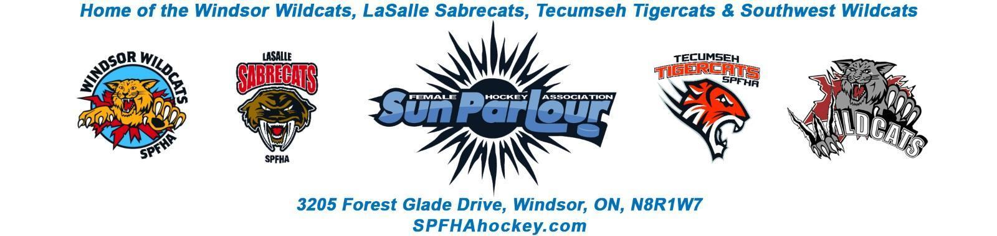

Sun Parlour Female Hockey Association
MEETING MINUTES
November 14, 2022
7:00 pm

Present: Lorie Gregg, Gary Quenneville, Maria Lloyd, Steve St. Louis, Rob Poisson, Francine Stadler, Glen Powney, Stephen Truong, Joseph Gajda, Jen Soulliere, Mike Martin
Late:
Regrets: Stacie Lobzun-Howe, Stephanie Bell, Kevin Bell, Katie Doe
Guest : Jeff Casey – Play for a Cure
Meeting called to order at 7:05 pm
Approval of Agenda:
Motion to Approve updated agenda for November 14, 2022 by Jen , seconded by Maria. Approved

Additions to agenda– Tournament Update
Approval of Minutes:
Motion to Approve of Minutes from October 17, 2022 by Maria and seconded by Lorie.
Approved

Old Business - None

New business:

- New board member introductions – Steve Truong – Skills Development and Joseph Gajda - Webmaster

- Play for a cure

Play for a Cure Skills Camp – SS

Presentation by Jeff Casey

Next update will be January 16, 2023

Sub – committee - Jen, Steve, Stephen, to sit on the committee

- Finance -LG

October
Cash in – $27,523.67
Cash out – $82,030.20 – October and November ice is paid
Balance as of – $72,094

Motion to go in camera at 8:25 pm by Steve and seconded by Glenn.

Motion to go out of camera at 8:33 pm by Steve and seconded by Glenn.

- House League Sponsorship – FS

Jersey sponsorship funds goes to SPFHA and name go on the jerseys. We need to follow the constitution.

We need a policy on fundraising for house league.

- Spitfire Jersey Wall of Fame – FS

We will provide jerseys to the Spitfires for their wall of fame.

- House League Update -RP

  - HL fundraiser forms – discussed above
  - HL skills U22 – add additional skills sessions will be sent to the coaches , to the website and social media.
  - Body contact cost is $20 per player

- Travel Update -SS –

- Tournament Update – KD

- Roundtable

Glenn – House league jerseys will be shipped on Nov. 21 and delivered December 2 . Photography schedule coordination required.

Steve –
Lanspeary game – Outdoor classic January 21st – we will see the availability
Banners – where do we hang the banners – FG
Non parent coach policy for re-imbursement – we need the policy
Referee – Lakeshore has a house league tourney this weekend. We have a couple of games need coverage
Mike – RAMP is working better
Lorie- expense reports must go through the VPs

Next meeting – December 12 , 2022

Motion to Adjourn at 9: 18 pm by Rob , seconded by Jen. Approved

