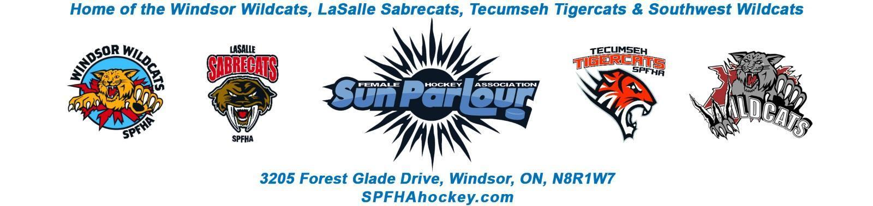

Sun Parlour Female Hockey Association
MEETING MINUTES
September 12, 2022
7:00 pm

Present: Stephanie Bell, Steve St. Louis, Rob Poisson, Francine Stadler, Jen Soulliere,
Katie Doe, Kevin Bell, Glen Powney
Late: none
Regrets: Lorie Gregg, Mike Martin, Gary Quenneville, Maria Lloyd, Stacie Lobzun-Howe, Monica St.John- Illman

Meeting called to order at 7:21 pm
Approval of Agenda:
Motion to approve Sept 12, 2022 by Jen, seconded by Kevin. Approved
Approval of Minutes:
Motion to Approve of Minutes from August 16, 2022 by Katie and seconded by Rob.
Approved

Old Business - None
.
New business:

1. Finance -Lorie Gregg
LG absent – to supply next month meeting

2. Rowans Law – Fracine Stadler
New Rowen’s Released, suggested all trainers re-read and familiarize themselves with it. With teams that have multiple trainers, one head trainer should be in charge of all injury reports, communication amongst staff about return to plat, etc.
3. OWHA Insurance – Stephanie Bell
What is covered – What is not covered – Stephanie to supply digital copy for attachment and filing for future reference.

4. House League Update – Rob Poisson
A. Registration process for teams – Tabled until October meeting
B. EKGIHL Meeting Update - October 3 – Schedule Meeting – Essex, HL coaches to be informed
6pm U9 and U11, 7pm U13, 8pm U15, 9pm U22
- Team count for interlock, U9 (4), U11 (10), U13 (10), U15 (10) U22(11/12)
- Special date – Oct 7 – Regular season, Day of Champions Apr 2 in Leamington
C. Goalies (HL) - lack of goalies in all centers, looking at options, possible bumping goalies up, sharing, etc. Will address U11 goalies after travel tryouts conclude
D. Coaches – all HL coaches are now getting goalie gear from Glen, jerseys, team lists, etc. U15 is short one coach, RP filling in for now but one must found

5. Referees – Mike Martin
Motion by Jen Soulliere to increase to association wide $18.50 for 50 minute games, $25 for 80 minute games, seconded by Kevin Bell
Approved
6. Travel update – SS
U11 tryout registration numbers – approaching 40, including 5 goalies. Still need volunteer for Trainer on Saturday icetime (found Paula S).
Other travel teams have hit ice, regular practices, some have played exhibitions, more to report next month.
Fundraising forms – SS – SS and LG to work together with input from board to update form and present in October with relevant additions.

1 Roundtable
Kevin Bell – u9 and u11 teams emailed schedules, team list TBD
Rob Poisson =- all jerseys distributed except U9
Glenn Powney – some instances of small jersey sizing, will reach out on case by case basis, coment positive about look and quality of new jerseys,
Katie Doe – tournament teams
2 U13 HL
1U13BB
1 U15 HL
1 U22 HL

Fracine Stadler – skills will be lead by Carrie Sekela and Candance Chevalier, Rob will supply schedule to them
Jen Soulliere- first tournament this weekend

Steve St. Louis – cleaning office Wednesday with KD, GP, SB, FS
- Any VSC or criminal dec hand to me for fwd to gary
- Play 4 A Cure camp sanction sent in Aug 17 – no word back – will follow up at 6 weeks

Motion by Jen Soulliere to adjourn at 8:37PM and seconded by Stephanie Bell

Next meeting October 17 , 2022. Location – Hotel TBD

