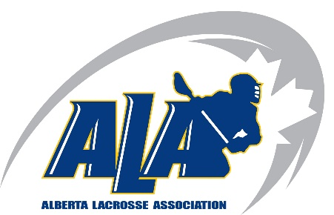ALA Return to Activity Stage 1 – FAQ

Events:
Do I need to space out arrival of different groups? Yes, coming and going to and from an event needs to be staggered at least 15 minutes and attendees should not loiter after session is complete
Does the number of attendees include parents? Yes, as they are included in your maximum of 50 participants; parents must be in a designated area it is suggested to have only one parent in attendance; no siblings or grandparents
Do parents need to social distance? Yes
Are spectators permitted? No just parents and it is suggested one parent per athlete
Do I need to mark my area of competition? Yes, separate your group with others using pylons or flags
How do I maintain 2 m distance for younger age groups? This is more difficult so more coaches may be required. Younger age groups should be organized as cohort groups (same group each session of the program) to limit the number of cross interactions between participants
Where are sanctioned ALA events held? Outside only, with a secured contract or open recreation area depending on you municipality; this may be fields or outdoor boxes
Can participants share equipment and water bottles? No
Are group snacks permitted? No
Who should supply first aid if required? First Parent. Second, first aider should use appropriate Personal Protective Equipment, including medical mask and gloves.
Where can I find drills to assist coaches to adhere to guidelines? https://www.albertalacrossetv.com/en/
What equipment is required? Helmets, gloves, and mouthguard
Who is required to have hand sanitizer? All Players and Coaches

Health:
Do athletes need to wear masks? No, this is optional
Do organizers need to supply hand sanitizer? Yes, or request all athletes bring sanitizer with them
Are there dressing rooms for players? No, players are to come dressed
Should any participants attend if they have symptoms such as cough, fever, shortness of breath, runny nose, or sore throat symptoms? No, they are required to complete the self-assessment and get tested for COVID-19 and advise the ALA of results if they have participated in an ALA event previously

Administration:
Who can obtain sanctioning from the ALA? ALA Members
How do I obtain sanctioning? ALA Member completes the sanction form and emails it to info@albertalacrosse.com
Who needs to be registered? All players and coaches need to be registered in the 2020 Return to Activity Season in RAMP prior to participation
Where can an athlete participate if home club is not offering a program? The next closest club in your area who is offering a program
Where can I find a list of sanctioned programs? http://www.albertalacrosse.com/content/return-to-activity
How can groups of participation be formed? Age and skill needs to be considered informing groups
How large can the participation groups be? The size of the field and number of coaches needs to be considered; limiting parent attendance may be required; 2 m distancing must be adhered to (maximum 50 people)
Who is responsible for the adherence to ALA Policy and Government Health Orders? The Competitive Introduction trained coach (in any lacrosse discipline) heading up the event
Who can coach the Return to Activity Sanctioned event? At least one Competitive Introduction registered coach who is 18 years of age. All coaches must meet CLA Minimum Standards for Coaching for applicable age division.
Does the host need to track attendance? Yes, on the ALA attendance sheet and supplied to the ALA biweekly
How do I pre-screen attendees? Players and coaches are to complete and hand in the pre-screening form available on the Return to Activity web page
What are the stages for Alberta Lacrosse to proceed to full Lacrosse Games? Return to Activity – drills and physical preparation; Return to Sport – drills and tactical development; Return to Lacrosse – full game play
When will the new stages be introduced? When government restrictions allow and ALA provides updated framework for each stage
What are the guidelines I need to follow for Return to Activity? ALA Framework for Return to Activity – Stage 1; ALA Regulation 37; Alberta Health Directives; All can be found on this webpage - http://www.albertalacrosse.com/content/return-to-activity
When can lacrosse programming to move to stage 2? When ALA announces the transition g to stage 2 as ALA stages are different from Alberta Health Directives and the stages of the Alberta Relaunch Plan
Who is covered by ALA Insurance? Registered players, registered coaches and registered executives in the 2020 Return to Activity Season

Reference:

http://www.albertalacrosse.com/content/Return-To-Activity
https://www.alberta.ca/assets/documents/covid-19-relaunch-guidance-organized-sport-physical-activity-and-recreation.pdf

Questions:
info@albertalacrosse.com

