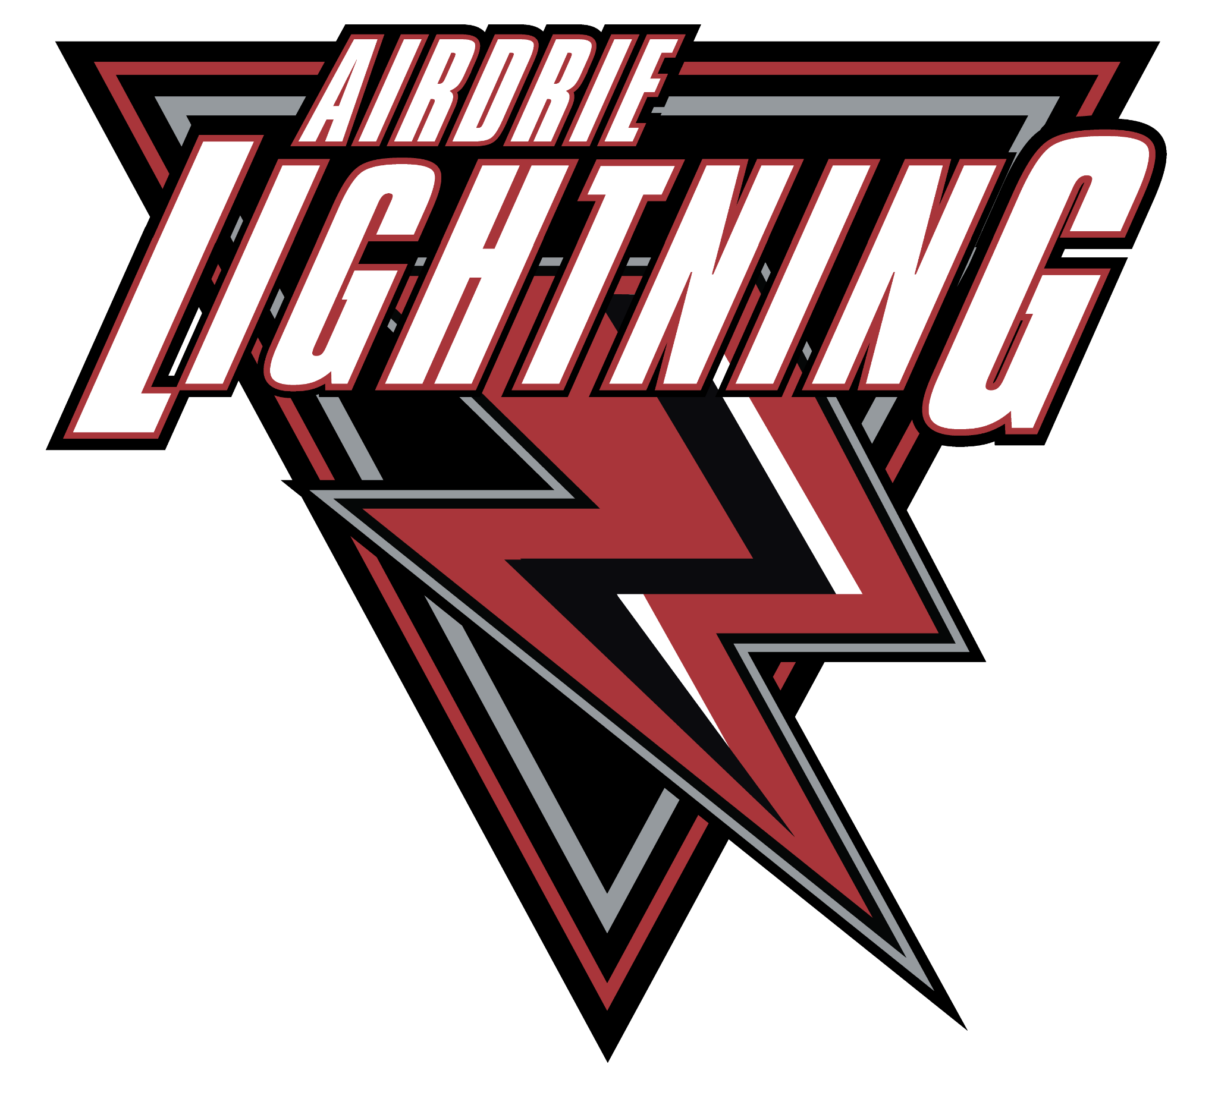
Airdrie Minor Hockey Association
200 East Lake Crescent NE
PO Box 10218 Stn Main
Airdrie, AB T4Z 2HB
Ph# 403.912.2680
Email: officeadmin@airdriehockey.com

