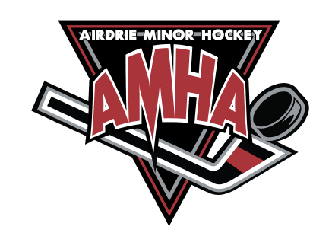
Coaches Reimbursement Form
(for Courses and Clinics)

Please complete this form fully, attach receipts and supporting documents. Sign, date and email into: coachreceipts@airdriehockey.com

Make Cheque Payable to:
Phone # and Email for E-transfer to be sent to:

Team and Position:

Summary of charges

Date (m/d/y): | Description: |  | Amount:
 | (Receipts must accompany all requests for Reimbursement)
 |  | GST
 |  | TOTAL

Signature of Submitter
Date

For AMHA Use Only
G/L Account
Date Paid
Cheque # or Etrf
Total Amount Paid
Entered into QuickBooks

