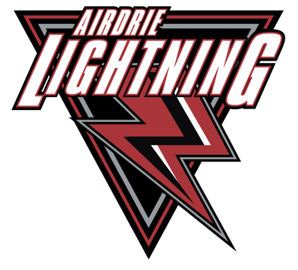
AMHA Coach Course Reimbursement Form

Please complete this form fully, attach receipts and supporting documents.
Sign, date and email into: coachreceipts@airdriehockey.com

Full Name of Coach:
Email to receive E-transfer:

Birthdate to verify in Hockey Canada Registry:
Team and Position:

Date submitting the receipt for payment:

Summary of charges

Date (m/d/y): | Description: |  | Amount:
 | (Receipts must accompany all requests for Reimbursement)
 |  | GST
 |  | TOTAL

For Accounting Use Only
G/L Account
Date Paid
E-transfer amount
Entered into Quick books

