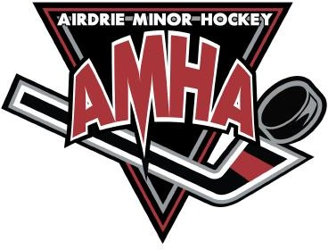
HOME EXHIBITION GAME
Hockey Alberta Sanction # Request

*Please send in at least 1 week in advance*

*This form is for all Exhibition Games played at Home
(Exhibition Game Away – any game outside of Airdrie – please fill out Travel Permit document)

Home Team Contact Name and Email:

Visiting Team Contact Email:

Home Team Name, Division, and Tier:
- For example: U11 - Atom Tier 1, U11 - Atom Red 3, U13 - PeeWee AA, etc.

Home Team Hockey Canada Registry (HCR) ID#:
- Your HCR ID# is located on the top right corner of the Hockey Canada Registry Roster that was sent out to you once your team was finalized.

Visiting Team Name, Division, Tier:

Visiting Team HCR ID:

Date of Game (m/d/y):

Location/Facility:

Address/City:

Any other comments or special requests:

Process:
Please fill in the blanks of this form, save it and email into the AMHA office.

AMHA will then input into the Hockey Alberta website and your team will be notified of the sanction # via the email you provided above.

