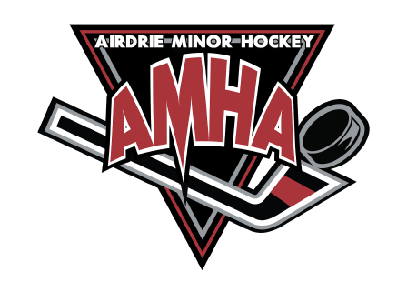
Player Acceleration Application

Please complete this form, attach letters of recommendation, a cheque in the amount of $250 and drop it off to the AMHA office in the Ron Ebbesen Arena, or save and email to: officeadmin@airdriehockey.com.

Player Information
Name:
Date of Birth (yyyy/mm/dd): |  | Position Played:
Previous Year’s Team:
Previous Year’s Coach Name & Phone #:
Parent Information
Name, Phone # & Email:
Name, Phone # & Email:
Team Trying out for:
Justification as to why you are applying to Accelerate, be specific:

By signing below, you are acknowledging that you have read and fully understand the Acceleration Policy #8.12 as written.

______________________________________ ______________________________________
Parent Signature(s) Players Signature

