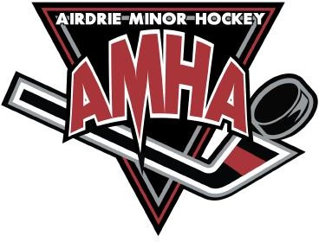
T RAVEL PERMIT
For Tournaments/Exhibition Games played outside of Airdrie

*Please send in at least 1 week in advance*

Please select one of the following:
- Exhibition Game Sanction #:
- Tournament Sanction #:

Airdrie Team Contact Name and Email:
Airdrie Team Name, Division:
- For example: U11 - Atom Tier 1, U11 - Atom Red 3, U13 - PeeWee AA, etc.

Airdrie Team HCR ID:
- Your HCR ID# is located on the top right corner of the Hockey Canada Registry Roster that was sent out to you once your team was finalized.

Date(s):

Travelling to:

Number of Games:

Any other comments:

Process:
Please fill in the blanks of this form, save it, and email it into the AMHA office.

AMHA will then input into the Hockey Alberta website and you will be notified of your approval via the email you provided above.

