An Annual General Meeting of the Airdrie Ringette Association held in the Rotary Room Genesis Place, 800 East Lake Blvd NE, Airdrie, Alberta, Thursday, May 22nd, 2025, commencing at 7:30 pm.

**2024/25 Board of Directors**

Mark Roblin – President

Faith Waters - Vice President

Meaghan Kernaghan - Treasurer

Sheila Murphy - Secretary

Leah Rappel - Registrar

Tyler Woolsey - Ice Scheduler - (absent)

Rickie Neufeld - Fundraising Director

Matt Brodie - Tournament Director

Drew McKnight - Director of Coach Development -(absent)

Tanya Reisner - Player Development

Matt Bisschop - Equipment Director

Tara Bissell - Director of Officials

Dawn Papp - Volunteer Coordinator

Alana Berger - Public Relations Coordinator- (absent)

Pat Richards - Member-At-Large I- (absent)

Shawn Kraft - Member-At-Large II

1. **OPENING ACTIONS / ITEMS**
   1. **Call to Order**

The 2025 ARA Annual General Meeting is called to order by the Board President Mark Roblin at 7:40 pm

* 1. **Declare Conflict of Interest**

None.

* 1. **Quorum**

The President acknowledged that a quorum of the membership was established with present thirteen (12) Board members, plus one (1) member in good standing. Total (32).

* 1. **Adopt AGM Agenda**

MOTION: Moved by [R. Neufeld]; Second by [D. Papp]

THAT the agenda be approved as presented. No Dissension Carried

* 1. **Review and Approve 2024 May AGM Meeting Minutes**

Minutes were emailed to the membership prior to the meeting. There was no open business arising from the minutes.

MOTION: Moved by [M. Brodie]; Second by [M. Bisschop]

THAT the draft meeting minutes of 2024 AGM be approved as presented. No Dissension Carried

* 1. **Review and Approve 2024 June Special Meeting Minutes**

Minutes were emailed to the membership prior to the meeting. There was no open business arising from the minutes.

MOTION: Moved by [D. Papp]; Second by [M. Bisschop]

THAT the draft meeting minutes of the June 2024 Special Meeting be approved as presented. No Dissension Carried

1. **Highlights and Reports**
   1. **Reports of the Board of Directors included the following:**

2024/25 ARA had 254 players across 18 teams. Most notably: 60 Athletes in U10. There were 18 Head Coaches + 59 Assistant Coaches and Jr. Coaches for every team U14 and below, in some cases 3-4

Morning Power skating had 75 Athletes participate. Spring Ringette Camps: Learn to Play Full Ice- 22 participants;

Intro to Ringette – 22 participants; U12, U14, U16/19 3vs3- 96 players

Each ARA Team had approx. 6 Power Skating sessions with Cary Grant

The Branding and Apparel Initiative for this season was successful and contributed to a more cohesive ARA image.

New this year the Ring of Fire tournament was a Single 4 Day event. It was overall very successful raising over $30K and hosted all ARA Teams and Divisions (Exception being a combined 16B/C Division).

Hosted the 2nd ARA Year End Celebration - ~150 Attendees

Hosted Come Try It’ – Attended by 14 Aspiring Lil’ Stingers!!

On-Ice Success for 2024-25 Season included: 16A won 3rd place in provincials;14A 4th place in provincials; 19A, 12A, won Zone 2 Banners; 12A Won CRL League Banner + Regional Championship

During the 2024-25 season 31 regular weekly ice hours, including power skating on Friday nights and mornings 2x/week, plus game ice was provided. Utilized weekly practice ice at Explosive Edge for Active Start. Held 8 goalie training sessions in Calgary. Total number of ice sheets this season was 634 (not incl. tournaments)

Completed first year of 3 yr contract with Sports Evaluations Inc.

* 1. **Financial Report**

The Airdrie Ringette Association Statement of Operations ending April 30, 2024, was presented. These are the audited results. ARA had total income of $272,664, Expenses of $370,074 and Net Income of -$97,410.

The unaudited Profit/Loss Statement and Balance Sheet ending April 30, 2025, was presented. ARA had a total income of $374,079; Expenses of $334,560; Net Income of $41,370. Balance as of April 30th, 2025, current assets $128,371.

MOTION: Moved by [L. Rappel]; Second by [M. Bisschop]

THAT the 2023/2024 Financial Report as presented be accepted. No Dissension Carried

1. **Old Business**
   1. Policy reviews, as mandated by Ringette Alberta was conducted and ARA adopted the RAB Safesport Policies. Updated policies will be posted to the ARA website shortly
   2. Bursary Program has been placed on hold until financial balances improve and enable funding the program.
   3. Airdrie-Cochrane Combination: Motion was defeated in June 2024. ARA did welcome 3 athletes at U19 and was able to access 1 ice time per week in Cochrane.
2. **New Business**
   1. **Bylaw Amendments**

Proposed Bylaw amendments were presented for approval by the membership. Amendments included:

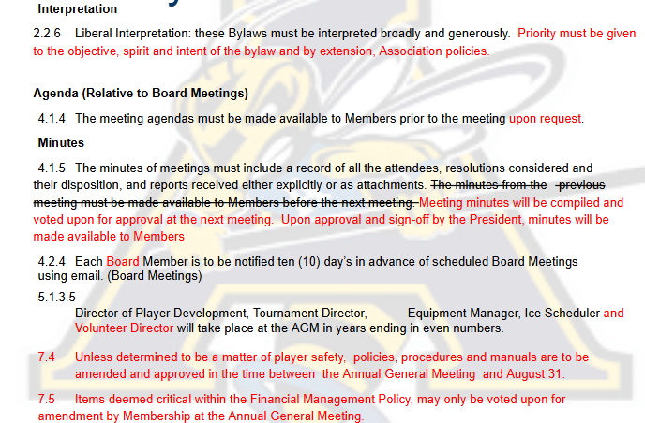

MOTION: Moved by [T. Rodgers]; Second by [L. Rappel]

THAT the ARA Bylaw Amendments as presented be accepted. No Dissension Carried

* 1. **Fee Updates and Revenue Generation**

M. Roblin reviewed the current operating cost per team by division. Registration fees do not fully cover team operations as ARA funds regular season and costs for Session 3, Regionals and Provincials. There has been no fee increases in over 5 years and increased costs including ice rentals requires that fees will be increased for the 2025/26 Season.

To offset years where ARA does not have access to an AGLC Casino fundraiser an association wide Cash Lottery will be introduced to generate much needed funds to offset operating costs. The fundraiser will be added to the 2025/26 registration fees and will be mandatory for all U10 through to U19 divisions. Each player will be assigned 15 tickets at $10 each.

* 1. **Appoint Auditor**

MOTION: Moved by [M. Kernaghan]; Second by [R. Neufeld]

THAT Tanner Desrosiers and Associates be accepted as financial reviewer for the 2024/2025 Financial statements. No Dissension Carried

* 1. **Financial Management Policy**

M. Roblin reviewed the Financial Management Policy that was approved by the Board in May 2025.

Need to ensure ARA maintains ongoing fiscal guardrails/covenants. The goal is to maintain the Association’s financial position to ensure long term viability and funds are available to develop our athletes with critical priorities being: Equitable access to ice time for all age groups; Use of independent 3rd party evaluators for athlete evaluation and team selection; Goalie and Skill development; Power skating; Player retention.

The policy provisions the Association has a base operating deficit (Operating Cost vs Registration Fees)

Budget established to ensure at the end of each season banking assets equal 1.25x the base operating deficit (3 yr weighted rolling avg). Surplus above the minimum balance available to be reinvested

* 1. **2025-26 Preliminary Budget**

M. Roblin presented the preliminary budget. Current projections are in accordance with the Financial Management Policy and project a $51,500 cash surplus.

* 1. **Upcoming Season**

M. Roblin provided an update to upcoming season. Registration will open May 25th and close June 30th. It is the goal of the Board to provide quality programming in a safe and respectful environment, we will continue to evolve under SafeSport. ARA Board will be in need of volunteers to serve on the following committees: Fundraising Committee; Evaluation Committee; Bursary Award (Pending budgets).

* 1. **Election of Directors**

Board positions are 2 years and begin immediately after being elected/acclaimed. All positions were acclaimed. The new elected Directors are:

President - Mark Roblin

Secretary - Sheila Murphy

Registrar - Leah Rappel

Director of Officials - Tara Bissell

Director of Coach Development - Pat Richards

Director of Fundraising - Rickie Neufeld

Director of Public Relations - Serena Heintz

* 1. **2025/26 Free Membership Draw**

For all those in attendance at the 2025 AGM will have one (1) entry for each athlete registered with ARA during the 2025/2026 season. The winner via random draw Leah Rappel.

* 1. **Meeting Adjournment**

The May 12, 2025, meeting adjourned at 8:44 pm.

____________________________________________

President

I hereby certify these minutes are correct.

____________________________________________

Secretary