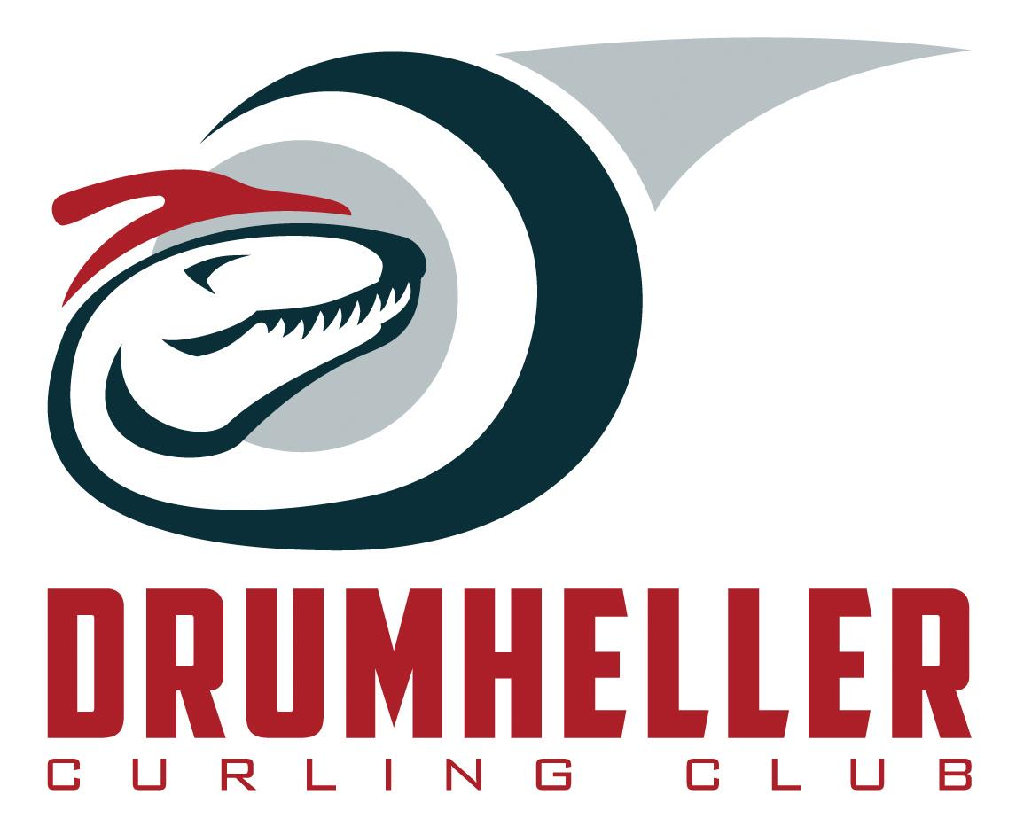

UPCOMING BONSPIEL!

Drumheller Mixed Bonspiel

March 29-31, 2019

**Entry Fee: $200 per team**

Contact: Sarah Barton – 403-820-1139

Email: Sarahdb@hotmail.com

Follow: Drumheller Curling Club.

Drumhellercurlingclub@gmail.com