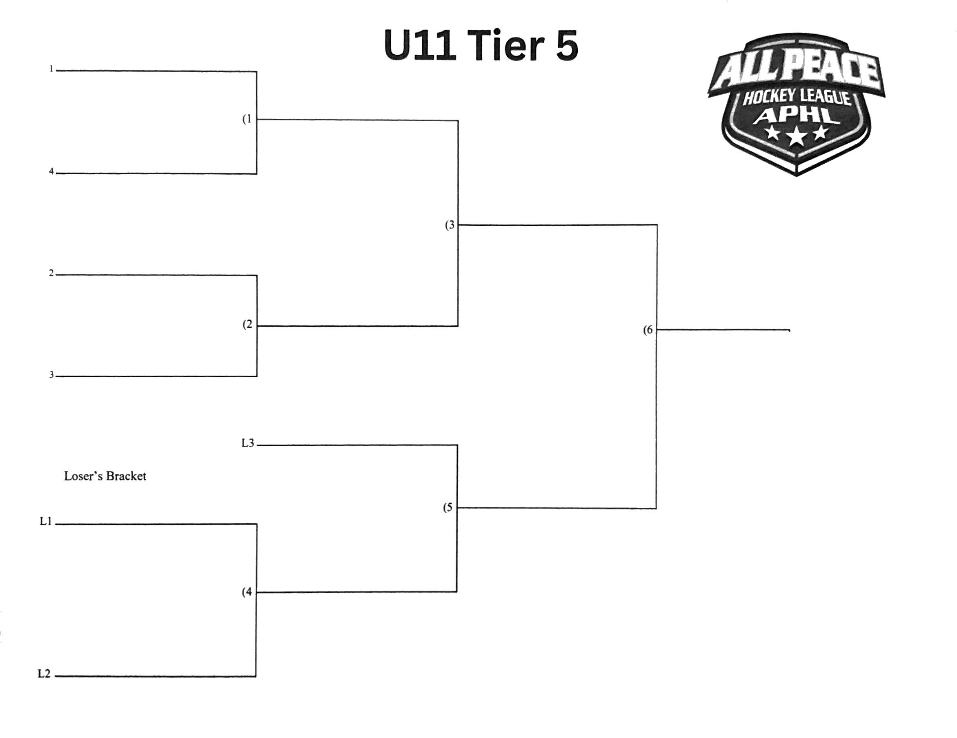
GRANDE PRAIRIE FEMALE
BEAVERLODGE
HIGH PRAIRIE
WEMBLEY
BEAVERLODGE
HIGH PRAIRIE
GRANDE PRAIRIE FEMALE
WEMBLEY

