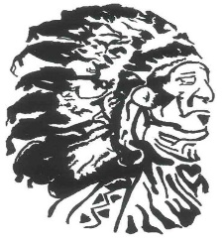

ASHCROFT INDIAN BAND

Medical Travel Cheque Distribution
Privacy and Security Policy and Procedure

Please be advised that all medical travel cheque/ payments, must be picked up by the person whose name is on the cheque, effective immediately.

If for some reason, you cannot pick up your own Medical Travel payment, we require a phone call or a written note granting a parent/child, or other relative permission to pick up the cheque on your behalf.

Please remember that all Medical Travel requests must be brought to Char Pittman at the Health Center to be forward to the Finance Department.

Please allow 3-5 days for your Medical Travel cheques to be processed.

Thank you,

