Barrhead Minor Hockey
Tournament Guidelines

TOURNAMENT GUIDELINES
Tournament Mentor:
Kelly Klein
ksklein06@hotmail.com
*the tournament mentor is available for questions from coordinators who need guidance while organizing their tournament*
Please note that funds raised from your tournament are to help subsidize hockey expenses only. Please follow AGLC guidelines for spending any money raised by gaming. Most notably, gaming funds cannot be used for social functions or apparel. See this link: 22-05-02_CGP_Handbook_3.pdf (aglc.ca). Funds that are not considering money raised by gaming may be used for, but not limited to: tournament entry fees, exhibition games, extra ice for practices, mileage from travel or team BMHA logo wear. Please refrain from fundraising for a year-end party or non-hockey related events.
Tournament Coordinator (1 or 2 people)
- Tournament sanction numbers are obtained by the BMHA Systems and Development Director at the beginning of the season. The contact person for the tournament will be based off information known at the time. May be a manager, tournament coordinator, or delegate. The sanction number must be posted where it can be seen at the tournament.
- Determines the number of teams that will be attending the tournament and choose the teams that will come as requests come in. Coordinators may wish to create a registration package for visiting managers to fill out with their roster, coaches names, team tier level, and team logo.
- Determines tournament schedules (games and floods) and emails finished schedule to ice allocator, ref allocator, town staff and concession. Must confirm all ice times (start and end times) with ice allocator prior to making the schedule.
-Create tournament rules in terms of behavior, time slots, formats for determining finals, tie breaker rules, etc.
- Ensures all areas of the tournament have a coordinator and that each coordinator has done their job
-Determine the tournament entry fees for visiting teams
-Create a budget that can be used a guide for the coordinators of each area (ex. Goodie bags). You can ask ice allocator and ref allocator for help with the costs of ice/refs.
- Is the contact person for the tournament for visiting teams
- Makes up schedules for dressing rooms for teams and volunteer sheets for time clock, scoresheet, penalty box, music, raffle tables, 50/50 workers etc
-Make sure all parents have signed up for their predetermined number of volunteer time slots
- Ensures all volunteers have shown up for shifts
- Make sure you have game sheets available in time box (U9 and above). Coordinators may prefill gamesheets with rosters or ask other team managers to supply roster stickers. It is suggested to have tournament rules and box instructions available in the time box.
-Create an information/welcome letter for managers of attending teams that can include lists of potential accommodations, restaurants, hours of concession and raffle table, draw times, availability of ATM, etc. This should be emailed with the tournament schedule at least two weeks before the tournament start date.
- Ensures that all tournament game sheets have been entered into e-Gamesheets (the link will be in the email that lists the sanction number). This is time sensitive and must be done immediately following the tournament. This can be done by the tournament coordinator or manager.
Tournament Treasurer (team(s) treasurer usually fills this role)
- To operate 50/50 sales, raffles, etc. your team must obtain an Alberta Gaming Licence ID. Each individual tournament is responsible for obtaining its own licence. First, go online to the Alberta Gaming and Liquor Control website (Raffle: $20,000 and less | AGLC) and print off the ‘Eligibility for Raffle Licence’ Form and the ‘Internet Account Request Form’. Email or fax your completed request forms to the AGLC for approval; you will be contacted via email by a representative and issued an AGLC ID and internet access login and password. You can then sign in via their online portal and apply for a raffle license under $20, 000. There is no cost associated with applying for a license this way. This job may be allocated to a member of the raffle table as ticket numbers, colors, prize amounts and ticket values all need to be known to get a raffle license.
- Keeps track of ALL incoming and outgoing funds
-Accept cheques from visiting teams for tournament fees. If teams inquire about e-transfers please consult with BMHA treasurer before accepting.
- Pays all expenses
- Keep receipts!
- All costs incurred will be the responsibility of the teams that are part taking in this tournament.
- All tournament fundraising activity is to be documented, collected and disbursed as to per Alberta Gaming and Liquor Commission guidelines.
- Certain activities, such as raffles (i.e. 50-50 tickets), requires approval and licensing by the Alberta Gaming and Liquor Commission. It is the responsibility of the individuals obtaining such approval to ensure that all requirements are met and the Association is not penalized.
- Teams that carry out Tournament Fundraising activities will adhere to Association rules. Only the following items are expenses that may be paid from the tournament fundraising. Receipts are required for ALL items except ice fees and referee fees.
- Ice
- Referees
- Team Prizes and Player of the Game Awards
- Raffle Prizes
- Telephone/office expenses
-Programs

-Tournament treasurers are expected to count money at the conclusion of the tournament before money leaves the arena. Recommended one from each team, one to do initial count, one to verify.
All BMHA Policies and Procedures must be followed
-In the event that the division tournament involves teams that have separate team accounts, Team treasurers must coordinate to make sure all expenses and profits are distributed equally (i.e. 2 teams: Funds raised split 50/50. 3 teams: Funds raised split 1/3, 1/3, 1/3). One team account may be used for all initial income and expenses and then distributed as necessary.

Raffle Table Coordinators (usually two to four people)
– Raffle items or cash to be used towards items may be donated by the family or solicited from a family member or friend. Remember that hockey is already a financial burden on most families. If using cash donations to purchase items, please try to shop local. Do not solicit town businesses for donations!
- Determine prices and purchase/make tickets (i.e. 10 tickets/$5), give these numbers to the poster volunteers
- Collect all raffle items from parents and keep a list of donations and who they came from so the list can be given to the Tournament, Poster and Program Coordinators. Do not collect raffle items until the day before your tournament. The storage room cannot be used for days leading up to the tournament. Coordinators may ask their respective delegate for any supplies that may be located in the storage room (tickets, numbered raffle bags, cash boxes, etc.) Raffle items and estimated values, ticket colors, number of tickets to be sold and ticket prices must be given to whomever is responsible for reporting to AGLC.
- Set up raffle table and procure any items necessary for it. Can set up tables with items around an hour prior to the first game.

- Take down raffle table and make the draws. (For convenience’s sake, it is recommended to only have raffle table running on first day of the tournament.)
- Must get a float and cash box as well as all of the supplies needed for the table
- Organize suitable gift for Coaches Draw (if applicable)
- Remember, less is more! Only ask families to donate an item if they want to, or know someone who has a business or one of their own. Encourage families to donate an item for the booze cooler, lotto board, and hockey bag instead. Your team can use a portion from the tournament entry fees to purchase items for the raffle table if needed. (Smaller items for younger aged tournaments and larger items for older aged tournaments).

Other Prize Ideas Include
- Puck/Toonie toss (only if there is time in your tournament schedule – this usually takes a half hour too complete. Most often consists of three higher priced donations placed from blue line to blue line….buyers purchase numbered pucks ($2/puck) to throw at prize markers….closest puck to the prize marker wins.
- Hockey Bag - Every family brings in an items valued between $5-$10. All items are put into a new hockey bag - bag is either donated or purchased. Hockey bag can either be used as a Raffle Table Prize or Puck/Toonie Toss prize)
- Liquor Basket – Families who choose to participate donate a bottle to be put into a basket (Rubbermaid, cooler, basket). Tickets are sold individually and must have a different color than other raffle table items. (ex. 3 for $20, 1 for $10?) This basket must be kept separate from the rest of the other raffle items (on its own table) since purchasers must be over 18 to buy tickets.
- Lotto Board - Each family donates $5 worth of scratch tickets to be placed together on a LOTTO board (i.e. poster board, picture frame) Tickets are usually sold individually for this item.
- Player Board - Determine number of players attending your tournament. On poster board, draw out grid to make enough squares for all attending players. Number each square in numerical order. Write each players name on a separate square. (Best to mix up teams and players!) Cover each name with tape. (Duct tape works well). Sell each square for $3. Buyer writes their name on the square they purchase. At designated time, do a draw for winning number. Winning player receives 1/3, Winning buyer 1/3, and your tournament 1/3, of the Player Board Income.
-Loonie stick - $2 one loonie on stick, one to tournament. Get stick(s) donated and either give the option of left or right (put money on stick they choose when purchasing) or give receipt so they can exchange themselves
-Spin to win, plinko board – fun games that kids can do. Suggested $2 a spin or puck drop. As long as a prize is given everytime to the player, this will not require an AGLC license.
Package deals are always a hit. Remember you cannot give anything for free (AGLC rules). Lump items from table that will always be there to total $20(i.e. 3 pkgs. raffle tickets $15, 1 loonie stick $2, Lotto board $2, Program $1) =$20

Posters (one or more people)
- Raffle Table Signs (i.e. ticket prices, packages etc.)
- Prize list of winners - Item won, with line to write winners name
- Sponsors/Thank you’s
-50/50 winners
-Scoreboard and tournament schedule
-Dressing room schedule
- Attending Team logo posters can be made to hang along hallway or lobby if desired (if age applicable or if poster people want to do this – can be time consuming)

Coaches Packages (one person)
-schedule or program
-tournament rules
-lists of restaurants and services in Barrhead (can use welcome letter that the coordinator(s) wrote up)
-possible items: package of gum, dry erase marker, pen, notepad, ticket(s) for Coaches Draw (if applicable), coupon(s) for free coffee (if applicable)
-must bring packages prior to the first game of the tournament so they can be handed out to coaches or left in dressing room

Kids Corner (one or two people) (if applicable)
- Organize T.V., movies, coloring books, etc.
- Coordinate with tournament Coordinator as to how many table and chairs you will need.
- Set up space and clean up afterwards
-Can ask to rent Charles Godberson Room, inquire with town

Awards (one or two people)
-this can include team medals/trophies and MVP, Heart and Hustle or Lucky Player awards
- Order and pick up awards
-MVP, Heart and Hustle and Lucky Player are traditionally one winner per game per team. Ensure to order enough. Make sure whatever is decided is communicated to coordinators so they can list in the welcome letter.
- Order and pick up trophies/medals (pay for trophies prior to picking up)
-examples for H&H, MVP, Lucky Player are: toques, shirts, gift cards, hats
- Ensure team prizes have been boxed according to teams and are in the penalty box for each team’s last game.
- Ensure Heart and Hustle, MVP or Lucky Player awards are in the penalty box for each game
-If you decide to do Lucky Player, winners can be pulled prior to the tournament by random draw
-Gold/Silver winners (U11 and up) can do banners, trophies, individual medals
-Team prize for U7, U9 or even older could do candy trophies

Program Coordinator (one or two people) (if applicable)
- Designs and creates a program (schedules for the day, sponsors and any info that parents might need throughout the day).
- Tournament rules must be made available to all participants

Team Snacks (two people - optional but always a nice touch)
-Drinks (water, juice boxes, sports drinks, chocolate milk)
- Snacks (apples, oranges, granola bars, hot dogs)
- Can coordinate with arena concession if you want to do hot dog coupons or coffee coupons for coaches (they provide, you make tickets and pay concession after tournament)

Goodie Bags (one or two people) (if age requires it)
- Organize items for goodie bags.
-Suggestions: hockey cards, bracelets/necklaces, photos, toques, towels, hockey pucks, mini hockey sticks, water bottles, gift cards, shower kits etc. The Tournament Committee can decide what is desired and the budget for these items.
-can includes snacks if wanted in bag instead of separate – fruit, granola bars, water bottle

Parents
- Parent volunteers will be required to work the following positions: clock, scorekeeper, penalty box, music, 50/50 Sales, Raffle Table etc.
- IF PARENT VOLUNTEER SPOTS CANNOT BE FILLED PRIOR TO THE TOURNAMENT TAKING PLACE YOUR TOURNAMENT THE TOURNAMENT COORDINATOR MAY NEED TO ASSIGN POSITIONS.

ALL BMHA Policies and Procedures must be followed throughout the tournament

SAMPLE TOURNAMENT GAME FORMATS

U7:
Half ice – take care with your dressing room schedules, this can get difficult. If possible, room teams from the same town together. Do not have teams that are playing against each other share.
Game duration: 1 hr Periods
Time to put up/move half ice boards (at beginning/end of day and with floods – need volunteers for this, recommend helmets) two 24 minute periods or one 45-48 minute period, and time for awards.

U9:
Half ice – take care with your dressing room schedules, this can get difficult. If possible, room teams from the same town together. Do not have teams that are playing against each other share.
Game duration: 1 hr Periods
Time to put up/move half ice boards (at beginning/end of day and with floods - need volunteers for this, recommend helmets) two 24 minute periods, and time for awards.

U11:
Game duration: 1.5 hrs
Round robin: straight time, 20 minute periods
Finals: if within 3 goals, the last 5 minutes will be stop time
No overtime or shoot out in round robin play.
Give finals more time to allow for any overtime or shoot out and for team prizes (medals/trophies)

U13:
Game duration: 1.75 hrs
Periods: First and second period: straight time (flood halfway 2nd per.)
Third period: stop time
No overtime or shootout in round robin
Give finals more time to allow for any overtime or shoot out and for team prizes (medals/trophies)
**can modify times/floods depending on how much time you are given for your tournament

SAMPLE TOURNAMENT SCHEDULE AND RULES (U7/U9)
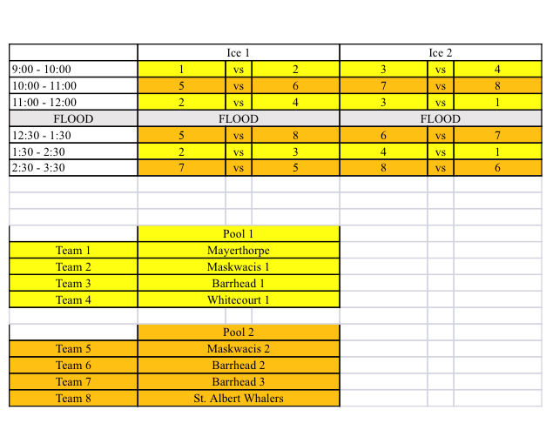

Barrhead U7 Tournament Rules
- Each game will consist of a two minute warm up, one 45 minute straight time period with three minute shifts. Player hand shakes and awards will take place after each game.
- Face offs will occur at the beginning of each game. The puck will be thrown into the corner after goals and stoppages.
- There will be no referees for the tournament. One coach from each team is required to be on the ice to help direct the game.
- No score will be kept on the game sheets.
- A goalie stick is the only goalie equipment allowed. Goalies are not permitted to lay across the goal crease and goalies are encouraged to stay on their feet as much as possible.
- Heart and Hustle awards are to be picked by coaches for their own team and will be handed out at the end of each game. A player can only be awarded this one time.
- Please line players up on the blue line after each game for the heart and hustle awards.
- All games are played on half ice with board dividers. Teams will share the bench for the game.
- Appropriate coach, player, and spectator conduct is expected!
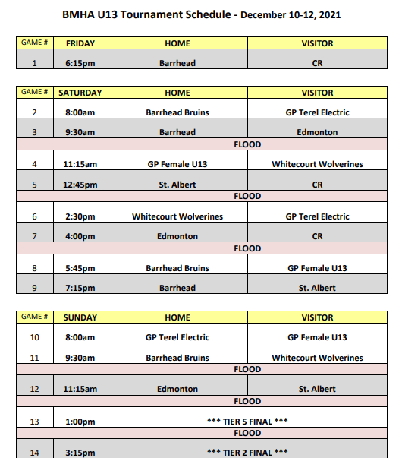

SAMPLE COACH PACKAGE LETTER

Barrhead Novice Tournament 2020

HA# -19339080
Tournament Coordinators: __________________

Welcome everyone to our annual Barrhead Novice Tournament! Included in this package are the tournament schedule, rules, and information on activities for the day.

**attach schedule and rules

The raffle table is located in the Agrena lobby and will be open Saturday morning at 9 am and closing at 3:40 pm. 50/50 draws are occurring with each game. Concession is open for players and spectators with a full menu, cash only. An ATM is available for your convenience in the lobby. There is a coach’s corner located in the lobby with coffee and muffins for team staff. Skates can be sharpened at Sanderman’s Home Hardware, Barrhead Shoes or John’s Men’s Wear all located main street Barrhead. Players will be provided with muffins in the morning and two hot dogs each in the afternoon in their dressing rooms. Restaurant options include: Crazy Mama’s Concession, Sal’s Famous, Subway, A&W, BTown’s, Prairie Chef and more. The Aquatic Centre next to the rink is open Saturday 10 am – 8 pm. The Bowling Alley is also located right next to the Agrena Parking Lot with varying open hours.
Thank you to all teams for attending our tournament. Enjoy the day!

Barrhead Novice Bears and Bruins
SAMPLE REGISTRATION FORM

Barrhead Initiation Tournament Registration Form
Saturday, January 11th, 2020
Barrhead Agrena
Team Name: | ______________________________________________________
Initiation Player Ages | # 5 year olds ______ |  | # 6 year olds ______
Initiation Player Year of Playing |  | 1st year ______ |  | 2nd year ______
Coaching Staff: | ______________________________________________________
 | ______________________________________________________
 | ______________________________________________________
 | ______________________________________________________
Team Manager: | ______________________________________________________
Contact Number: | ______________________________________________________
Contact email: | ______________________________________________________
Team Roster
Player Number | Player Name

