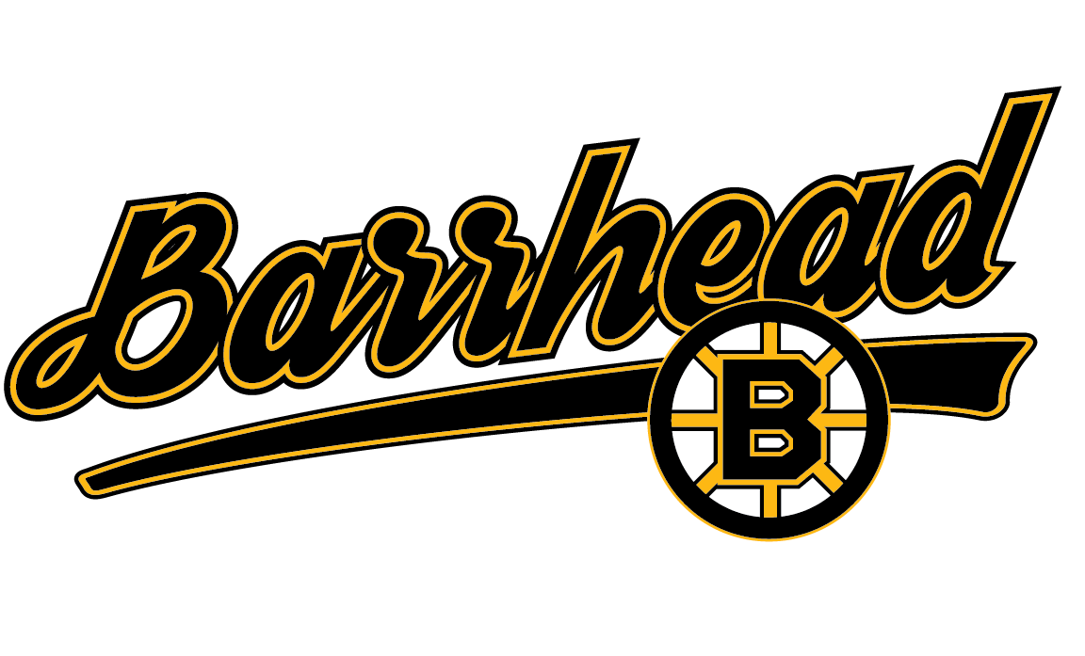
Barrhead Minor Hockey Association
Affiliation Agreement

Season:

Players Registered Team Information

Players Name:

Players Date of Birth:

Players Current Team:

Division of Hockey: Novice Atom Peewee Bantam Midget

Teams Current Tier: Tier 1 Tier 2 Tier 3 Tier 4 Tier 5 Tier 6

Current Coaches Signature:

Team Requesting Affiliation

Team Name:

Division of Hockey: Novice Atom Peewee Bantam Midget

Current Tier: Tier 1 Tier 2 Tier 3 Tier 4 Tier 5 Tier 6

36.2 P&P: As per BMHA and Hockey Alberta regulations, and affiliated Player may play with the hockey team to which the player is affiliated up to a maximum of ten (10) games, excluding exhibition and tournament games. Should an affiliated player play more than the ten (10) games with the team to which the player is affiliated, they shall be considered an “Ineligible Player”. However, if the players registered team completes its regular season and playoffs before the players affiliated team, the player may thereafter affiliate an unlimited number of times. Appearance of a registered Player’s name on the official game report shall be considered participation in the game except in the place of an alternate goalkeeper, in which case actual participation only shall be considered as taking part in the game and such participation shall be specially noted on the official game report.

36.6 P&P: Any players registered team’s activity will take precedence over the affiliated team. Permission must be granted from the player’s registered team coach and documentation should be completed prior to the player attending any activity of the affiliated team. (Refer to Appendix J in BMHA P&P)

Current Season Coach Signature:

Coach Requesting Affiliation Signature:

